**Owen Galvin, CSCI E-88 Homework04**

Environment for non-EMR flume activity: CentOS 7 VM running on Windows 10 host. The active user is “cloudera” but this is not in fact a Cloudera Quickstart VM

**Problem 1: (Points: 20) simplest Flume setup**

* + **Setup Flume on a server (can be any server: EC2 instance, local laptop, VMWere VM)**

Download the tar and extract to /usr/local

wget http://mirror.cc.columbia.edu/pub/software/apache/flume/1.7.0/apache-flume-1.7.0-bin.tar.gz

sudo tar -zxvf apache-flume-1.7.0-bin.tar.gz -C /usr/local/

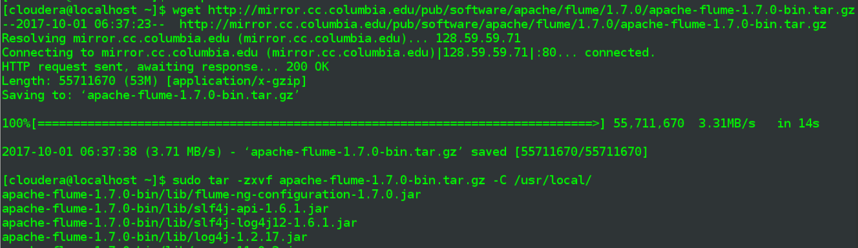

Edit my .bash rc and insert two below lines, so can run flume from wherever I want to.:

export FLUME_HOME=/usr/local/apache-flume-1.7.0-bin

export PATH=$PATH:$FLUME_HOME/bin



Tried a few different ways of getting confirmation things have been set up but it appears some form of a complete command needs to be run in order to get meaningful feedback and I’m not there yet, so settle for confirming the path is working:

flume-ng –help

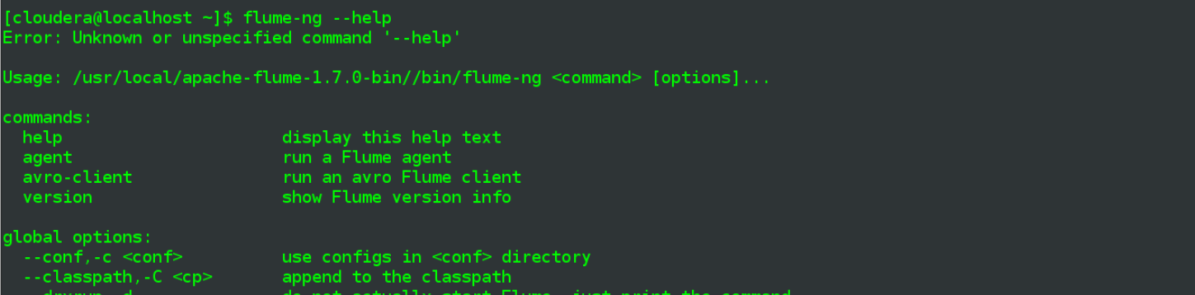

Could have put flume in my user’s home directory to make permission issues easier, instead I’ll hit the existing installation directory with a chown hammer, since cloudera is the primary user on the VM:

sudo chown -R cloudera:cloudera /usr/local/apache-flume-1.7.0-bin



* + **Configure "Spooling Directory" Source - to read data from some specified directory**
  + **Configure a "File Roll" sink (local directory sink) for some output directory on your local server**
  + **Use memory channel**

First I’m going to make the spool/sink directories in my home directory:

mkdir e88

mkdir e88/A4

mkdir e88/A4/p1_flumeSpool

mkdir e88/A4/p1_flumeSink



Create a conf file directly for this problem, based on information from <https://flume.apache.org/FlumeUserGuide.html>, though I update the abbreviations they use to an expanded form that lets me keep track of things better.

**flume1.conf**

|  |
| --- |
| # Name the components on this agent  agent1.sources = sources1  agent1.sinks = sinks1  agent1.channels = channel1  # Describe/configure the source  agent1.sources.sources1.type = spooldir  agent1.sources.sources1.spoolDir = /home/cloudera/e88/A4/p1_flumeSpool  # fileHeader: Whether to add a header storing the absolute path filename.  agent1.sources.sources1.fileHeader = true  # Describe the sink  agent1.sinks.sinks1.type = file_roll  agent1.sinks.sinks1.sink.directory = /home/cloudera/e88/A4/p1_flumeSink  # Use a channel which buffers events in memory  agent1.channels.channel1.type = memory  # Bind the source and sink to the channel  agent1.sources.sources1.channels = channel1  agent1.sinks.sinks1.channel = channel1 |

Other than the basic chaining that will be present in all conf files like this, the key lines include

**agent1.sources.sources1.type = spooldir**

* + - setting the type on my source to “spooldir”, which is the component type for using a spooling directory source

**agent1.sources.sources1.spoolDir = /home/cloudera/e88/A4/p1_flumeSpool**

* + - the directory from which files will be read

**agent1.sinks.sinks1.type = file_roll**

* + - “file_roll” is the predefined component type for storing events on local filesystem

**agent1.sinks.sinks1.sink.directory = /home/cloudera/e88/A4/p1_flumeSink**

* + - directory in which files will be stored

**agent1.channels.channel1.type = memory**

* + - store events in an in-memory queue. Default capacity=100 and transactionCapacity=100 will hopefully be fine for this small experiment.
  + **Create 5 files with 10 lines of text each (anything goes) - named file1.txt, file2.txt,.... File5.txt**

Going to create these using a quick python script, writing them into a staging directory

**p1_make_files.py**

|  |
| --- |
| **import** os *# Create 5 files with 10 lines of text each (anything goes) - named file1.txt, file2.txt,.... File5.txt* output_folder = **'staging'  for** i **in** range(1,6):  **with** open(**'staging/file{}.txt'**.format(i), **'w'**) **as** f:  **for** j **in** range(1,11):  f.write(**'I am line {} in file {}\n'**.format(j, i))  print(**'\nDONE, contents of {}\n - {}'**.format(output_folder, **'\n - '**.join(os.listdir(output_folder)))) |

The code does a simple look to iterate through numbers 1 to 5, creating file1.txt through file5.txt. For each file, do another loop through numbers 1 to 10, writing one line for each iteration.

Run the above script in parent directory for assignment4 = /home/cloudera/e88/A4. Do a cat on one of the new files to confirm expected contents.

python3 p1_make_files.py

cat staging/file1.txt

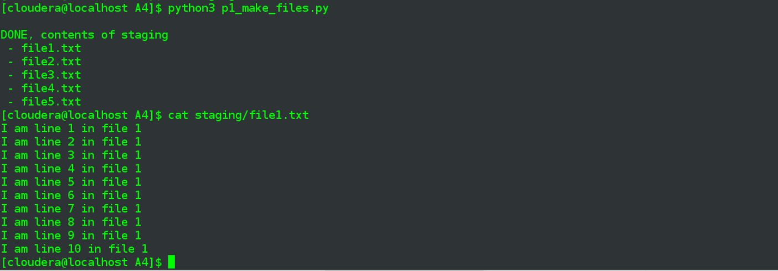

* + **Place them into the spooling source directory**

At this point I’ll actually kick off the flume agent, using the agent name (agent1) specified in my conf file, as well as passing in the whole flume1.conf file I detailed earlier.

flume-ng agent -n agent1 -f $FLUME_HOME/conf/flume1.conf

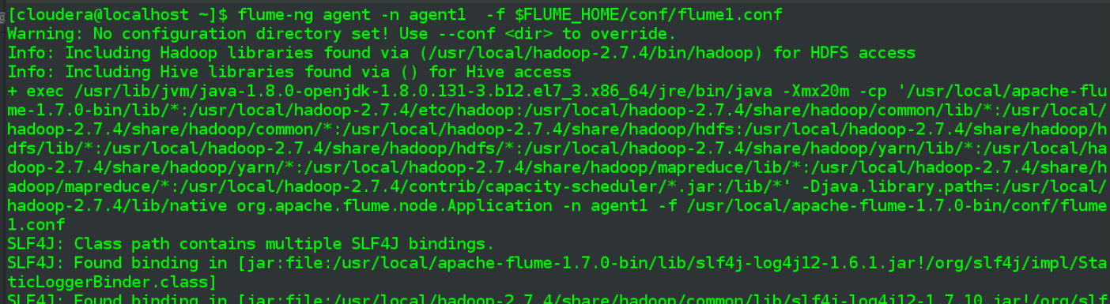

…

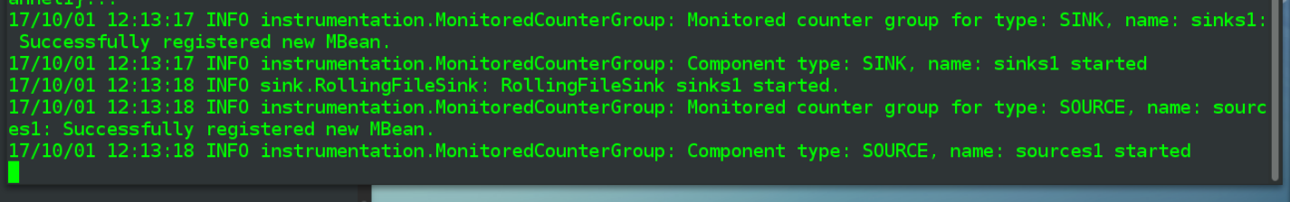

Then I’ll copy them one-by-one

cp staging/file1.txt p1_flumeSpool/

cp staging/file2.txt p1_flumeSpool/

cp staging/file3.txt p1_flumeSpool/

cp staging/file4.txt p1_flumeSpool/

cp staging/file5.txt p1_flumeSpool/



* + **Observe them copied to the destination directory - demo the results**

and observe behavior in the running flume agent output, can see them being “consumed” and renamed with a .COMPLETED file suffix.

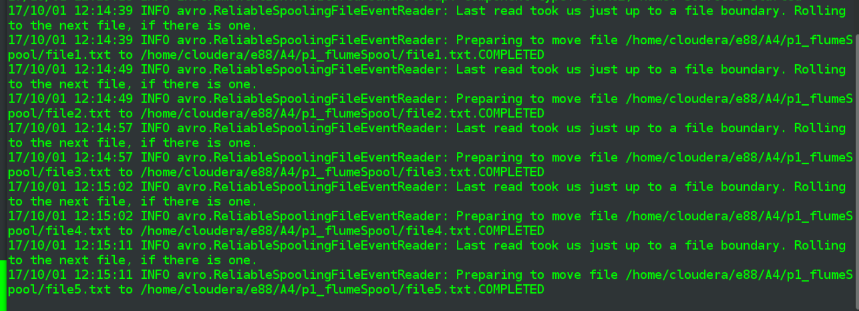

check contents both directories

ls -halt p1_flumeSpool

ls -halt p1_flumeSink

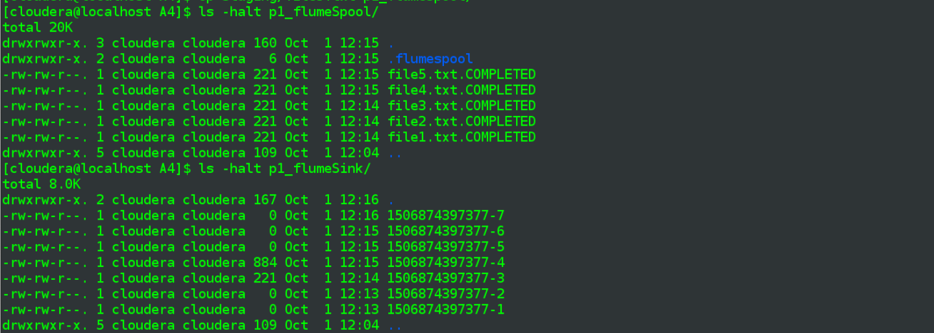

There are empty files being generated in the sink directory – the file_roll component has a default 30 second roll period so it would make sense a file is generated every 30 seconds no matter what. But if there are files added to the spool directory in between that polling period, files being generated in sink directory will iapparently nclude contents of those files.

Reviewing the files in above screenshot that actually have a file size, the first is ¼ the size of the second, so my guess is that the “-3” file will have contents of file1.txt while “-4” will have contents of files 2 through 5.txt.

And that is what I observe. Below screenshot shows entire contents of the “-3” file and the lines within are from file1.txt. I did a head/tail of file “-4”, outputting 11 lines so as to capture the border between source file contents and see that “-4” appears to have contents of files 2 to 5.

cat p1_flumeSink/1506874397377-3

cat p1_flumeSink/1506874397377-4 | head -11

cat p1_flumeSink/1506874397377-4 | tail -11

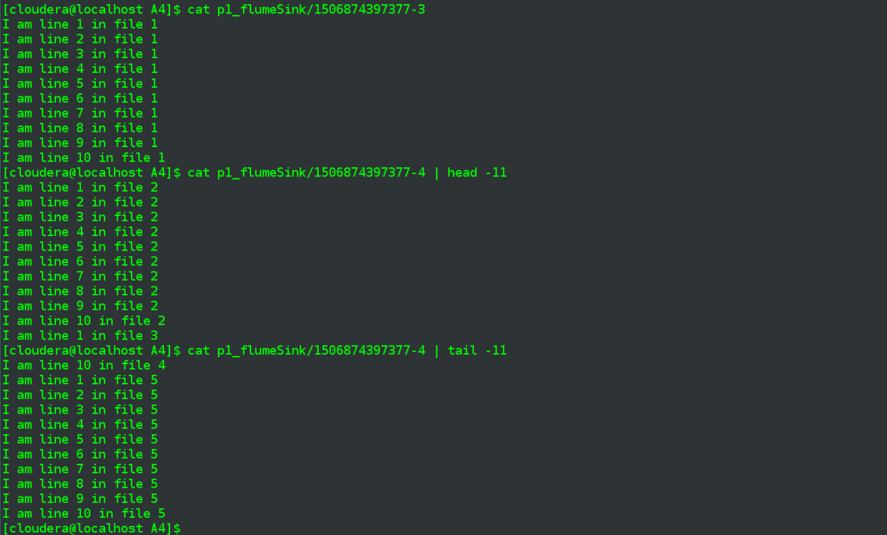

Before I more fully understood the 30 second sink.rollInterval I was going to do a second iteration where I copied all files in at once but I believe above shows both scenarios of single files arriving spread over time (multiple files) and also what happens when they come in all at once (presumably a single populated file, with contents of all files.)

* + **Try to copy the same files again into the spooling source directory - explain and demo the results**

This time I’ll copy them all in again at once

cp staging/* p1_flumeSpool/

and observe bad things happen on the agent output:

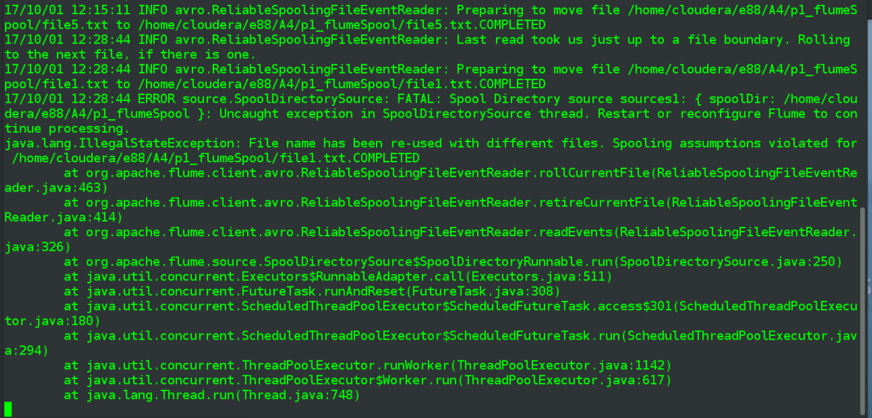

Specifically error equal to the below:

ERROR source.SpoolDirectorySource: FATAL: Spool Directory source sources1: { spoolDir: /home/cloudera/e88/A4/p1_flumeSpool }: Uncaught exception in SpoolDirectorySource thread. Restart or reconfigure Flume to continue processing.

java.lang.IllegalStateException: File name has been re-used with different files. Spooling assumptions violated for /home/cloudera/e88/A4/p1_flumeSpool/file1.txt.COMPLETED

Create a quick ad-hoc non-empty test file in staging = “file_new.txt” and try copying that into the spool directory.



I don’t observe any further action in the agent’s terminal window, likely that the agent process is indeed broken. Look at the sink directory and note that

1. there are still zero-byte “checkpoint” files being written
2. my file_new.txt file, above, did not make it in
3. the first file in my cp *, the one that apparently broke the agent, did technically make it as the “-32” file, below shows a cat of its contents.

ls -halt p1_flumeSink/ | head -15

cat p1_flumeSink/1506874397377-32

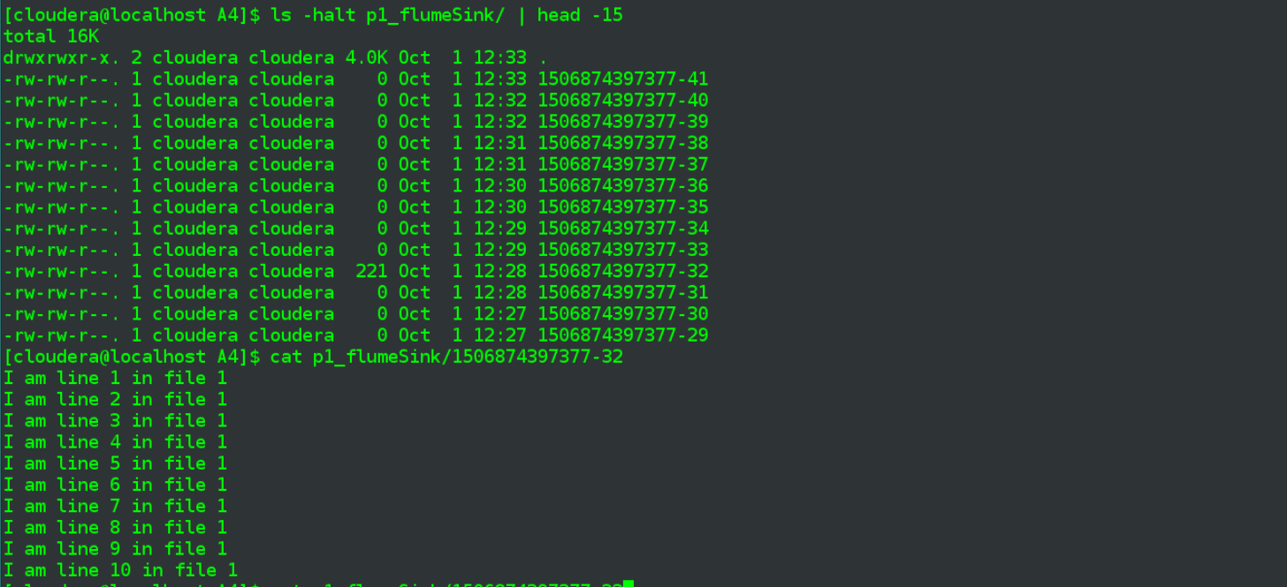

The end result is that putting more than one file with the same name into spool directory will effective ly break the flume process. That’s not to say this scenario can’t be handled, I don’t know, but the default behavior of the Spooling Directory -> File roll workflow does not allow for that.

**Problem 2: (Points: 20) setup web server and a client to issue requests to the server**

* + **Install Tomcat or Nginx web server on your server (can be local server, EC2 instance or VMWare CentOS VMs) - you can use port 80 or any other port you want to use**

I don’t have a web server already installed on my Linux VM, so I can dive right in and install nginx (select that option mostly because I’ve installed Tomcat before, on other servers).

sudo yum -y install nginx

service nginx start

Run the above yum install and it proceeds directly, so my local repo information must have what it needs (online resources indicated a repo update might be necessary . Once complete start nginx (didn’t use sudo in there but there is a UI prompt for me to enter cloudera’s password.)

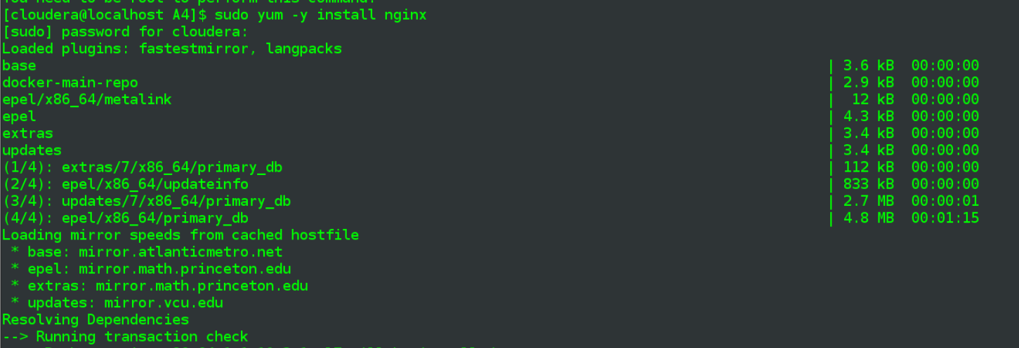

…

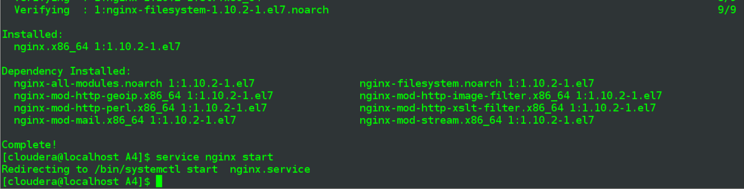

Leaving any port config unchanged, so I’m assuming it will be exposed via port 80.

Open up Firefox on my VM and navigate to <http://localhost> and the expected page comes up, so install is presumably a success:

|  |
| --- |
|  |

* + **Create a simple static html page and make it index.html (home page of the web server)**

I find out that the local nginx directory form which pages are served = /usr/share/nginx/html, so I cd over there. Backup the existing index.html and create a very simple one of my own

cd /usr/share/nginx/html

ls -halt

sudo cp index.html index.html.ORIG

sudo vim index.html

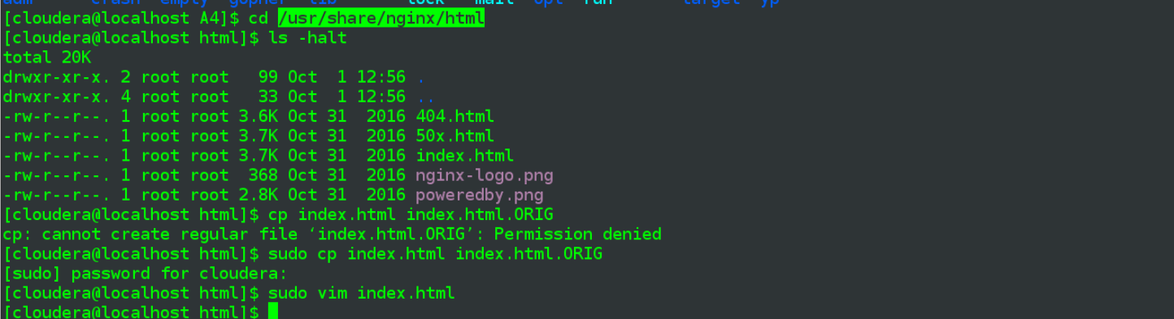

Contents of my index.html:

|  |
| --- |
| <html>  <body>  <h1>HI! I'm index.html for e88 </h1>  </body>  </html> |

Refresh my localhost url and see the changes reflected

|  |
| --- |
|  |

* + **Test your page by issuing 'curl' requests to the index.html page; something like "curl** [**http://localhost:80/index.html**](http://localhost:80/index.html)**"**

In addition to above, perform a curl of the index.html page on localhost:

curl <http://localhost/index.html>

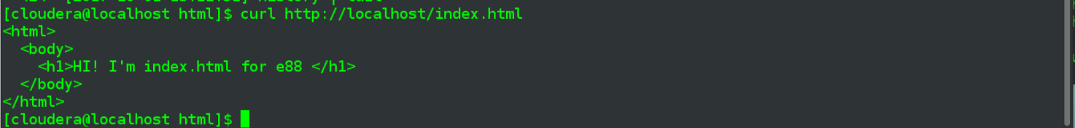

* + **Find and examine logs generated by the server**

The nginx.conf should reveal location of the log file:

less /etc/nginx/nginx.conf



Contents indicate access_log = /var/log/nginx/access.log

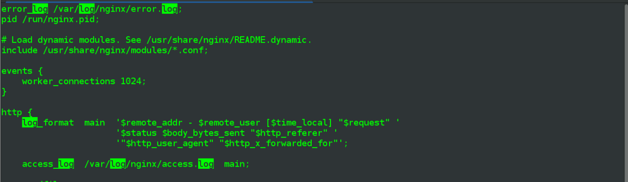

Tail the log file in that location. Do a simple refresh on index.html in Firefox and see a line immediately added to the log, so it looks like this is the correct file.

sudo tail -f /var/log/nginx/access.log

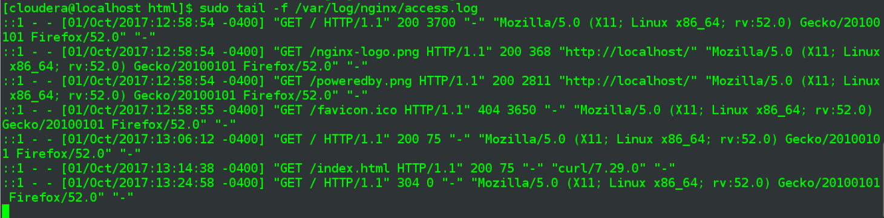

* + **Write a script on an app that would issue 'curl' requests to your web server constantly, with a  configurable rate (number of requests to send per second); you script/app should run "forever" when started, until you stop it**

The “curl” equivalent for my app will be a GET via the requests library in python. as per the below line:

r = requests.get(**'http://localhost/index.html'**)

Everything else is infrastructure related to the “number of requests to send per second” requirement. There are a number of inline comments discussing the code but the general idea is:

1. take a **--count-per-second** arg with the number-per-second to send
2. also take a **--debug** mostly useful during development, has hard-limits & addtnl output
3. begin the real code, first make sure we are beginning with a brand new second
4. (non-debug) do an infinite loop, and within that loop
   1. make the requested number of requests and wait for remaining milliseconds of that “second” unit of time to expire before moving on to the next second
   2. warn if the number requested is > than what the script can actually do

**p2_curl.py**

|  |
| --- |
| **import** requests **import** datetime, time **import** argparse   **def** do_gets(gets_per_second_limit, is_debug=**False**):  *# this first bit is just about starting off at the beginning of the next whole second* begin = datetime.datetime.now().second  new_now = begin  **while** new_now <= begin:  time.sleep(.01)  new_now = datetime.datetime.now().second   total_count_limit = 500*# use total_count as a failsafe in debug mode* total_count = 0  *# essentially run "forever" (unless is_debug = True, in which case exit after GET count hits total_count_limit* **while True and** (**not** is_debug **or** total_count < total_count_limit):  gets_made = 0  *# normally want to wait after x GET request made in "this" second, but not if gets_per_second > number that can be performed  # w/o skip_wait the script would wait a full second in between loops* skip_wait = **False** new_now = datetime.datetime.now().second  *# keep making GETs while in current second and still under requested limit* **while** gets_made < gets_per_second_limit:  gets_made += 1  total_count += 1  *#print(datetime.datetime.now().second, gets_made, total_count)* r = requests.get(**'http://localhost/index.html'**)  *# spent more than a second making requests, gets_per_second_limit was too high* **if** datetime.datetime.now().second > new_now:  skip_wait = **True** print(**'gets_per_second_limit ({}) higher than can be performed ({}), going to continue doing best we can'**.format(  gets_per_second_limit, gets_made))  **break** *# we've made number of requested GETs for this second, hold off until we hit a whole new "second" unit of time* new_now = datetime.datetime.now().second  **while** datetime.datetime.now().second == new_now **and not** skip_wait:  time.sleep(.01)   **if** __name__ == **'__main__'**:  parser = argparse.ArgumentParser(description=**'Perform requested number of GETs per second on http://localhost/index.html'**)  parser.add_argument(**'-c'**, **'--count-per-second'**, type=int, required=**True**, help=**'number of GETs per second to attempt'**)  parser.add_argument(**"-d"**, **"--debug"**, type=bool, default=**False**)  args = parser.parse_args()   do_gets(args.count_per_second, args.debug) |

My VM, given the RAM I’ve allocated and the other apps that are running etc., seems to be able to only make 50-80 requests per second (though I see closer to 200 on another day). If I do a limited run in debug mode and with a high count-per-second value submitted, the script will point out its limits:

p2_curl.py -c 200 -d True

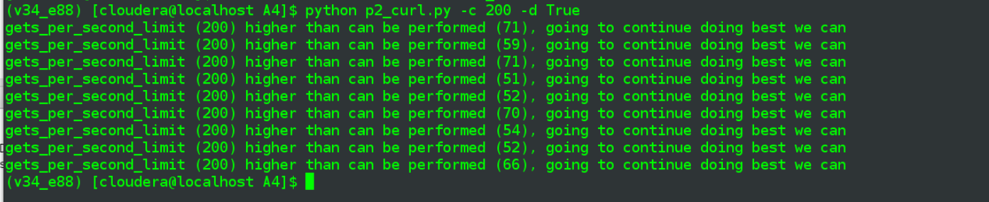

Earlier, simpler version of the script, where I just had it go in a simple loop, could do upwards of 85 requests per second. below is an example of how I tested that, counting the number of lines in the log for a given second:

cat /var/log/nginx/access.log | grep 2017:15:14:08 | wc -l



* + **Make sure you see all generated requests being logged in the web server log**

In one terminal do a tail -f of the nginx log:

sudo tail -f /var/log/nginx/access.log

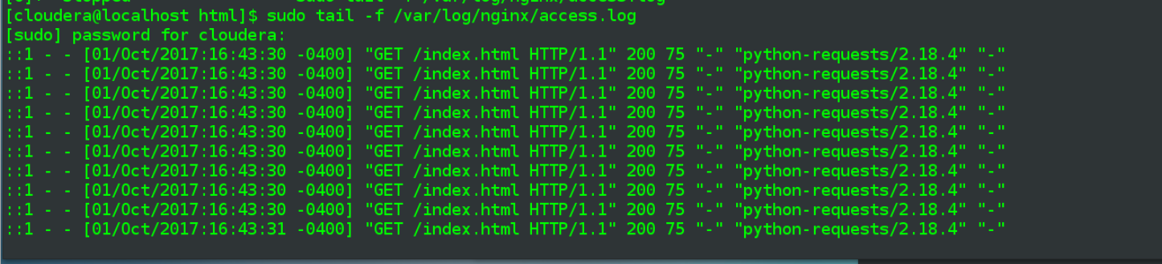

In another window do a “forever” run at 25 requests per second in one terminal window:

python p2_curl.py -c 200 -d True

confirm the earlier tail -f window is showing action, preferably at 25 hits per second:

(couple of :44 in below, then 25 :45 lines, followed by a few :46)

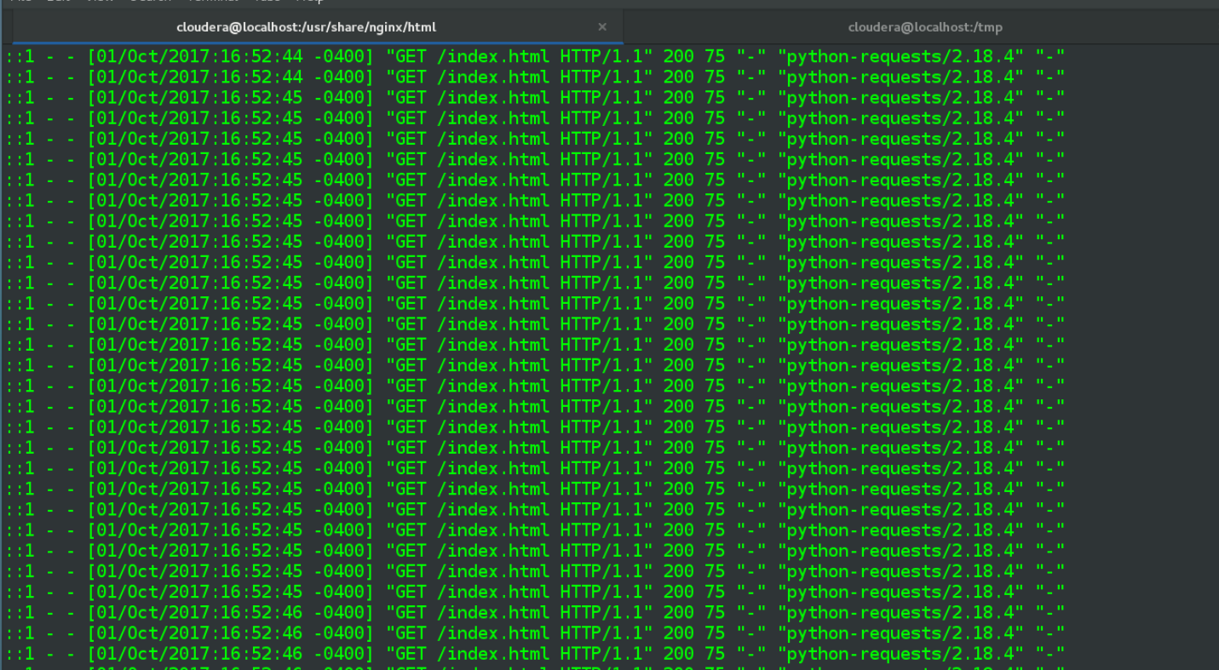

Then follow that up in a third terminal with some ad-hoc per-second line counts:

cat /var/log/nginx/access.log | grep 2017:16:52:45 | wc -l

etc.

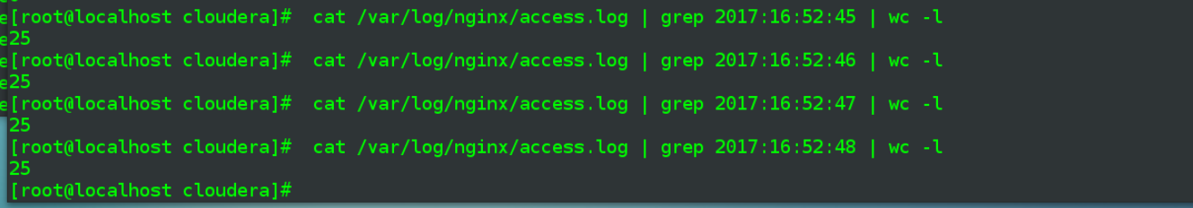

Looks good, launching script with **--count-per-second** = 25 results in 25 nginx log lines within a given second.

**Problem 3: (Points: 20) experiment with the Memory Channel**

1. **Install and configure Flume on the same server (where your web server is running)**

Not much to report here, as I’m using the same CentOS 7 Linux VM onto which I had installed Flume in Problem 1, and then installed nginx, for Problem 2.

1. **Configure a "tail -F"  Exec source for web server logs**
2. **Configure a "File Roll" sink (local directory sink) for some output directory on your local server**
3. **Configure a memory channel with the capacity of events**

Contents of the related conf are below.

**flume3.conf**

|  |
| --- |
| # Name the components on this agent  agent1.sources = sources1  agent1.sinks = sinks1  agent1.channels = channel1  # Describe/configure the source  agent1.sources.sources1.type = exec  agent1.sources.sources1.command = sudo tail -F /var/log/nginx/access.log  # Describe the sink  agent1.sinks.sinks1.type = file_roll  agent1.sinks.sinks1.sink.directory = /home/cloudera/e88/A4/p3_flumeSink  # Use a channel which buffers events in memory  agent1.channels.channel1.type = memory  # default capacity for memory channel is 100  agent1.channels.channel1.capacity = 1000  # default for transactionCapacity is also 100  agent1.channels.channel1.transactionCapacity = 250  # Bind the source and sink to the channel  agent1.sources.sources1.channels = channel1  agent1.sinks.sinks1.channel = channel1 |

Compared to the first flume .conf file, the source is now defined with component type = “exec”. The second line related to source is the command that does a simple “tail -F” on the nginx log file.

Not a lot of thought went into the capacity and transactionCapacity values, though I did want to change them from the defaults, they struck me as a little given that there would be at least 20 “events” per second.

After multiple failures where the agent appeared to be running ok but the sink directory was not getting populated with real data, realized my cloudera user wasn’t able to read the access.log file with current permissions. My experience working with Linux file permissions is limited and I restorted to a a simple chown:

sudo chown cloudera:cloudera /var/log/nginx/access.log



Along with calling the tail command with sudo. Not pretty but it works.

1. **Start your script - to start generating log entries in the web server log**
2. **Start your Flume agent - observe creation of local files with the events from the web server log**

Start my script with a 20-“curl” per second limit, do a tail on the nginx log to confirm working as expected:

python p2_curl.py -c 20

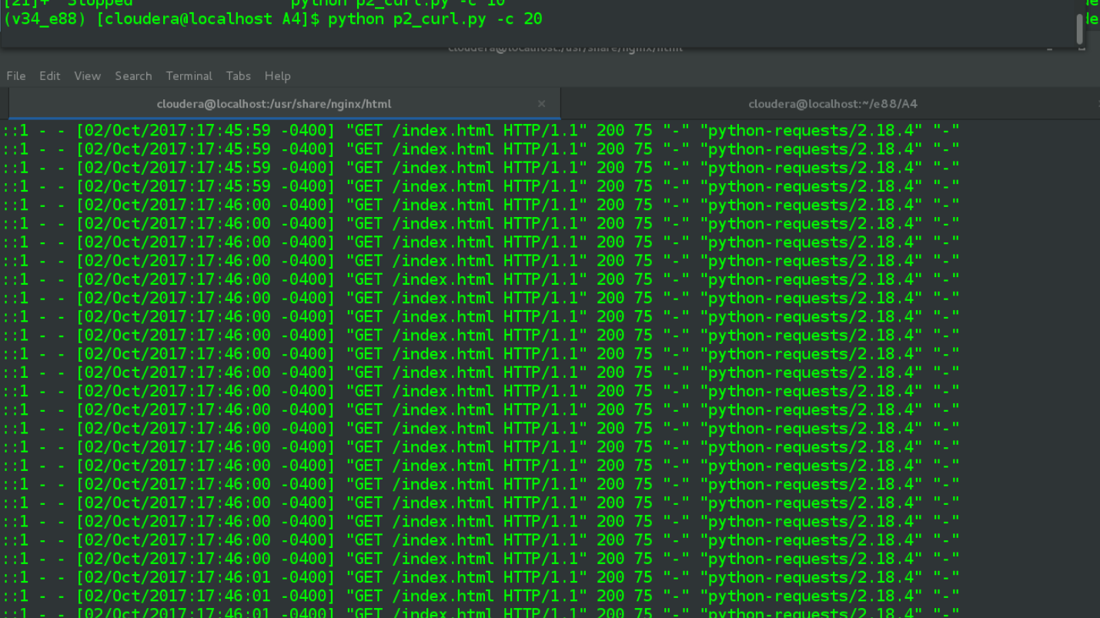

Start my flume agent using the flume3.conf discussed earlier, enter my pwd due to sudo:

flume-ng agent -n agent1 -f $FLUME_HOME/conf/flume3.conf

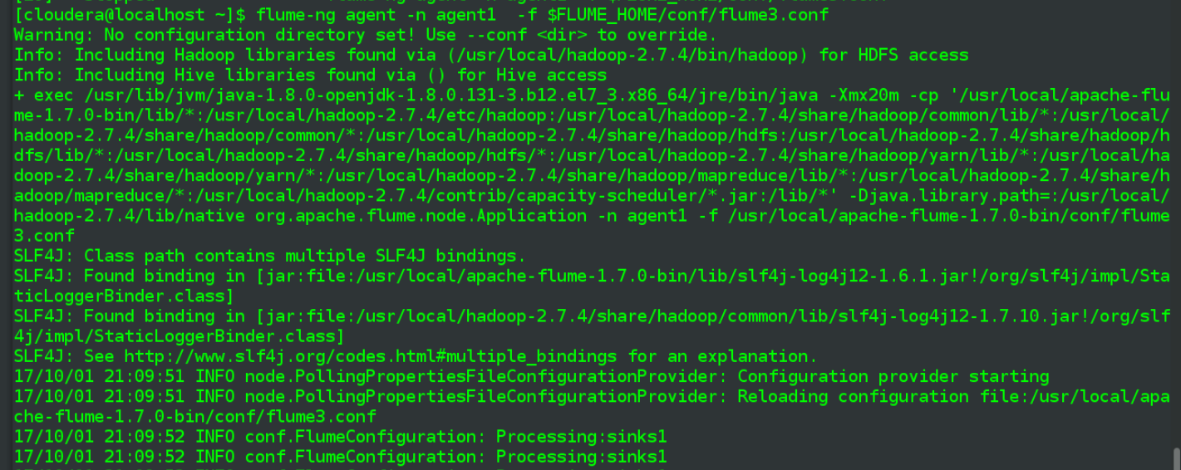

…

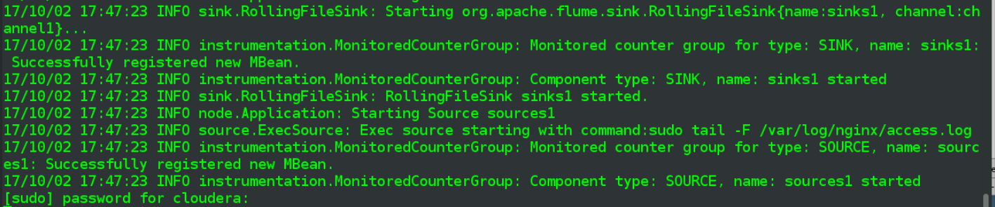

Check on my sink directory = p3_flumeSink, see populated files:

ls -halt p3_flumeSink/

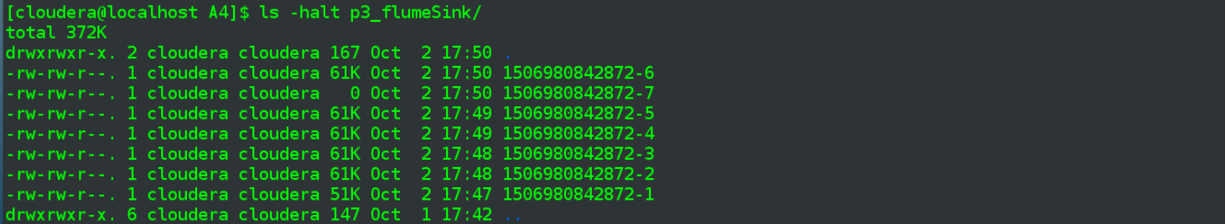

Pick a file in the middle bunch = “-4”, check the line count first,

cat p3_flumeSink/1506980842872-4 | wc -l



Get back 600 lines, had earlier noticed on the apached FlumeUserGuide page that the file_roll sink had a default 30 second interval:

|  |  |  |
| --- | --- | --- |
| sink.rollInterval | 30 | Roll the file every 30 seconds. |

If making 20 requests a second, and the file gets turned over every 30 seconds, that makes sense – 30 * 20 = 600 events/lines.

I’m still going to hypothesize that is the situation but note that requests “cross” the second-unit boundary. The tail of the “-3” file contains sevearl entries in the 54th second, which then continue to the top of the “-4” file:

cat p3_flumeSink/1506980842872-4 | head -25

cat p3_flumeSink/1506980842872-3 | tail -25

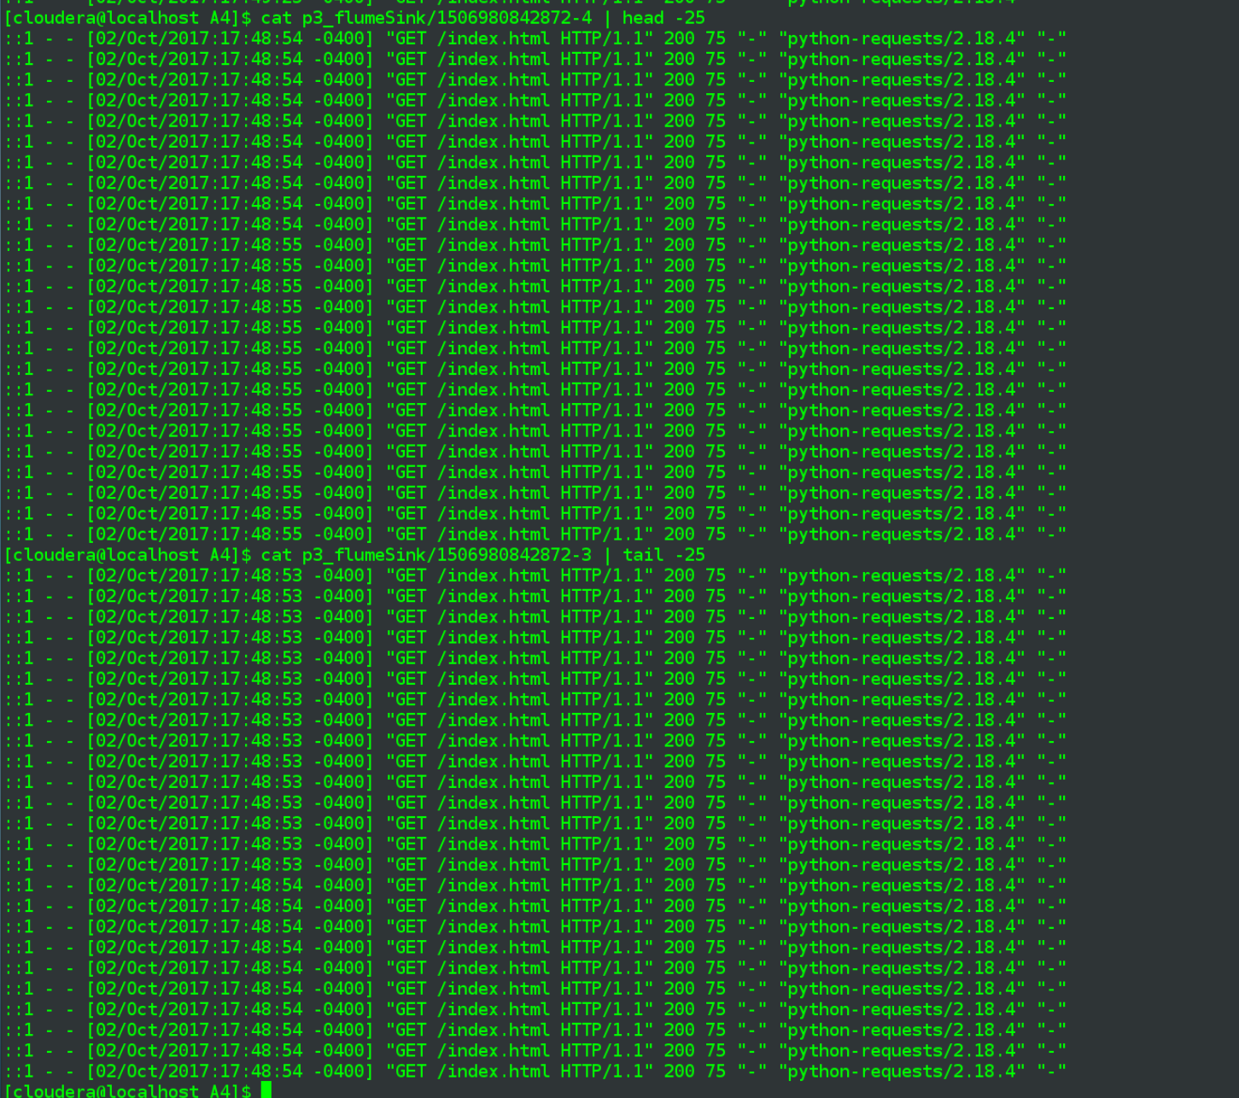

1. **Simulate Flume agent failure - stop your flume agent (do NOT stop the event generation app)**

Picking up again after above screenshots, launch the flume agent again at around “20:12” and llet it run for several minutes.

Then kill the agent process at about 20:20.

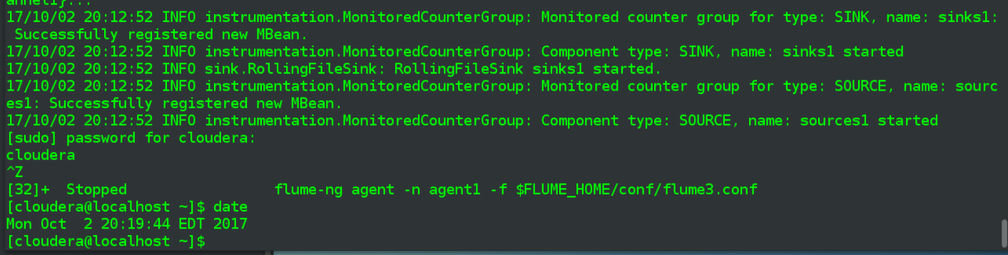

Do an -ls on the sink dir a couple of minutes later to confirm nothing being written

date && ls -halt p3_flumeSink/ && date

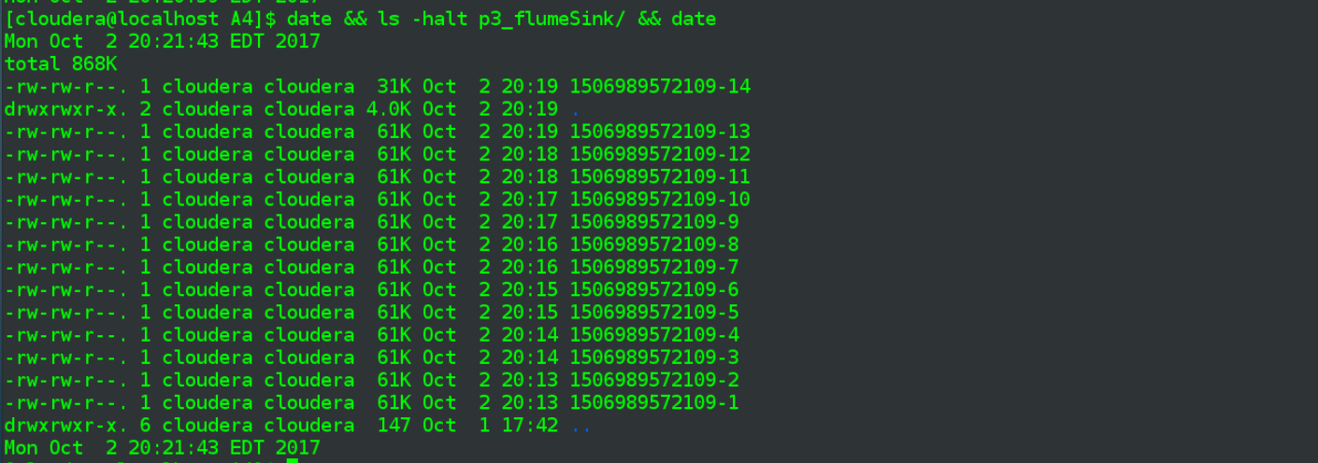

1. **Wait for 5 min - restart the Flume agent**

At about 20:25, resttart the Flume agent with same .conf file as before

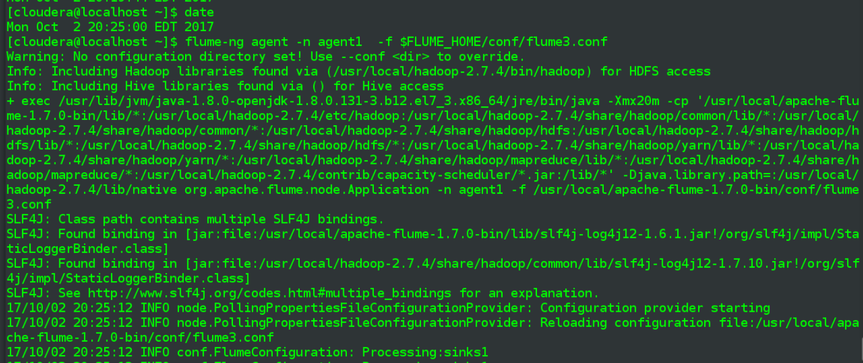

1. **Stop data generation app**

and stop my data generation app a few moments later with a Ctrl+Z



1. **Once all log data is processed by Flume (monitor the destination directory) - stop Flume**

Do an -ls on the sink directory every minute or so to check to see if no new files are being generated

ls -halt p3_flumeSink/

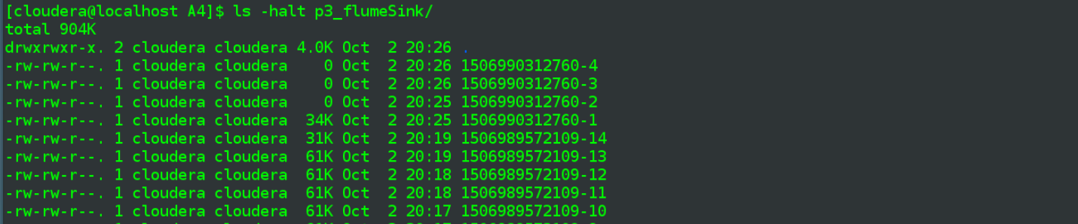

And actually it quickly stopped writing non-zero byte files, the last one is dated 20:25 and is 34k in size. The file written before that was at 20:19 and 31k in size.

1. **Compare destination logs with the source web logs - did you loose any data? Report the results**

Things aren’t looking promising data-loss-wise, going by the file sizes but first I’ll tail the last file that was written before the time gap in the sink directory, i.e. the 2nd file that was written in 20:19 minute span, which ends with a “-14” suffix.

cat p3_flumeSink/1506989572109-14 | tail -25

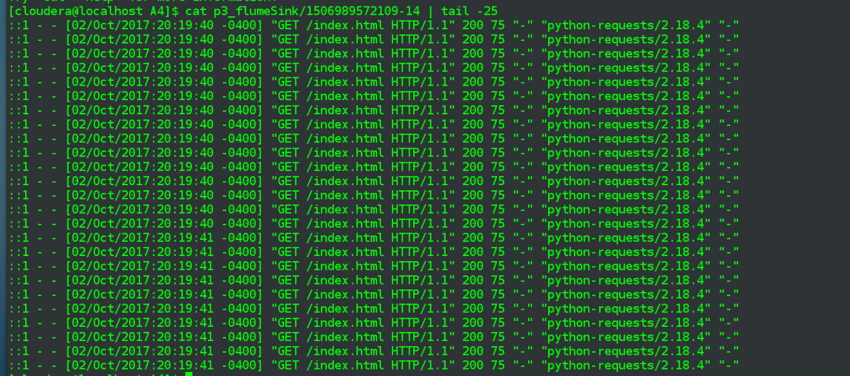

Last line recorded before the break was at 02/Oct/2017:20:19:41 and was part of a block of 10 lines written for during that “41” second

cat p3_flumeSink/1506989572109-14 | tail -25 | grep 20:19:41 | wc -l



Now look at the beginning of the first file written after flume agent was restarted (after the 5 minute break).

cat p3_flumeSink/1506990312760-1 | head -25

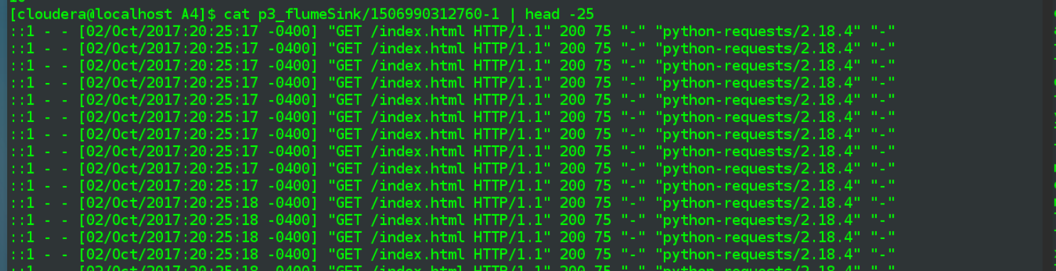

The first line is written for “second” = 20:25:17, after the agent was restarted, so going by that the log lines between 20:19:41 and 20:25:17 were almost enitirely lost. I say almost only because flume caught some requests that covered those beginning and ending seconds. Certainly, everything during the minutes 20:20 through 20:24 appears to have been unrecorded.

Sanity check on the nginx log itself to confirm log lines were generated during the missing period. Check the beginning of break

sudo cat /var/log/nginx/access.log | grep 02/Oct/2017:20:19:41

sudo cat /var/log/nginx/access.log | grep 02/Oct/2017:20:19:41 | wc -l

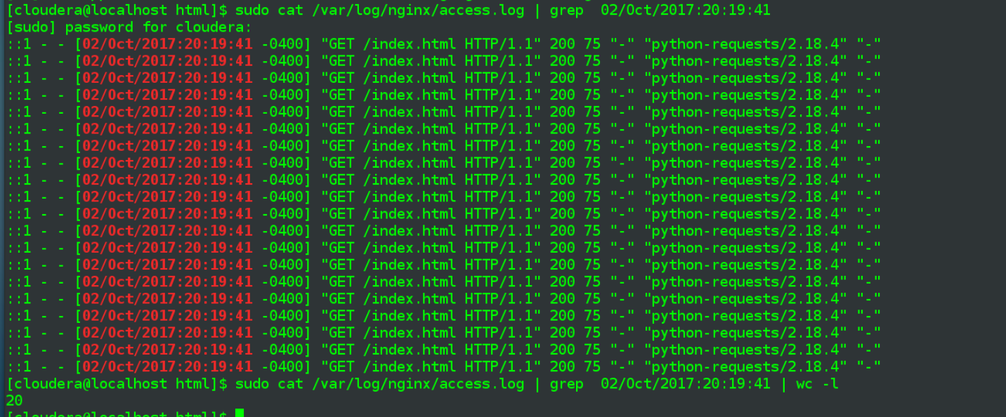

And note, as expected, there were a full 20 requests, even though flume only recorded (the first) half of them.

sudo cat /var/log/nginx/access.log | grep 02/Oct/2017:20:20:41

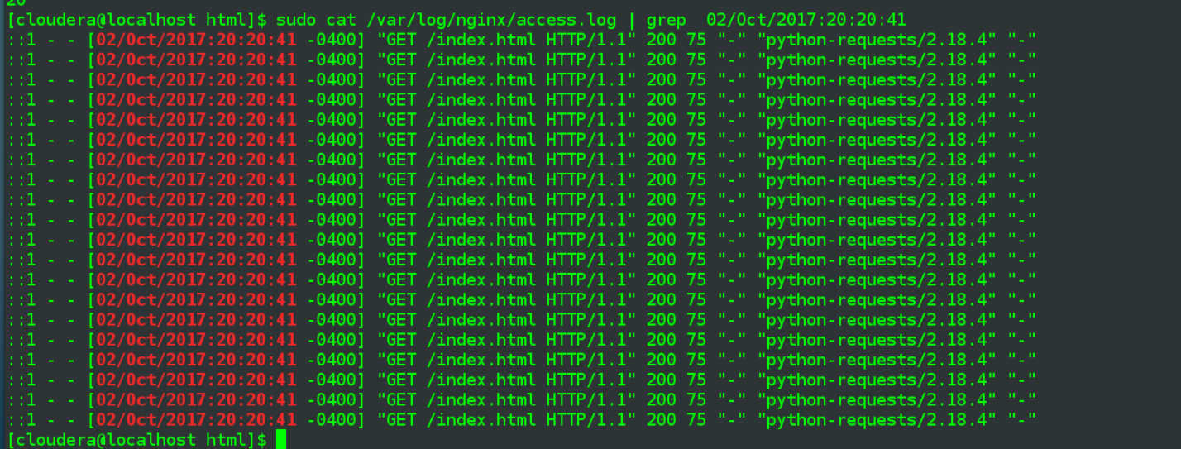

Yep, looks like 20. Check line count for a one of the full minutes that was covered by break, should see 20 requests * 60 seconds = 1200 log lines

sudo cat /var/log/nginx/access.log | grep 02/Oct/2017:20:22: | wc -l



So now have confirmed data loss, first by looking at the generated files in the sink directory and seeing zero-byte files being generated along with no big jump in file size at around the time of flume agent restart. And then by diving into those files and seeing where the data loss began and ended

1. Bonus: [+5] experiment with the event generation rates and memory channel configuration - how many events would you need to generate per second to see your memory channel filling up ? what happens then?

I did a quick check of this, maybe I’ll get back to it. Set the request app to do 200 per second, which it got close to a surprising number of times, wasn’t seeing many > 80 the other night.

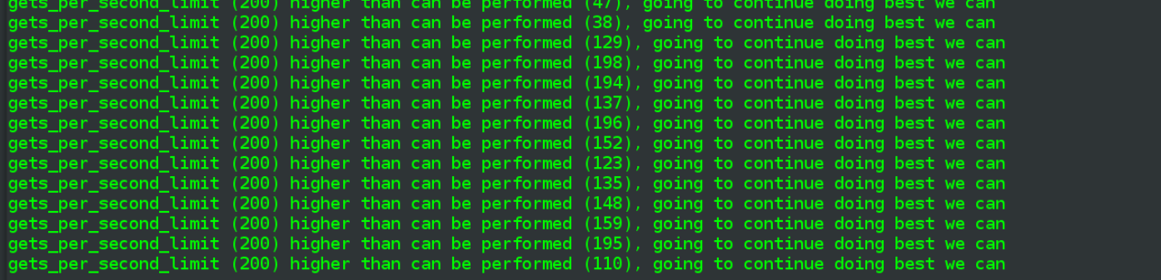

Either way, I tried reducing transactionCapacity value for the memory channel multiple times and even at 100 saw no problems. Not until I went down to 50 were there any problems,

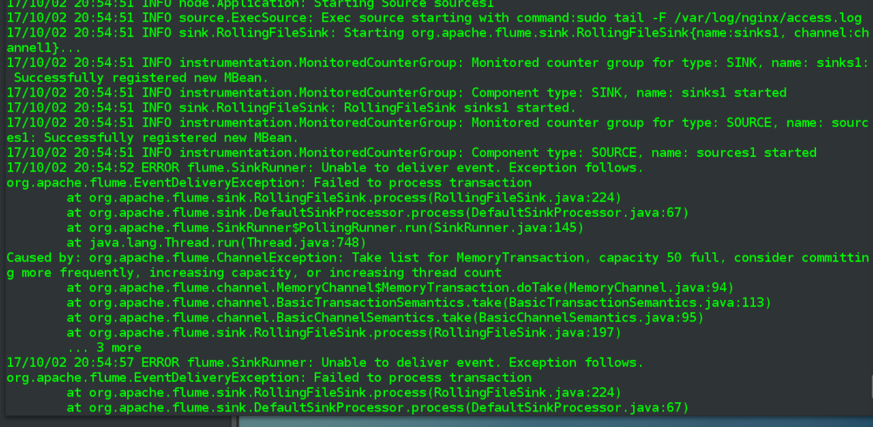

The exception indicates:

*Take list for MemoryTransaction, capacity 50 full, consider committing more frequently, increasing capacity, or increasing thread count*

So I try introducing a rollInternval for the file_roll and set it to 5 (seconds) instead of the default 30 seconds.

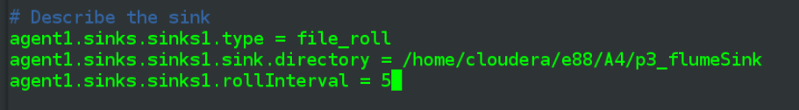

But that makes no difference and get similar exception on restarting the flume agent

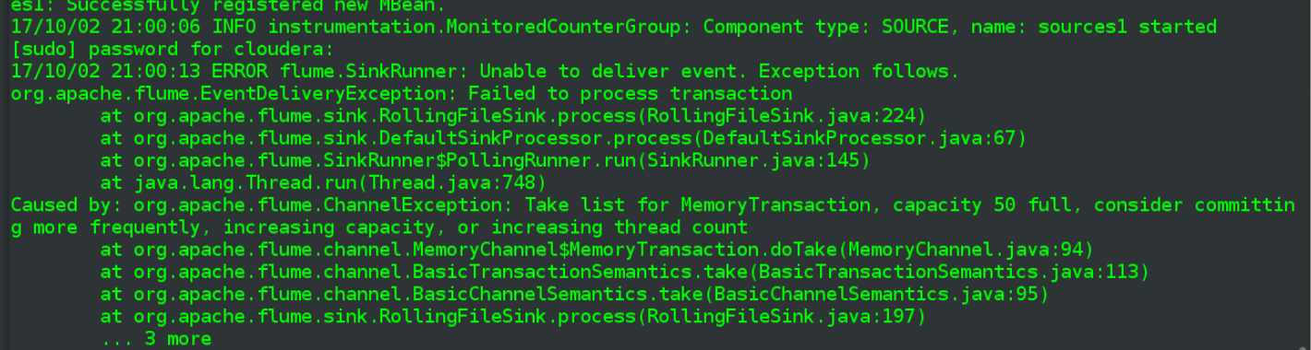

**Problem 4: (Points: 20) experiment with the File Channel**

* **Do the same exercise as in Problem 3 - but use the File Channel this time**
* **Configure checkpoint directory , and the 'dataDirs' File Channel log directory**

Update the .conf file to use file channel

**flume4.conf**

|  |
| --- |
| # Name the components on this agent  agent1.sources = sources1  agent1.sinks = sinks1  agent1.channels = channel1  # Describe/configure the source  agent1.sources.sources1.type = exec  agent1.sources.sources1.command = sudo tail -F /var/log/nginx/access.log  # fileHeader: Whether to add a header storing the absolute path filename.  #agent1.sources.sources1.fileHeader = true  # Describe the sink  agent1.sinks.sinks1.type = file_roll  agent1.sinks.sinks1.sink.directory = /home/cloudera/e88/A4/**p4_flumeSink**  #agent1.sinks.sinks1.rollInterval = 5  # Switching to File Channel  **agent1.channels.channel1.type = file**  # The directory where checkpoint file will be stored  **agent1.channels.channel1.checkpointDir = /home/cloudera/e88/A4/p4_checkpointDir**  # Comma separated list of directories for storing log files.  **agent1.channels.channel1.dataDirs = /home/cloudera/e88/A4/p4_dataDir**  # default for transactionCapacity under file type is 1000000, leave alone for now  #agent1.channels.channel1.transactionCapacity = 250  # Bind the source and sink to the channel  agent1.sources.sources1.channels = channel1  agent1.sinks.sinks1.channel = channel1 |

Inline comments discuss the new lines, isn’t much additional to point out. I’ve commented ou the transactionCapacity line, so that the default 1000000 value will be in force.

Create the new directories mentioned in the flume4.conf:

mkdir p4_flumeSink

mkdir p4_checkpointDir

mkdir p4_dataDir



Below are the steps from Problem 3, to be re-done with file channel:

1. Start your script - to start generating log entries in the web server log
2. Start your Flume agent - observe creation of local files with the events from the web server log
3. Simulate Flume agent failure - stop your flume agent (do NOT stop the event generation app)
4. Wait for 5 min - restart the Flume agent
5. Stop data generation app
6. Once all log data is processed by Flume (monitor the destination directory) - stop Flume

Request generation script started, with 20 GETs per second, same as in previous problem

python p2_curl.py -c 20



Start the flume agent, continuing to re-use agent1 but pointing at flume4.conf now  
 flume-ng agent -n agent1 -f $FLUME_HOME/conf/flume4.conf

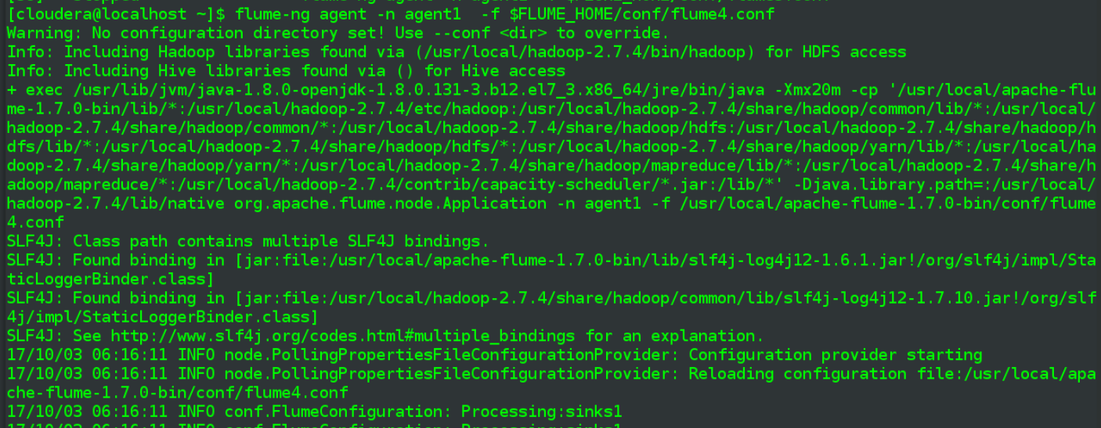

Check contents of checkpointDir

ls -halt p4_checkpointDir

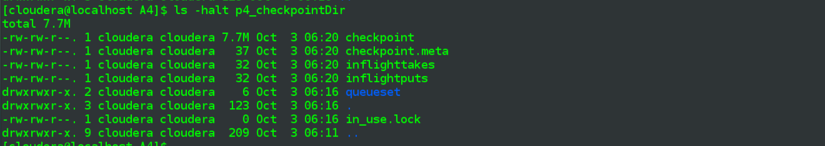

I check in a couple of files and in the queueset directory but I don’t think these are human-interpretable.

Move on to dataDirs folder:

ls -halt p4_dataDir

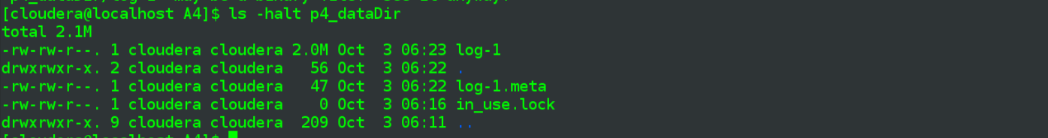

log-1 looks promising, use less to view contents, am prompted proceed since file appears to be binary

less p4_dataDir



Binary… but readable. Don’t see any immediate options as to storing File Channel details in a non-binary format, so I’ll go ahead with this.

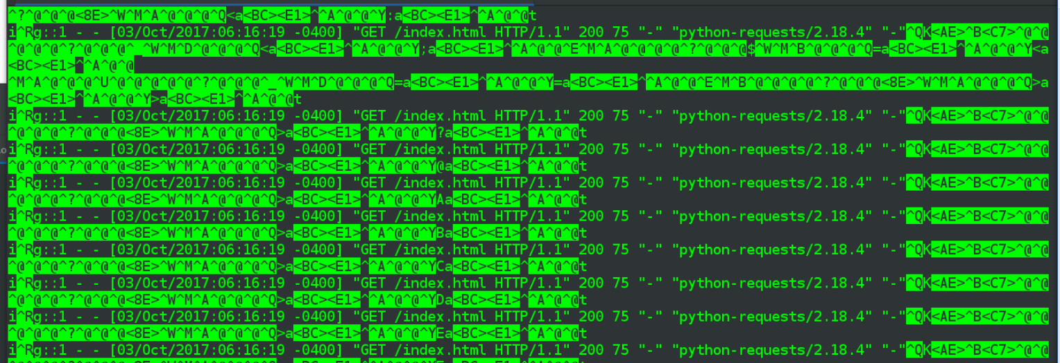

Confirm can parse the info if “-a” is included in the grep command

cat p4_dataDir/log-1 | grep -a 06:16:20

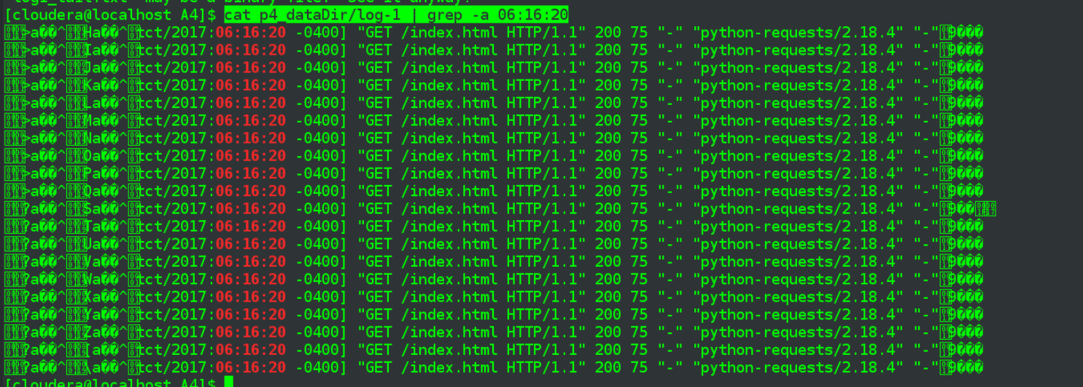

At approximately 06:32 hours I kill the flume agent, per the interrupted output, last recorded “checkpoint update” appears to have been at 06:31:43

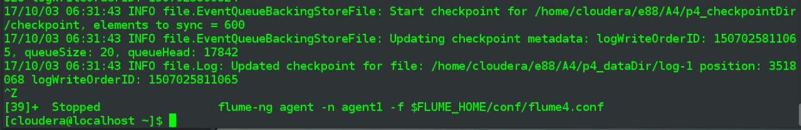

|  |
| --- |
| * I was busy following through the steps from problem 3 and didn’t see that problem 4 had inserted an an additional step in the middle, below, until after I had completed those p3 steps. I re-ran the agent, pointing to new …checkpointDir2 amd …dataDir2, for this step only, data loss analysis will be performed on the original directories. **When FLume agent is down (step 7) - observe behavior of the 'dataDir' and 'checkpoint' dirs content - what do you see there?**   Run flume again on checkpointDir2, dataDir2  Kill flume agent at 06:48    Look at both directories, per the timestamps the -ls was performed when the flume agent had been down ~4 minutes  date && ls -halt p4_checkpointDir2    date && ls -halt p4_dataDir2    Observe the effects of stopping the flume agent… basically nothing happened, i.e. once the agent went down, at 06:48, no further data was written to either directory. |

After 5 minutes or so, restart the flume agent, approximately 06:37:00

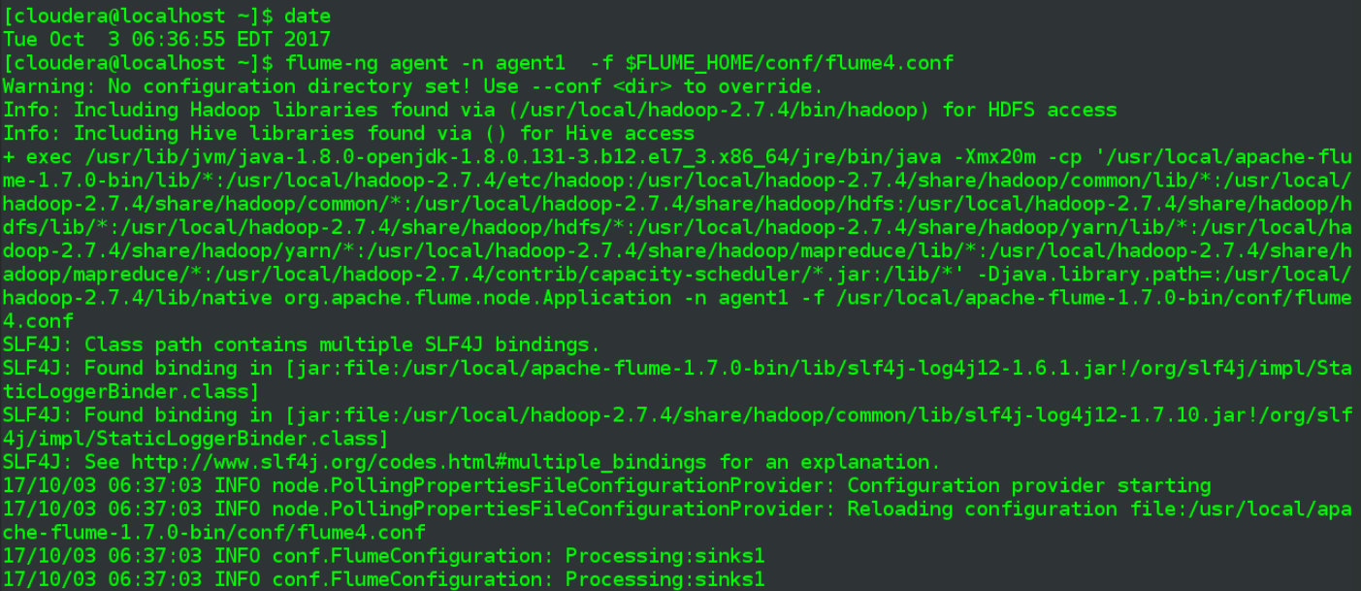

Wait several moments and kill the generation script



Both the checkpointDir and the dataDir appear to stop accreting information quickly, below are from 06:40

checkpointDir:

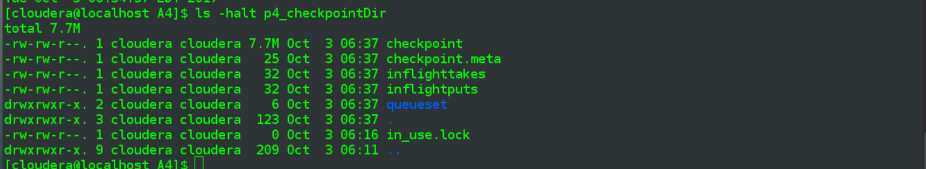

dataDir:

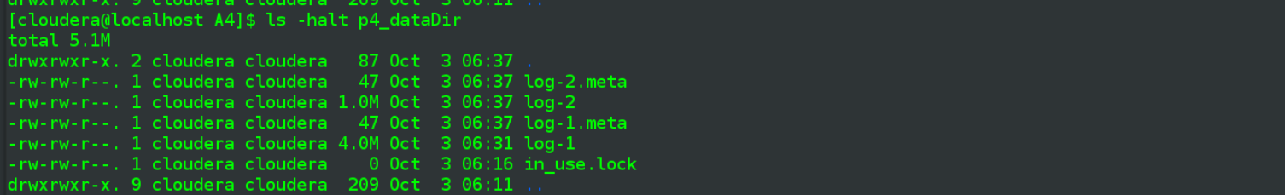

Kill the flume agent, which doesn’t appear to have done anything since around when the request generation script was killed:

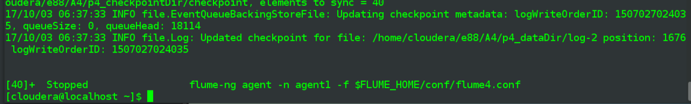

* **Restart your Flume agent and compare destination and source data again. Do you see any data loss now?**

Flume agent was restarted per earlier steps, and then all processes were later stopped. Going to go back and review in terms of data loss analysis.

The dataDir wound up with two “log” files, log-1 and log-2, both of which had a time modified = 06:37, which is around the time I restarted the flume agent. (Went down at 06:32)

A simple tail of log-1 would seem to indicate the last piece of data in there, assuming we disregard the binary footer info.

cat p4_dataDir/log-1 | tail

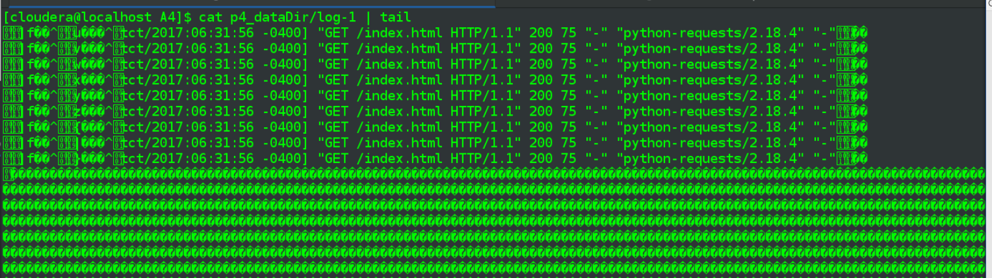

So last recorded info in there is from 06:31:56, shortly before I killed the flume agent process.

Using head on the log-2 file doesn’t seem a good approach since there is a whole bunch of binary header info, so less in instead

less p4_dataDir/log-2



… that goes quite poorly, I am unable to navigate properly w/in less, presumably due to binary nature of file. Going to try a workaround of grepping out only applicable lines and writing to a new file

cat p4_dataDir/log-2 | grep -a 06: > p4_log2_out.txt

less p4_log2_out.txt



Which doesn’t work, file is empty.

Try to grab any lines from the 06 hour via “grep -a” on the log-2 file:

cat p4_dataDir/log-2 | grep -a 06:



And there is no output, the same cat/grep combo that worked on log-1 does nothing here. Doesn’t appear to be anything further I can do at this point.

**Follow up:**

Some time after above, I revisit to run a couple of more quick tests, though I don’t capture screenshots, do this mostly as a sanity check. The main difference is that I update the checkpointInterval in the .conf, adding a line to have it checkpoint every 1 second instead of default 30, hoping this will somehow cause the generated files to “complete” more quickly. Basically I want some additional files on which grep -a will actually work.

# Amount of time (in millis) between checkpoints, default = 30000

**agent1.channels.channel1.checkpointInterval = 1000**

My notes were short for this run & don’t include many screenshots, here is an ls of the new dataDir3folder I created for this run

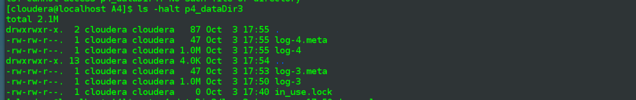

* (run flume on/off to check if directory contents are accreting differently with new setting, nope)
* run flume again at 17:49:10 against p4_dataDir3folder
  + see log info in the “new” log-3
* kill again at 17:50:34
* up again at 3 minutes later at17:53:27
* kill permanently at 17:55:19
* so are the logs for this missing period, e.g. 17:52, anywhere?
  + run a series of grep -a on both log-3 and log-4

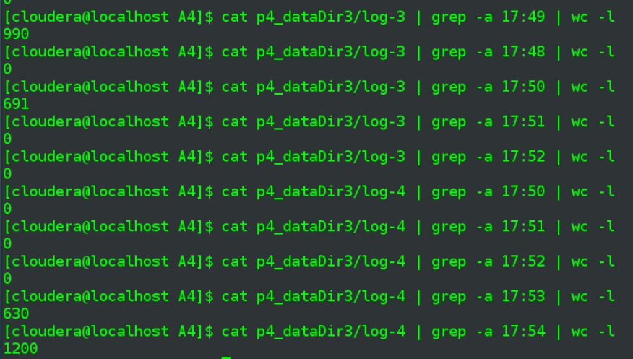

And at lest now the later logs have recorded “discoverable” info. The minute of 17:50, in the middle of which Flume was stopped, has plenty of entries in log-3. The minutes of 17:50 and 17:51 are not in log-3, nor are they in log-4. Then the minute of 17:53 has a bunch of hits in log-4, where Flume was started somewhere toward the middle of that minute., has about half of what a full minute should And then the minute of 17:54 has a full 1200 hits, where events were generated for a full minute 20*60=1200.

I don’t know if something went wrong in the first test and/or if the decreased checkpointInterval actually made a difference but either way I can be a good bit more confident in my analysis revealing that there indeed was data loss.

Happened to stumble upon the bit in grading rubric… nope, did some more research but I can’t see where I went wrong… though this problem is regarding file channel anyway, so I'm not sure.

|  |  |
| --- | --- |
| data durability due to memory channel usage is demonstrated | 10 |

-

**Update 2:**

So apparently several days after I first completed this problem the homework definition was updated without any announcement (not cool), happened to come across mention in Piazza. I can now see of course why halting the flume agent was going to be ineffective in running through the problem but I initially did exactly what the homework said to do.

I've begun work on the next assignment and only have time for a quick retry as it applies to data loss in this Problem.

Run curl script



edit flume4.conf, defining yet another set of checkpoint/data directories.

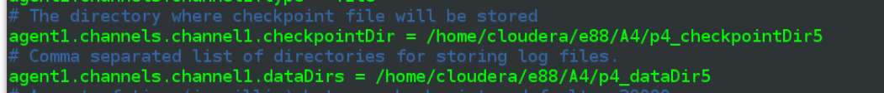

start flume, directing against above flume4.conf

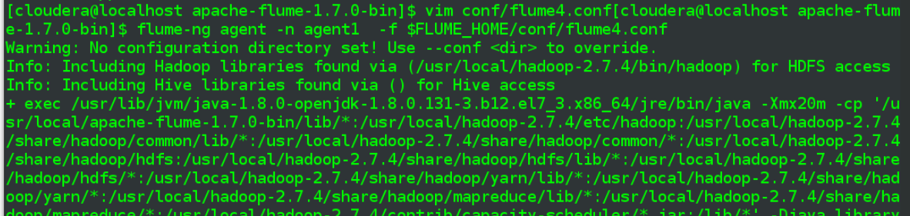

…

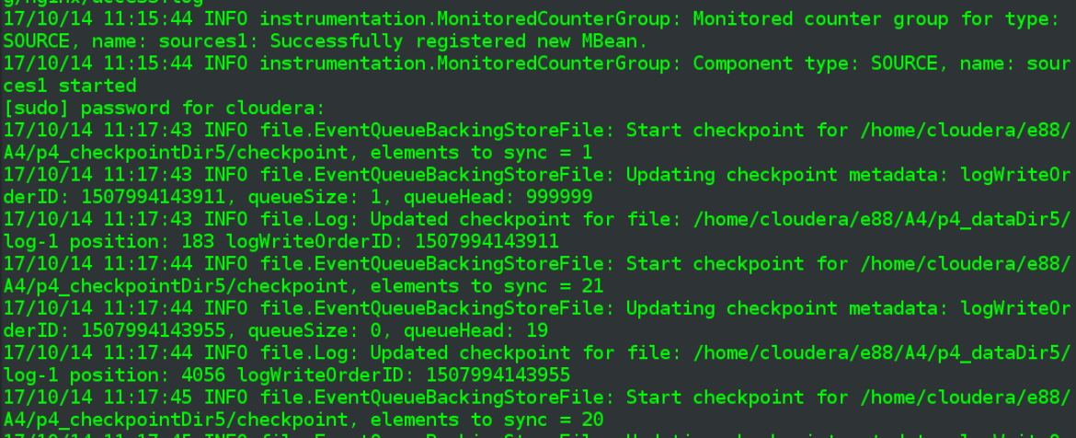

make the sink directory read only

date && chmod 444 p4_flumeSink



start to see some errors in the flume output

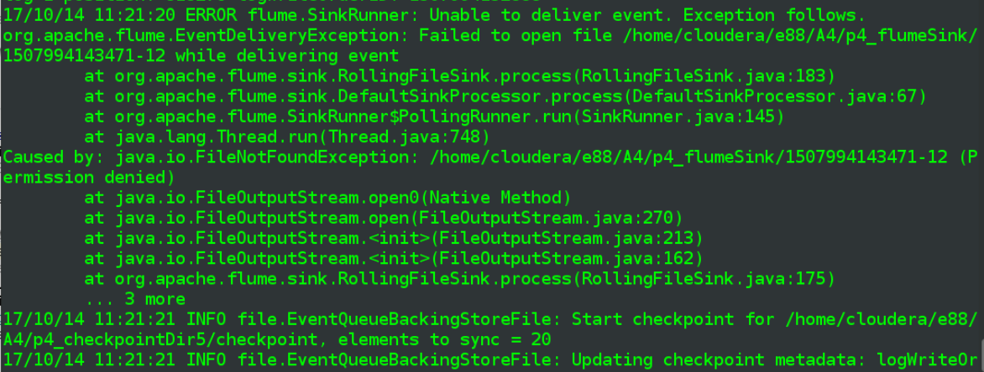

wait almost 5 minutes and make the sink directory writable again

date && chmod 777 p4_flumeSink



stop the curl script after a couple more minutes, followed by stopping flume once its output becomes static

Result: the sink directory (pf_flumeSink) was unwritable from 11:21:00 to 11:24:45

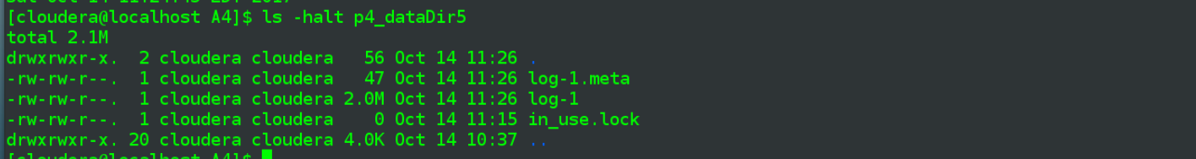

Doing a grep -a on log-1 file shows data being recorded just before directory was made read only (11:20:59), at moment of read-only change (11:21:00) and then for a given second a minute later (11:22:00).

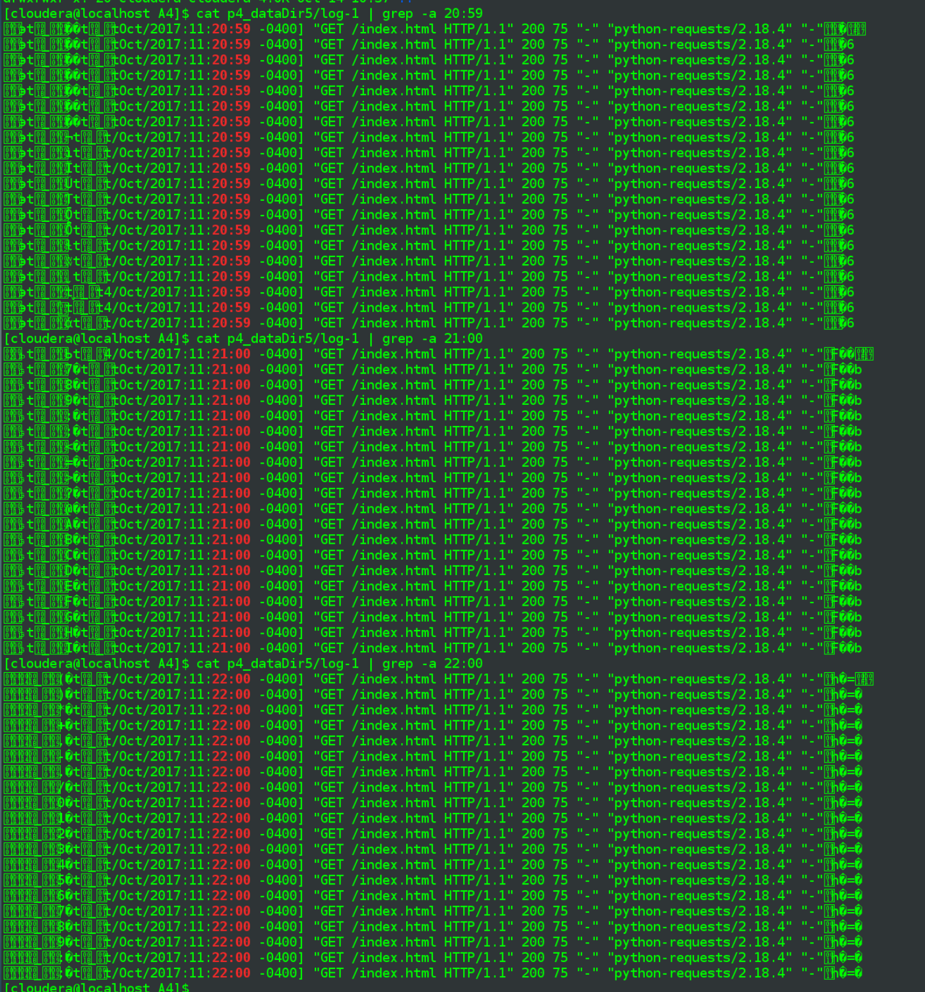

Pick some random seconds during the down period (11:21:00 to 11:24:45), followed by some second-periods after restoration, and see that each case 20 events were successfully recorded, no data loss occurred.

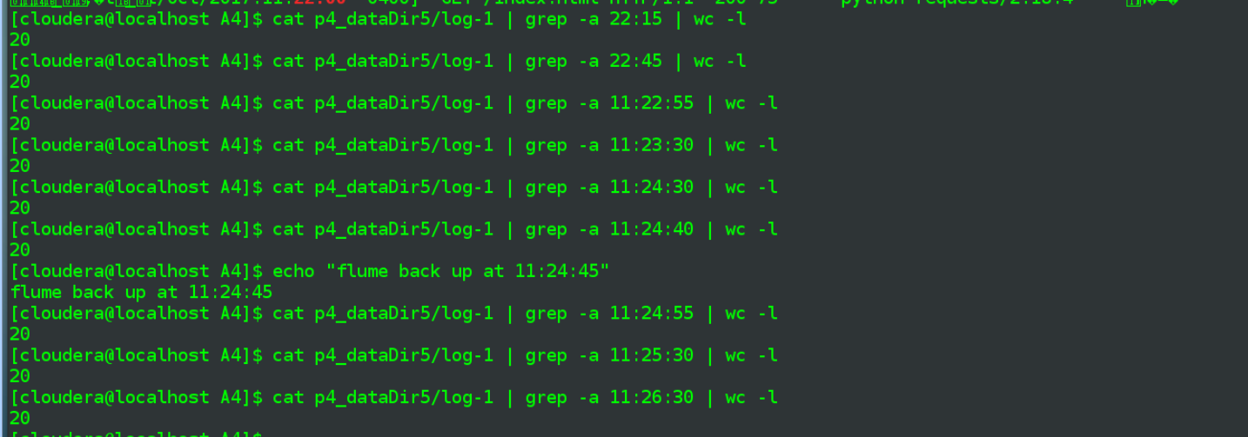

**Problem 5: (Points: 20) HDFS sink**

* **Create an AWS EMR cluster with Hadoop installed**

Not sure if there is any need to include text versions of the commands I’v been entering, but there will be less of that in this problem as most commands already have text versions, via previous problems above.

I’m simply going to clone the EMR Cluster I used for previous homeworks:, which means I also won’t have to worry about adding the nodes to a security group that allows ssh as that will be included in the clone.

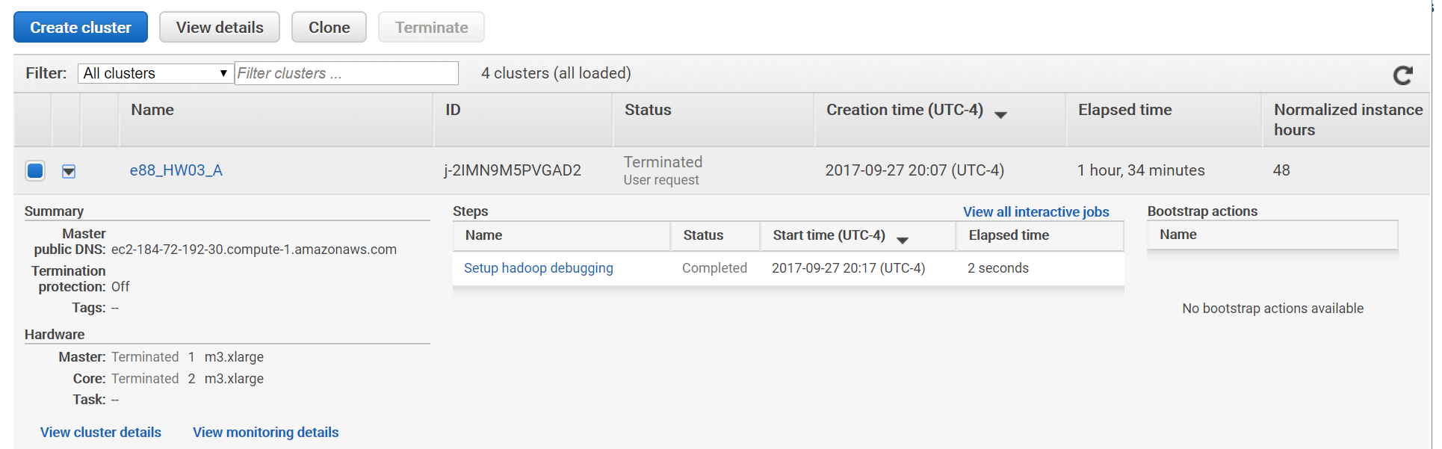

Wind up, w/below Master node DNS:

|  |
| --- |
|  |

ssh there (had already added my .pem key via ssh-add)

ssh hadoop@ec2-52-87-208-9.compute-1.amazonaws.com

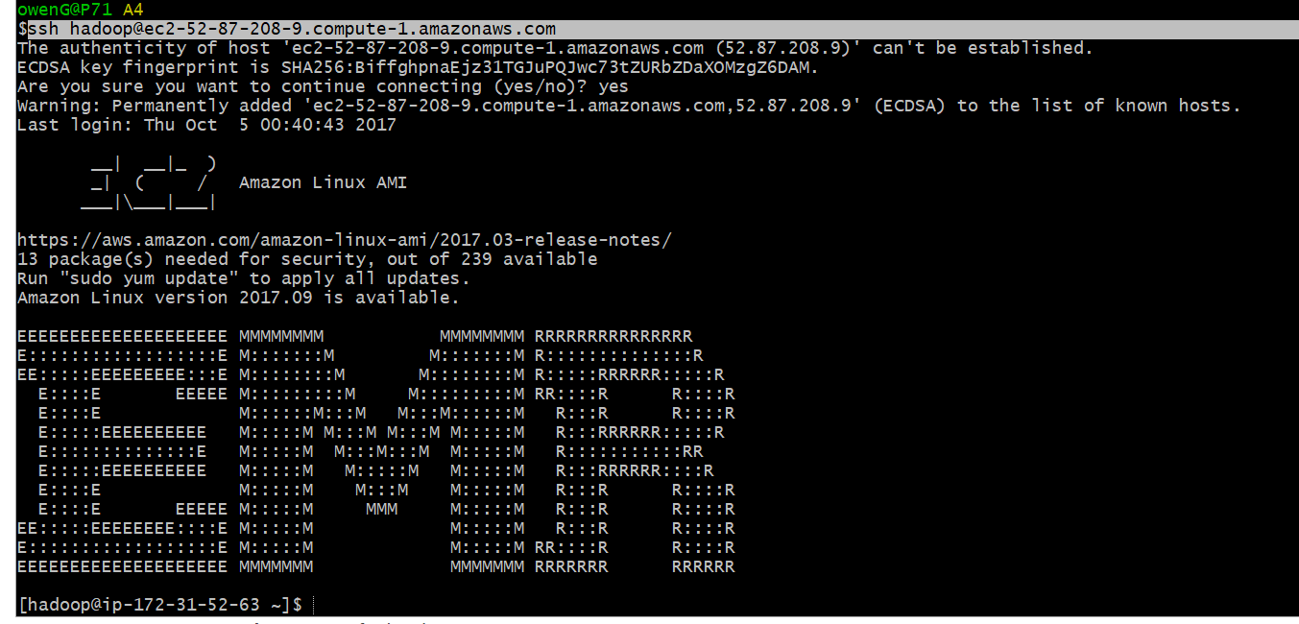

* **replicate the Web server +Flume setup on one of the EC2 instances from the cluster (does not matter if this is a master or slave node) -  install web server + Flume manually on that instance (you can also do it on a separate EC2 instance if you like - but beware of connectivity setup)**

Install flume on this master node, as earlier in the assignment:

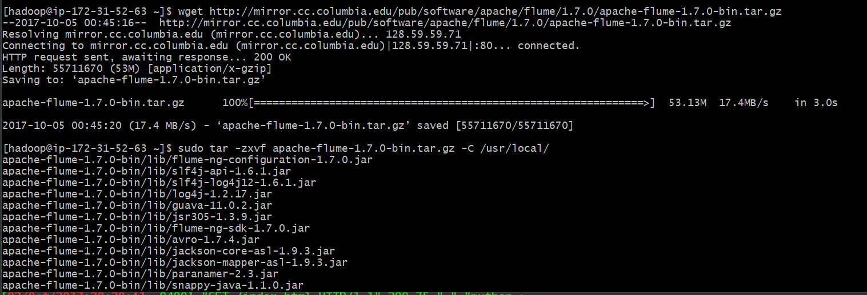

Set flume environment variables:



And install nginx as before, via yum:

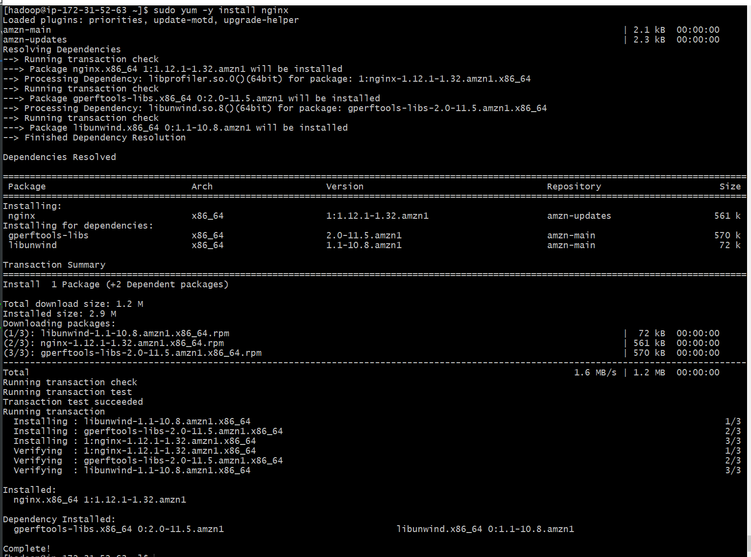

Start the service and…

sudo service nginx start

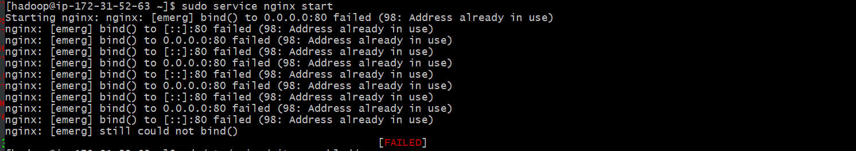

Somethings already using port 80, google around and apparently this AWS AMI lacks the /sites-enabled directory most posts refer to. But able to figure out I need to edit /etc/nginx/nginx.conf to change port to 8081, on the highlighted “listen” lines below:

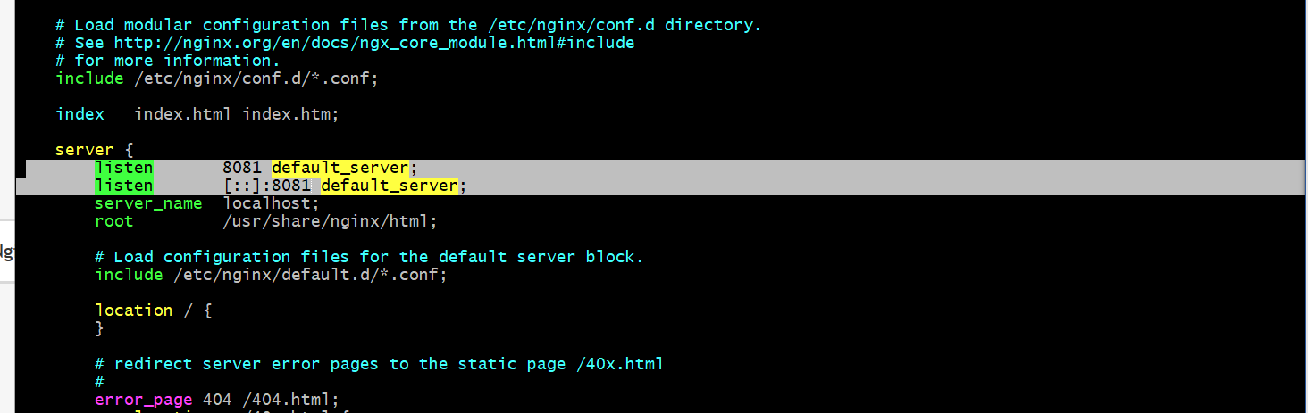

And then start the service again, looks fine.

sudo service nginx start



Try a curl or two on new port, seems to have worked

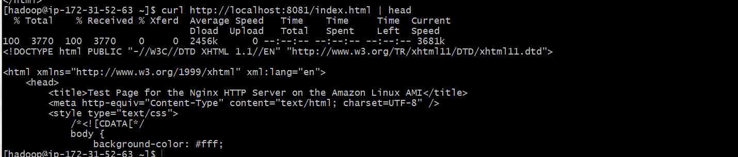

In different terminal, see the curls reflected in the log, which is in the same location as it was on my Linux VM:



* **Configure a "tail -F"  Exec source for web server logs**
* **Configure HDFS sink - define some time-based dir/file name structure e.g,  flume-out/problem5/events/%y-%m-%d/**

**flume5.conf**

|  |
| --- |
| # Name the components on this agent  agent1.sources = sources1  agent1.sinks = sinks1  agent1.channels = channel1  # Describe/configure the source  agent1.sources.sources1.type = exec  agent1.sources.sources1.command = sudo tail -F /var/log/nginx/access.log  # fileHeader: Whether to add a header storing the absolute path filename.  #agent1.sources.sources1.fileHeader = true  # Describe the sink  **agent1.sinks.sinks1.type = hdfs**  # subfolder pattern of one folder with todays date, e.g. 2017-10-03  # and then a per second folder, e.g. 20-56-03 for the 3rd second of the 56th minute of the 20th hour  **agent1.sinks.sinks1.hdfs.path = /e88/A4/p5_B/%Y-%m-%d/%H-%M-%S**  # number of events written to file before it is flushed to HDFS, default = 100  **agent1.sinks.sinks1.hdfs.batchSize = 1000**  # Use the local time (instead of the timestamp from the event header) while replacing the escape sequences.  # w/o, get: java.lang.NullPointerException: Expected timestamp in the Flume event headers, but it was null  **agent1.sinks.sinks1.hdfs.useLocalTimeStamp = true**  # Name prefixed to files created by Flume in hdfs directory  **agent1.sinks.sinks1.hdfs.filePrefix = nginx-events**  # Use a channel which buffers events in memory  agent1.channels.channel1.type = memory  # default capacity for memory channel is 100, leave  # default for transactionCapacity is also 100, leave  agent1.channels.channel1.capacity = 1000  agent1.channels.channel1.transactionCapacity = 1000  # Bind the source and sink to the channel  agent1.sources.sources1.channels = channel1  agent1.sinks.sinks1.channel = channel1 |

Inline comments discuss the various new settings for thehdfs sink, those lines are highlighted above. I’ll add that I increased the default batchSize from 100 to 1000 after reading of users complaining about the large number of HDFS files being created. Realistically, for this assignment, it doesn’t really matter but I can understand that being a concern in a production scenario.

* **Start your event generation app (either from your local server , hitting your EC2 instance - have to open ports), or run it locally on the same EC2 server**

Everything is running on master node of EMR cluster. I create a subdirectory and do a clipboard-copy of my code from my local VM. Try starting the script and get an error because the requests library is not a built-in library, I must have previously installed on my Linux VM.

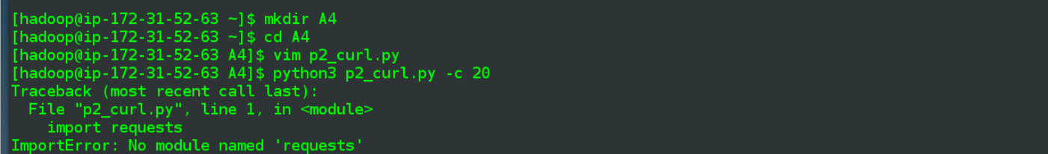

Figure out the correct syntax for installing against python 3 and run th script again

sudo python3 -m pip install requests

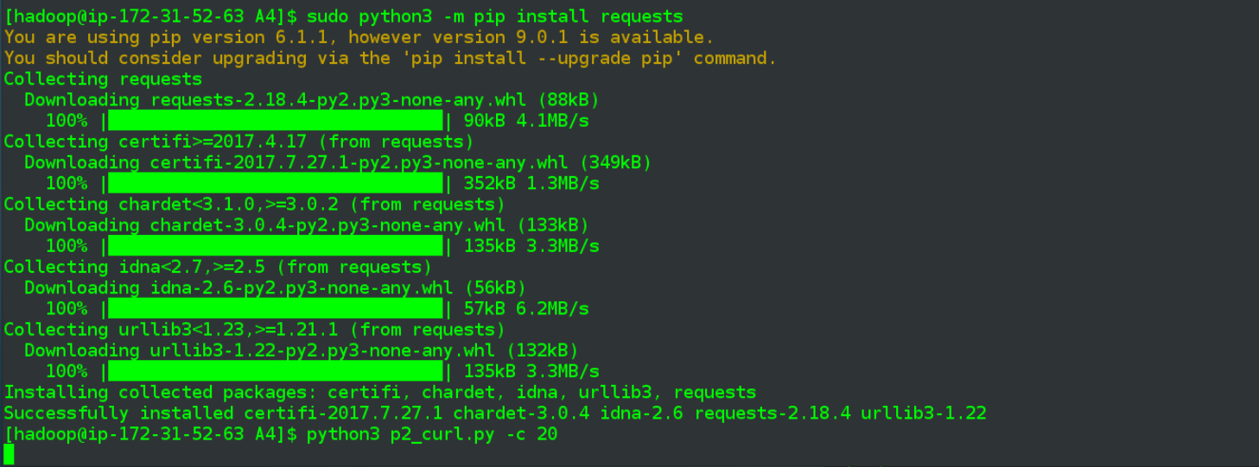

But check the nginx log and don’t see anything being logged….

Ah, forgot to change the port in the requests.get(), which came from my VM where port 80 was correct. Update below line to redirect to port 8081:

r = requests.get(**'http://localhost:8081/index.html'**)

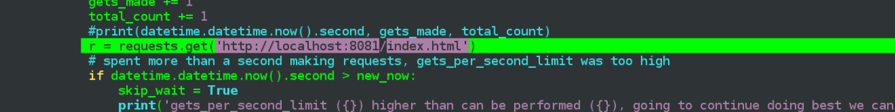

Run script again, tail on the log indicates success this time

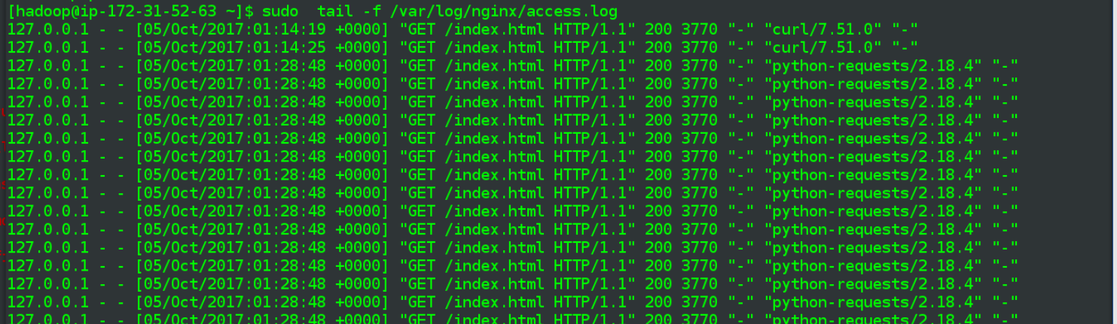

* **Observe correct directories/files being created in HDFS**

Run the flume process agains my flume5.conf

flume-ng agent -n agent1 -f $FLUME_HOME/conf/flume5.conf

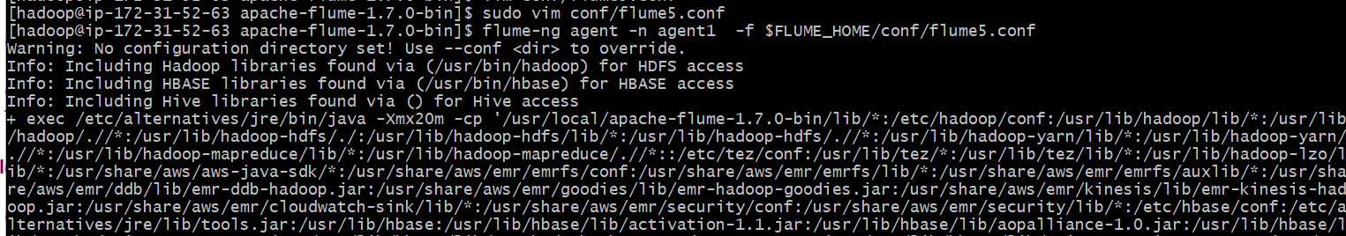

…

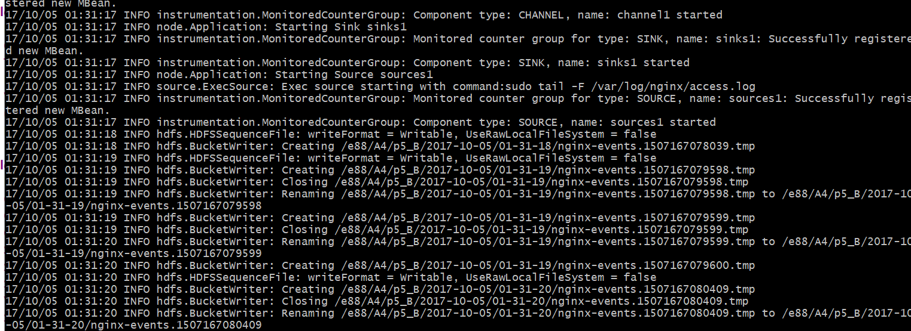

I quickly stop the agent process, in order to catch the first screenshot above, else it would have scrolled out of memory.

Originally had planned on creating the root /e88/A4 directories in hdfs beforehand. Then I realized in my pre-tests on my Linux VM flume had of course been creating a nested series of subfolders so it should be able to do all of them, and indeed it did.

And it all works out exactly as desired. My folder pattern had been below and what gets generated in HDFS is a parent subfolder for the (day) date, followed by a single subfolder for every hour-minute-second for which data was passed through flume, from flume5.conf:

# subfolder pattern of one folder with todays date, e.g. 2017-10-03

# and then a per second folder, e.g. 20-56-03 for the 3rd second of the 56th minute of the 20th hour

agent1.sinks.sinks1.hdfs.path = /e88/A4/p5_B/%Y-%m-%d/%H-%M-%S

Dive in via directory listings

hdfs dfs -ls /e88/A4/p5_B/

hdfs dfs -ls /e88/A4/p5_B/2017-10-05/

hdfs dfs -ls /e88/A4/p5_B/2017-10-05/01-31-26

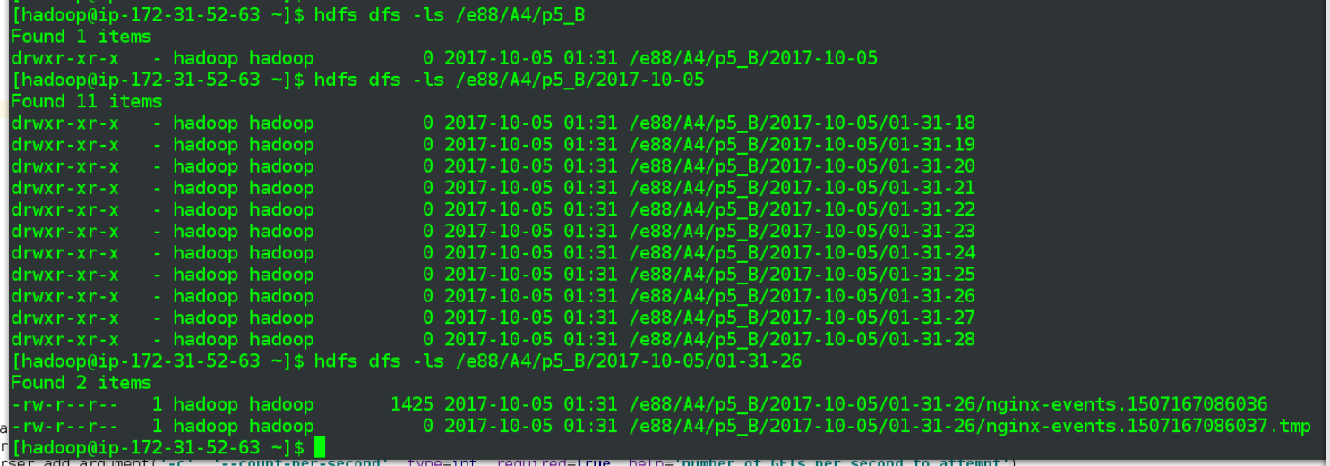

Also, note that the individual files are prefixed with “nginx-events-“, which had been one of the sink settings in my flume5.conf.

I do more quick flume run, with captured text log output:

17/10/05 01:41:47 INFO hdfs.BucketWriter: Renaming /e88/A4/p5_B/2017-10-05/01-41-47/nginx-events.1507167707035.tmp to /e88/A4/p5_B/2017-10-05/01-41-47/nginx-events.1507167707035

17/10/05 01:41:47 INFO hdfs.BucketWriter: Creating /e88/A4/p5_B/2017-10-05/01-41-47/nginx-events.1507167707036.tmp

17/10/05 01:41:48 INFO hdfs.HDFSSequenceFile: writeFormat = Writable, UseRawLocalFileSystem = false

17/10/05 01:41:48 INFO hdfs.BucketWriter: Creating /e88/A4/p5_B/2017-10-05/01-41-48/nginx-events.1507167708028.tmp

17/10/05 01:41:48 INFO hdfs.BucketWriter: Closing /e88/A4/p5_B/2017-10-05/01-41-48/nginx-events.1507167708028.tmp

17/10/05 01:41:48 INFO hdfs.BucketWriter: Renaming /e88/A4/p5_B/2017-10-05/01-41-48/nginx-events.1507167708028.tmp to /e88/A4/p5_B/2017-10-05/01-41-48/nginx-events.1507167708028

17/10/05 01:41:48 INFO hdfs.BucketWriter: Creating /e88/A4/p5_B/2017-10-05/01-41-48/nginx-events.1507167708029.tmp

17/10/05 01:41:49 INFO hdfs.HDFSSequenceFile: writeFormat = Writable, UseRawLocalFileSystem = false

17/10/05 01:41:49 INFO hdfs.BucketWriter: Creating /e88/A4/p5_B/2017-10-05/01-41-49/nginx-events.1507167709035.tmp

17/10/05 01:41:49 INFO hdfs.BucketWriter: Closing /e88/A4/p5_B/2017-10-05/01-41-49/nginx-events.1507167709035.tmp

17/10/05 01:41:49 INFO hdfs.BucketWriter: Renaming /e88/A4/p5_B/2017-10-05/01-41-49/nginx-events.1507167709035.tmp to /e88/A4/p5_B/2017-10-05/01-41-49/nginx-events.1507167709035

17/10/05 01:41:49 INFO hdfs.BucketWriter: Creating /e88/A4/p5_B/2017-10-05/01-41-49/nginx-events.1507167709036.tmp

17/10/05 01:41:50 INFO hdfs.HDFSSequenceFile: writeFormat = Writable, UseRawLocalFileSystem = false

17/10/05 01:41:50 INFO hdfs.BucketWriter: Creating /e88/A4/p5_B/2017-10-05/01-41-50/nginx-events.1507167710029.tmp

17/10/05 01:41:50 INFO hdfs.BucketWriter: Closing /e88/A4/p5_B/2017-10-05/01-41-50/nginx-events.1507167710029.tmp

17/10/05 01:41:50 INFO hdfs.BucketWriter: Renaming /e88/A4/p5_B/2017-10-05/01-41-50/nginx-events.1507167710029.tmp to /e88/A4/p5_B/2017-10-05/01-41-50/nginx-events.1507167710029

17/10/05 01:41:50 INFO hdfs.BucketWriter: Creating /e88/A4/p5_B/2017-10-05/01-41-50/nginx-events.1507167710030.tmp

17/10/05 01:41:51 INFO hdfs.HDFSSequenceFile: writeFormat = Writable, UseRawLocalFileSystem = false

17/10/05 01:41:51 INFO hdfs.BucketWriter: Creating /e88/A4/p5_B/2017-10-05/01-41-51/nginx-events.1507167711031.tmp

17/10/05 01:41:51 INFO hdfs.BucketWriter: Closing /e88/A4/p5_B/2017-10-05/01-41-51/nginx-events.1507167711031.tmp

17/10/05 01:41:51 INFO hdfs.BucketWriter: Renaming /e88/A4/p5_B/2017-10-05/01-41-51/nginx-events.1507167711031.tmp to /e88/A4/p5_B/2017-10-05/01-41-51/nginx-events.1507167711031

And a screenshot from HDFS that matches at least some of which was generated in above output:, i.e. the 49th and 50th second of the 41st minute

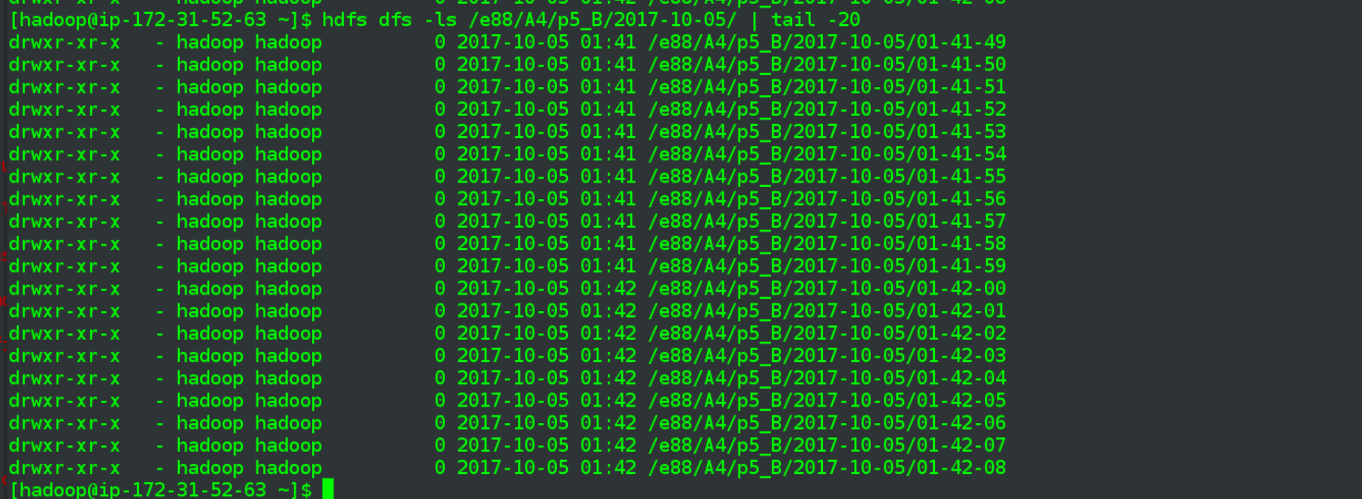

**Part 2**

**Problem 8: (Points: 20) Basic Kafka**

* **Install a simple Kafka cluster - it can be one node cluster , on your local laptop**

Look over some online tutorials, my Linux CentOS 7 VM has Java 8, so go on and and check <https://kafka.apache.org/downloads>, where it says 0.11.0.1 is the latest stable release, do a wget on that and uncompress to a generic /opt/kafka directory that I can possibly use for different releases of kafka

wget <http://mirror.cc.columbia.edu/pub/software/apache/kafka/0.11.0.1/kafka_2.11-0.11.0.1.tgz>

sudo mkdir /opt/kafka

sudo tar -zxvf kafka_2.11-0.11.0.1.tgz -C /opt/kafka/

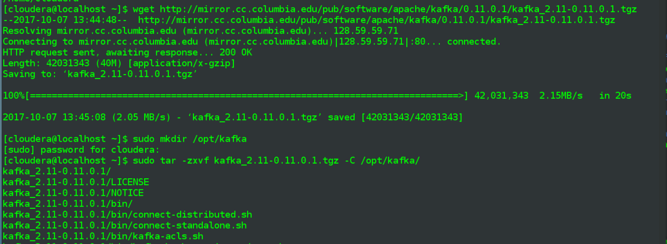

edit my .bashrc, add a $KAFKA_HOME matching above location



* **Create a topic "problem8" with 2 partitions**

Take care of some permissions issues, good enough for a vm. Then start zookeeper.

sudo chown -R cloudera:cloudera kafka_2.11-0.11.0.1/

cd kafka_2.11-0.11.0.1/

zookeeper-server-start.sh $KAFKA_HOME/config/zookeeper.properties

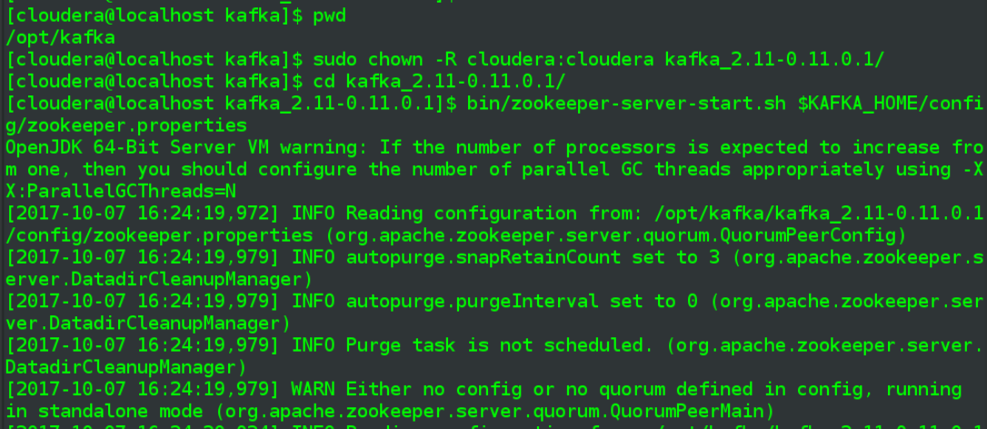

In a separate terminal window, start kafka server

kafka-server-start.sh $KAFKA_HOME/config/server.properties

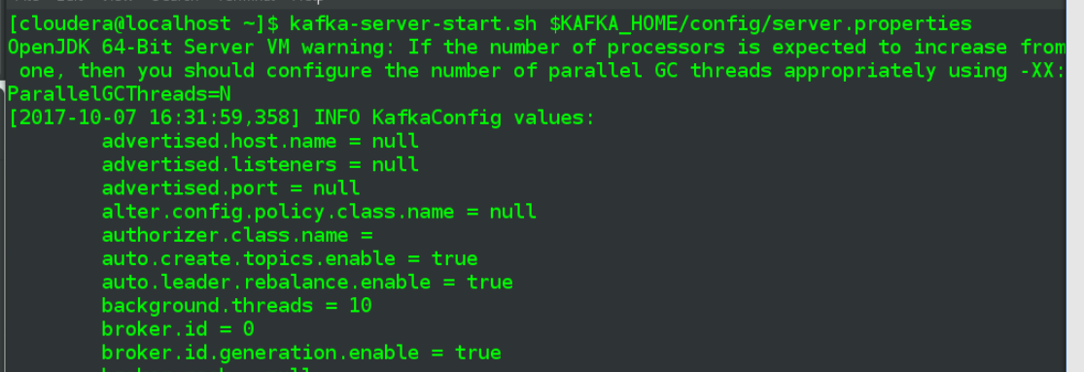

In a third terminal, create the requested topic = problem8, by passing in that value after “--topic". As part of that command also set the number of partitions = 2, via the --partitions argument. The replication factor of 1 in the professor's sample code.

kafka-topics.sh --create --zookeeper localhost:2181 --replication-factor 1 --partitions 2 --topic problem8

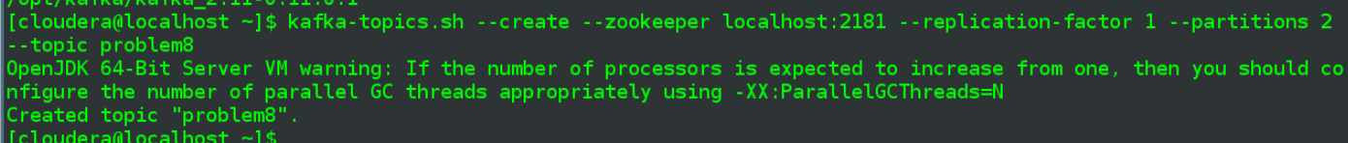

* **Describe the cluster and show its state via kafka-topics --describe command**

Run the --describe command as specified, passing in the zookeeper address. See that it only has this first topic created above, which is shown as having two partitions, as expected.

kafka-topics.sh --describe --zookeeper localhost:2181

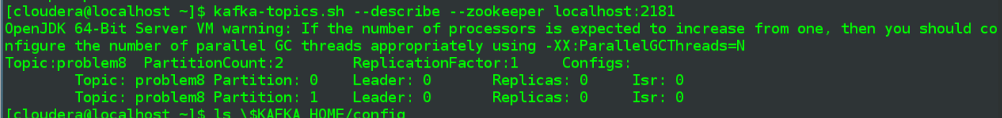

* **Verify that you can send message and receive messages to/from the topic by running Kafka console producer and consumer from two different terminals**

Start the producer in top terminal window below:

kafka-console-producer.sh --broker-list localhost:9092 --topic problem8

Start the consumer in bottom terminal:

kafka-console-consumer.sh --zookeeper localhost:2181 --topic problem8

Then start typing some text into the top/producer terminal and a few moments later the same text appears in the bottom/consumer terminal

>message 1 on topic=problem8

>some next message

>and a third one

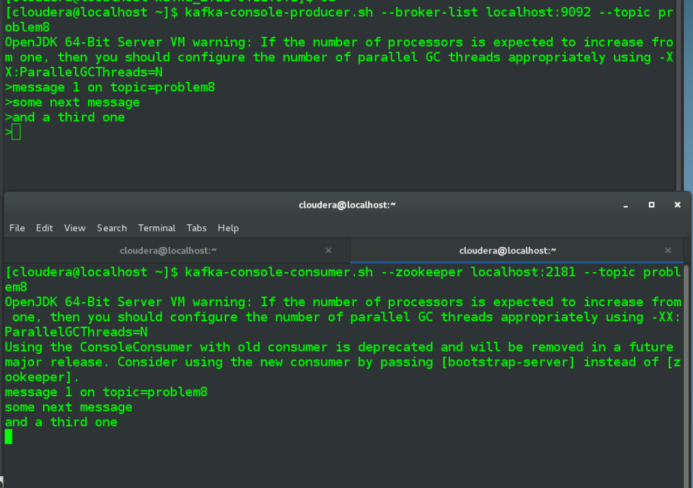

* **Examine kafka commit logs, by using the kafka.tools.DumpLogSegments tool , for each partition of the "problem8" topic**

Not sure where the default location for the logs is but apparently the server.properties file will indicate the current location, open that file up

less config/server.properties



Do a directory listing of the /tmp/kafka-logs directory specified in the properties file, followed by the two directories named in topic-partition format.

ls -halt /tmp/kafka-logs/

ls -halt /tmp/kafka-logs/problem8-0

ls -halt /tmp/kafka-logs/problem8-1

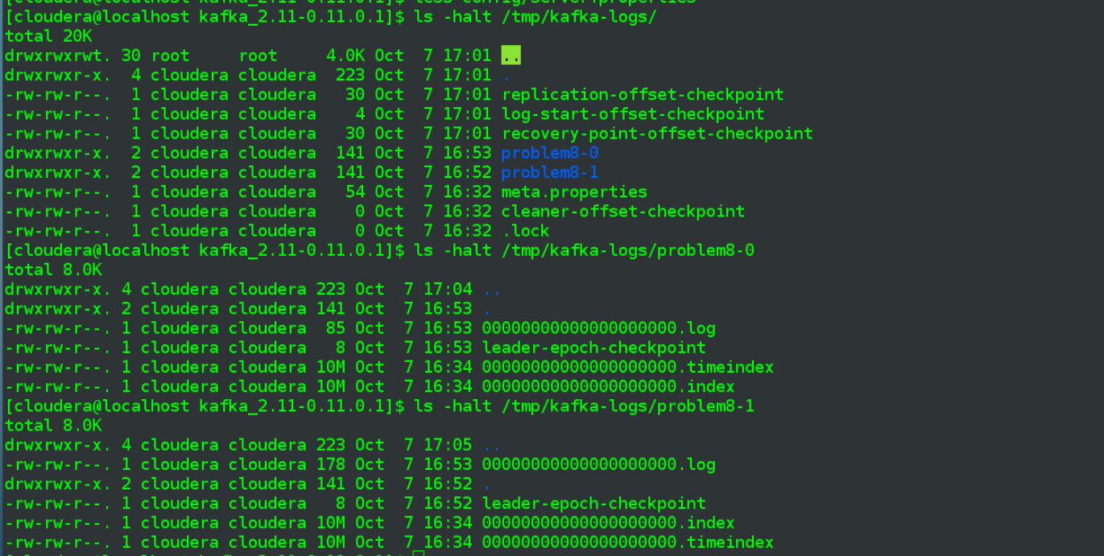

Display contents of first partition, i.e. problem8-0, and then the 2nd (ending with -1) partition:

kafka-run-class.sh kafka.tools.DumpLogSegments --files /tmp/kafka-logs/problem8-0/00000000000000000000.log

kafka-run-class.sh kafka.tools.DumpLogSegments --files /tmp/kafka-logs/problem8-1/00000000000000000000.log

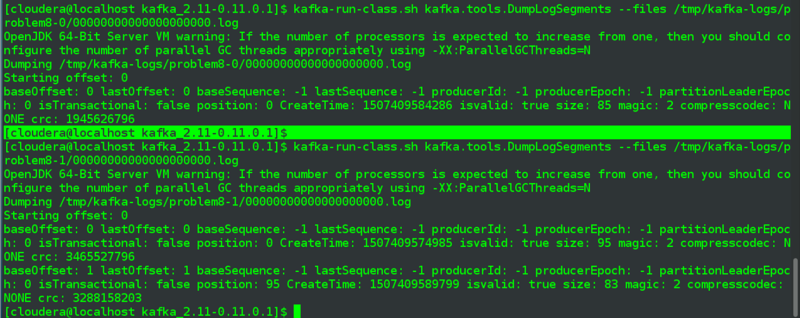

**Problem 9: (Points: 20) Kafka + Flume integration**

* **Use your local Web server + Flume setup, where Flume is getting data from your web server logs via "tail -f" source**

Create a flume9.conf in general format seen earlier.

**flume9.conf**

|  |
| --- |
| # Name the components on this agent  agent1.sources = sources1  agent1.sinks = sinks1  agent1.channels = channel1  # Describe/configure the source  agent1.sources.sources1.type = exec  agent1.sources.sources1.command = sudo tail -F /var/log/nginx/access.log  # Describe the sink - Must be set to org.apache.flume.sink.kafka.KafkaSink  **agent1.sinks.sinks1.type = org.apache.flume.sink.kafka.KafkaSink**  # List of brokers Kafka-Sink will connect to, to get the list of topic partitions  **agent1.sinks.sinks1.kafka.bootstrap.servers = localhost:9092**  **agent1.sinks.sinks1.kafka.topic = problem9**  # How many messages to process in one batch. Larger batches improve throughput while adding latency. Default = 100  **agent1.sinks.sinks1.kafka.flumeBatchSize = 50**  # Use a channel which buffers events in memory  agent1.channels.channel1.type = memory  # default capacity for memory channel is 100, leave  # default for transactionCapacity is also 100, leave  agent1.channels.channel1.capacity = 1000  agent1.channels.channel1.transactionCapacity = 1000  # Bind the source and sink to the channel  agent1.sources.sources1.channels = channel1  agent1.sinks.sinks1.channel = channel1 |

The lines in bold are new, with the type being one of the predefined flume types, in this case the value necessary for a KafkaSink. The bootstrap.servers value is the same broker value used on the command line. I decreased the .flumeBatchSize value to 50, from its default 100, thinking if it became an issue I would want results sooner vs. overall throughput.

* **Create a new topic, "problem9" , with 2 partitions**

Create a topic as before, but with name = problem9, Run the --describe on kafka-topics to confirm.

kafka-topics.sh --create --zookeeper localhost:2181 --replication-factor 1 --partitions 2 --topic problem8

kafka-topics.sh --describe --zookeeper localhost:2181

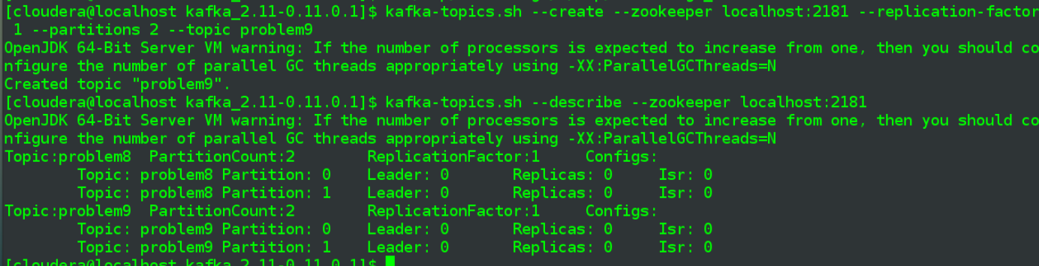

* **Add Kafka Sink to your Flume - to start pushing events into the "problem9" topic**

Configured in earlier step, per flume9.conf

* **Start your app to generate CURL requests to the web app**

As in part 1 of assignment, 20 requests per second

python p2_curl.py -c 20



* **Start a Kafka console consumer for "problem9" topic - verify you are getting your web server logs**

Start the conumer, subscribing to top = problem9

kafka-console-consumer.sh --zookeeper localhost:2181 --topic problem9

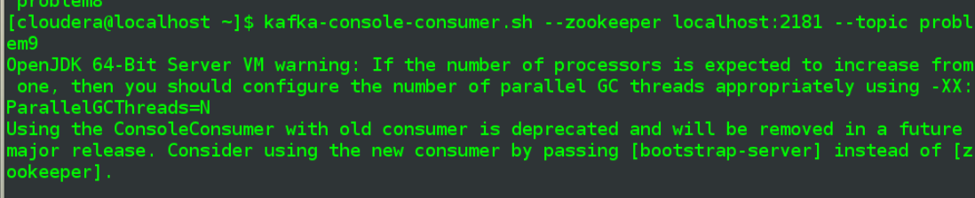

Now start the flume agent, pointing to my new flume9.conf, and kill it a few moments later, once I see some lines appearin in the producer terminal

flume-ng agent -n agent1 -f $FLUME_HOME/conf/flume9.conf

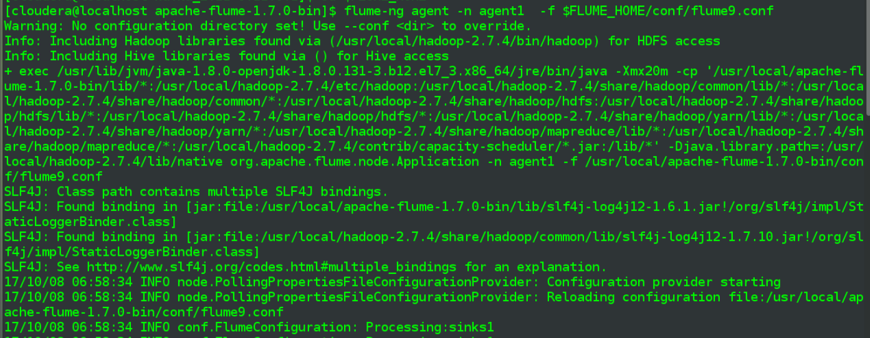

And in the few moments the flume agent was running, see that the Consumer terminal was populated with lines from the log.

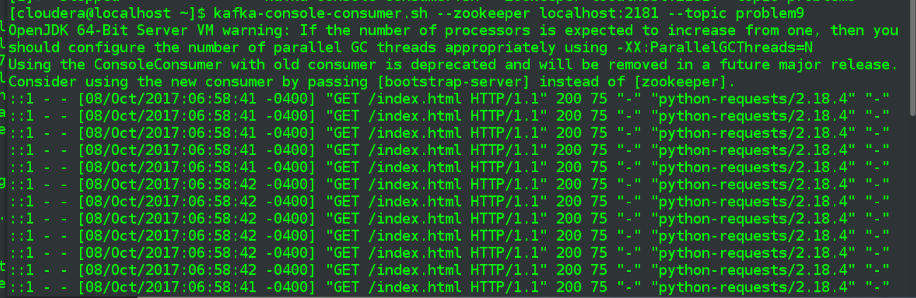

* **Add FLume's UUID Interceptor - to add UUID to each event**

Update my flume9.conf, adding the two lines in bold, the first to create an interceptor setting, and then do set the type on that to that necessary for an UUID interceptor.

(ui.headername value gets added later, after additional testing)

|  |
| --- |
| # Name the components on this agent  agent1.sources = sources1  agent1.sinks = sinks1  agent1.channels = channel1  # Describe/configure the source  agent1.sources.sources1.type = exec  agent1.sources.sources1.command = sudo tail -F /var/log/nginx/access.log  # UUID interceptor  **agent1.sources.sources1.interceptors = ui**  # type must be this value, this is the only required property  **agent1.sources.sources1.interceptors.ui.type = org.apache.flume.sink.solr.morphline.UUIDInterceptor$Builder**  **agent1.sources.sources1.interceptors.ui.headerName = key**  # Describe the sink - Must be set to org.apache.flume.sink.kafka.KafkaSink  agent1.sinks.sinks1.type = org.apache.flume.sink.kafka.KafkaSink  # List of brokers Kafka-Sink will connect to, to get the list of topic partitions  agent1.sinks.sinks1.kafka.bootstrap.servers = localhost:9092  agent1.sinks.sinks1.kafka.topic = problem9  # How many messages to process in one batch. Larger batches improve throughput while adding latency.Default = 100  agent1.sinks.sinks1.kafka.flumeBatchSize = 50  # Use a channel which buffers events in memory  agent1.channels.channel1.type = memory  # default capacity for memory channel is 100, leave  # default for transactionCapacity is also 100, leave  agent1.channels.channel1.capacity = 1000  agent1.channels.channel1.transactionCapacity = 1000  # Bind the source and sink to the channel  agent1.sources.sources1.channels = channel1  agent1.sinks.sinks1.channel = channel1 |

* **Verify you are getting events with UUIDs now in Kafka (in your console consumer)**

Initially, the only thing that comes anywhere close is if I edit the flume9.conf to specify a value for the interceptor's headerName, overriding the default "id" value:

agent1.sources.sources1.interceptors.ui.headerName = topic

Then if I start the flume agent there is total failure because presumably the above has replaced the actual topic with a UUID… at least the error lines reference a UUID value.

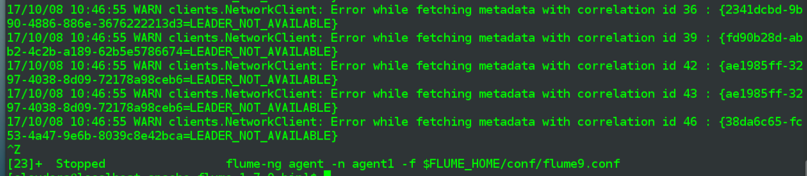

Running a --describe on the current Kafka cluster would support above, where now I have many topics, named by a UUID instead of the ones I manually created, problem8 and problem9

kafka-topics.sh --describe --zookeeper localhost:2181

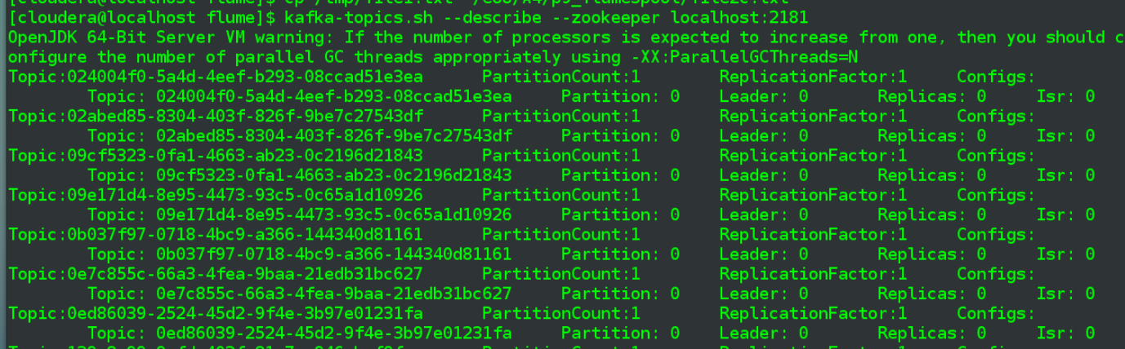

My guess is the ultimate resolution may involve specifying the correct Flume header in the interceptor config but I haven't found anything to support that.

… Some time later after playing around for a while, below combination is working, considering this one done:

For the flume5.conf, I added below

**agent1.sources.sources1.interceptors.ui.headerName = key**

On the kafka consumer terminal, start the .sh file with "print.key=true",

kafka-console-consumer.sh --zookeeper localhost:2181 --topic problem9 --property print.key=true

Start the agent one more time

flume-ng agent -n agent1 -f $FLUME_HOME/conf/flume9.conf

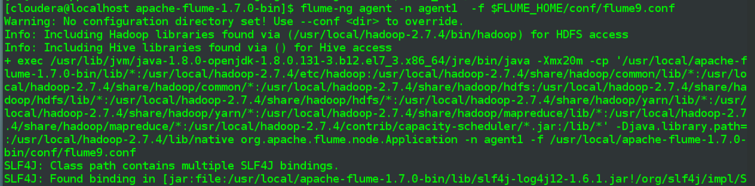

And now the kafka-consumer terminal output includes a UUID

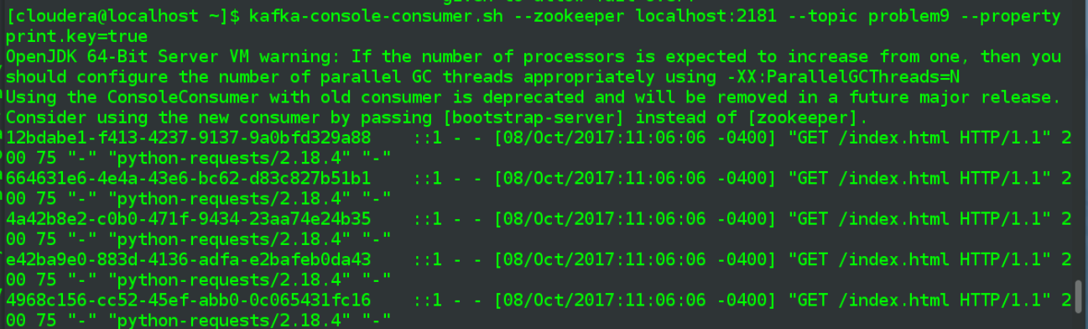

**Problem 10: (Points: 25) Basic Kafka producers and consumers**

* **Create a new topic, "problem10" , with 3 partitions**

As before, simply update --partitoins value and the topic name

kafka-topics.sh --create --zookeeper localhost:2181 --replication-factor 1 --partitions 3 --topic problem10

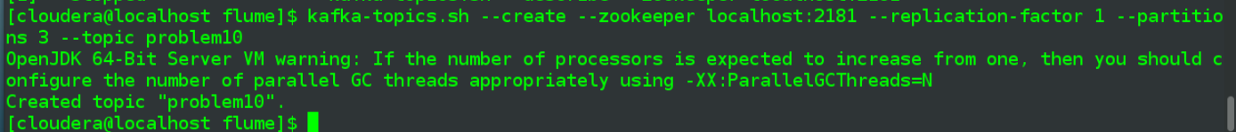

* **Using Kafka API, create a new Problem10Producer application that generates and sends events to the "problem10" topic - generate the same type of log events we've worked with so far, plus add a UUID: one event is one line in the format: <uuid> <timestamp> <url> <userId>; make sure you have at least 3 different userIDs**
  + **note: you can use your existing event generation app - just convert it into a Kafka producer**

Need to set up my environment first, install kafka-python to my python 3.4 virtual environment:

pip install kafka-python

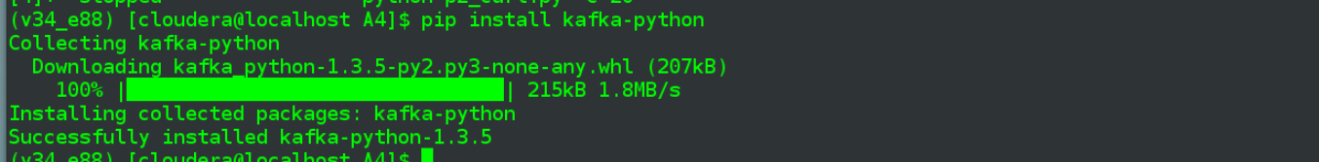

Update my assign01_p3.py to produce events to hard-coded topic = "Problem10". The full script be submitted but below I've excerpted some of the functions that were only relevent to it's original purpose from the first assignment.

**p10_producer.py**

|  |
| --- |
| *# based off my assign01_p3.py code from first assignment* **import** argparse **from** threading **import** Thread **from** random **import** randint **import** collections **import** os, shutil **import** time  **from** kafka **import** KafkaConsumer, KafkaProducer  . . .  *# make a deque with all the (random over a static day) timestamps that will be needed for given set of inputs* **def** get_all_timestamps(count):  *#'YYYY-MM-DD HH:MM:SS'* **return** collections.deque(**'2017-09-12 {hour:02}:{minute:02}:{second:02}'**.format(  hour=randint(0,23), minute=randint(0,59), second=randint(0,59)) **for** i **in** range(count))  *# generate a list of user-ids in format of u##, zero-filled from the left as appropriate to total count* **def** get_userids(count):  **return** [**'u'** + str.zfill(**'{}'**.format(i), len(str(count))) **for** i **in** range(1, count+1)]  **. . .**  **def** produce_topic_events(thread_number, data, is_debug=**False**):  *# use same url as passed into the --broker-list arge for kafka-console-producer.sh* producer = KafkaProducer(bootstrap_servers=**'localhost:9092'**)  topic_name = **'problem10'   for** line **in** data:  *# for aesthetic purposes, sleep 1 second between each send* time.sleep(1)  producer.send(topic_name, str.encode(line))  **if** is_debug:  print(**'-- topic {}, message sent: : {}'**.format(topic_name, line))   producer.flush()  **def** do_threads(num_userids, urls, event_count, thread_count, total_num_events, is_debug):  output_dir_path = **'output'** prepare_output_dir(output_dir_path)   ts = get_all_timestamps(total_num_events)  uids = get_userids(num_userids)  visits = []  **for** uid **in** uids:  **for** url **in** urls:  **for** i **in** range(event_count):  visits.append(**'{}\t{}\t{}'**.format(ts.pop(),url, uid,))   *#sort by the random timestamp, for better simulation* visits = sorted(visits) *#, key=lambda line: line.split()[-1])* **if** is_debug:  **for** visit **in** visits:  *#print(visit) # skip this for Assignment 4/Problem 10* **pass** log_threads = []  **for** i **in** range(1, thread_count + 1):  *#new_thread = Thread(target=generate_log, args=(i, output_dir_path, visits, is_debug))* new_thread = Thread(target=produce_topic_events, args=(i, visits, is_debug))  print(**'thread {} starting'**.format(i), flush=**True**)  log_threads.append(new_thread)  new_thread.start()   *#don't return until all the threads have completed* [t.join() **for** t **in** log_threads]   **return** output_dir_path   **if** __name__ == **'__main__'**:  parser = argparse.ArgumentParser(description=**'Run selected number of threads'**)  parser.add_argument(**'-n'**, **'--num-userids'**, type=int, default=5)  parser.add_argument(**'-u'**, **'--urls'**, type=str, default=**''**, help=**'comma separated string of urls'**)  parser.add_argument(**'-e'**, **'--event-count'**, type=int, default=5)  parser.add_argument(**'-t'**, **'--thread-count'**, type=int, default=1)  parser.add_argument(**'-d'**, **'--debug'**, type=bool, default=**False**)  args = parser.parse_args()  urls = [u **for** u **in** args.urls.split(**','**) **if** u]  url_count = len(urls)  print(**'BEGIN TEST, userid count: {}, number of urls: {}, number of events: {}, number of threads: {}, debug: {}'**.format(  args.num_userids, url_count, args.event_count, args.thread_count, args.debug))  total_event_count = args.num_userids * url_count * args.event_count  print(**'TOTAL EVENT COUNT: {}'**.format(total_event_count))   output_path = do_threads(args.num_userids, urls, args.event_count, args.thread_count, total_event_count, args.debug)   *#print('\nDONE, contents of {}\n - {}'.format(output_path, '\n - '.join(os.listdir(output_path))))* print(**'DONE, all events sent!'**) |
|  |

Modifications include

* import of objects from kafka-python library
* create the new produce_topic_events function, which is what sends each line of the log as a message
  + continued to have the sleep 1 second in there, made it easier to see events flowing through on multiple terminals (and to take screenshots)
  + the text needs to be encoded as bytes when sending
  + until I added in the producer.flush() the final message in each batch was not being sent, or at least not in a timely manner
* update do_threads to call the new function above
* print a simple DONE message at the end, no longer care about actually creating log files
* **Verify your producer works correctly by receiving generated events via Kafka console consumer**

Run p10_producer.py, telling it to use 3 userids, spread across the 3 specified urls, 20 events each. Going to run single-threaded (-t = 1) and also in debug mode, so that raw print output from python can be compared to as-received topic messages in the kafka-consumer terminal on bottom

python p10_producer.py -n 3 -u 'google.com,yahoo.com,harvard.edu' -e 20 -t 1 -d True

-

kafka-console-consumer.sh --zookeeper localhost:2181 --topic problem10

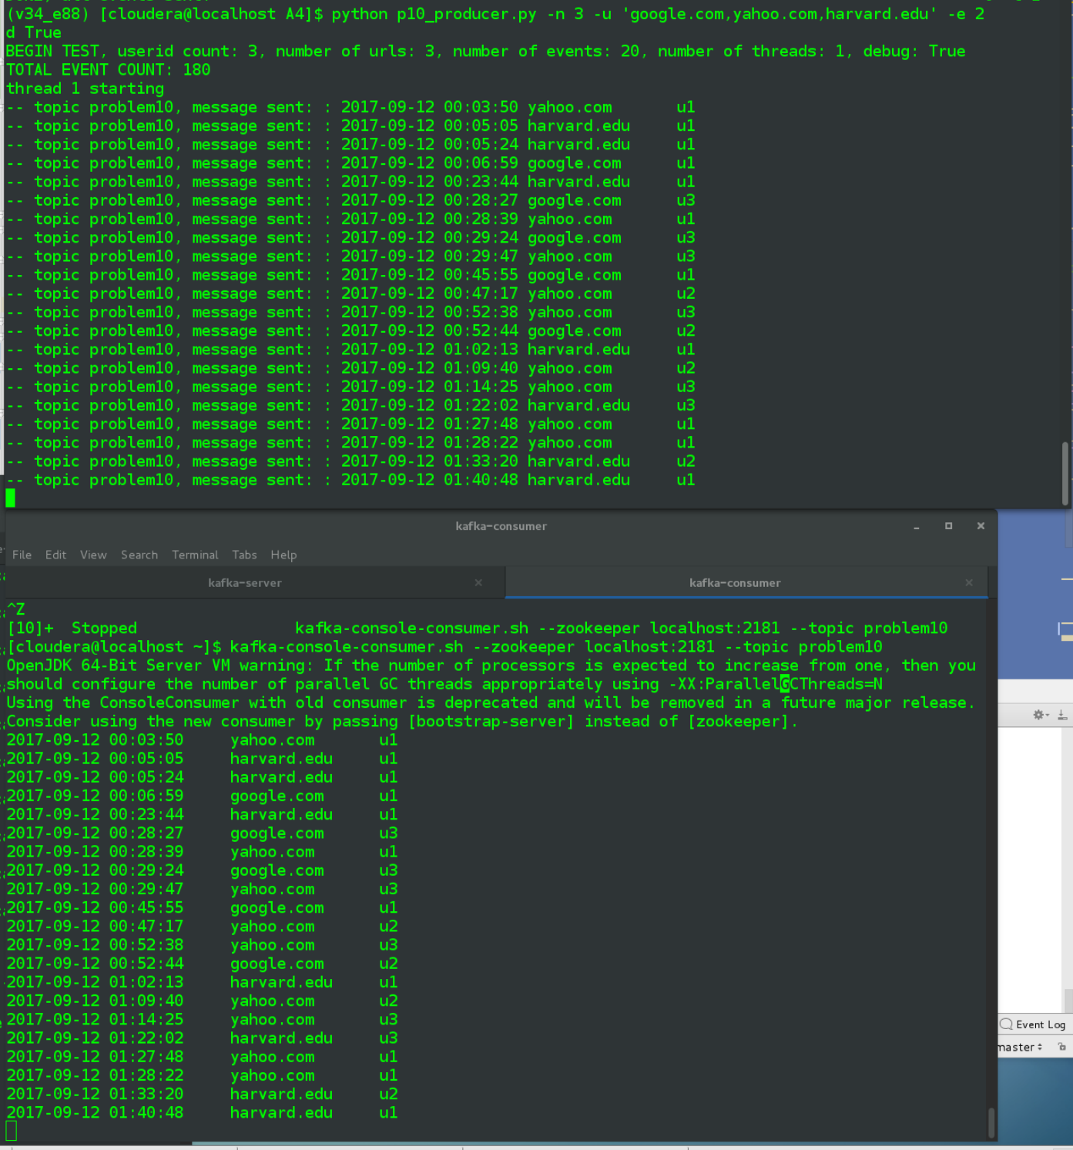

Each message text printed in top terminal, which technically occurs after a message has been .sent() to kafka, is reflected in the consumer terminal at bottom.

* **Using Kafka APIs, create a Problem10Consumer (single-threaded is OK), with the "p10consumer" consumer group.id,  that listens to the "problem10" topic - demonstrate that it recieves events generated by the Problem10Producer**
* **For each event received the Problem10Consumer should print out partition number, event key and event body**
* **Demonstrate that the Problem10Consumer receives events from all 3 partitions and they are equally distributed**

Create a very simple python consumer script, using the kafka-python library.

**p10_consumer.py**

|  |
| --- |
| *#!/usr/bin/env python* **import** time **import** collections  **from** kafka **import** KafkaConsumer   **def** main():  *# auto_offset_reset = 'earliest',* c = KafkaConsumer(  bootstrap_servers=**'localhost:9092'**,  group_id=**'p10consumer'**)  *# will create topic if it doesn't already exist* c.subscribe([**'problem10'**, **'problem10a'**])   topic_10_partitions = []   **while True**:  **for** msg **in** c:  **if** msg.topic == **'problem10'**:  key_value = **None if** msg.key **is None else** msg.key.decode()  info = **'''  message received  - partition number: {}  - event key: {}  - event body: {}'''**.format(msg.partition, key_value, msg.value.decode())  print(info)  topic_10_partitions.append(msg.partition)  **else**:  *# presumably topic = problem10a, give a summary on partition distrbution, since script started* **for** k, v **in** collections.Counter(topic_10_partitions).items():  print(  **'partition: {}, count: {}, pct total: {:.0f}%'**.format(k, v, v / len(topic_10_partitions) * 100))   *# sleep for 1/10th of a second before looping again* time.sleep(0.1)   **if** __name__ == **"__main__"**:  main() |

Later testing/updates with problem 13 lead me to believe there were better approaches but after reviewing a few examples on the internet, wich took different approaches (iteration vs. polling), I can say that above at least worked.

* + using a single group_id, subscribe to both problem10 and problem10a topics
  + "infinite" while loop
  + the more common path for incoming messages is the base problem10a topic and for those there is printout that includes partition number, key, and the actual message body, which needs to be be decoded from bytes into string (msg.value.decode())
    - add the incoming partitoin number to the topic_10_partitions list, re below
  + if topic <> problem10 then it pretty much be problem10a, in which case the code is instructed to display distribution information
    - use collections.Counter object, instantiated on the list of partition id values, to print the total count (up to this moment) per partition, including % of total messages
  + sleep for 1/10 of second in between loops

For first demo, run the new producer script at minimum level, so that all it does is create a total of six events, all for the same user id:

python p10_producer.py -n 1 -u 'google.com,yahoo.com,harvard.edu' -e 2 -t 1 -d True

-

python p10_consumer.py

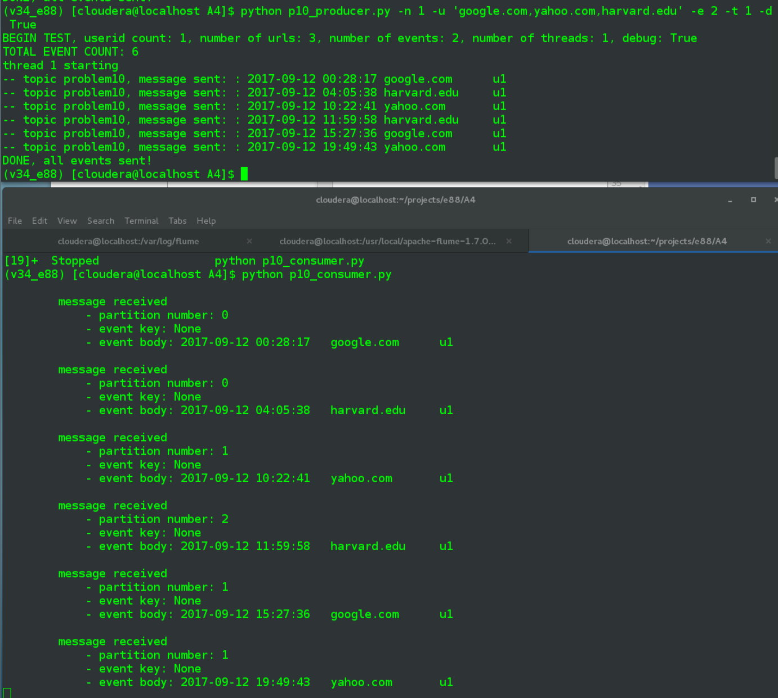

Since the producer script is launched in debug mode, in top terminal, can see each event message that is sent. On the bottom is the consumer script, printing out partition number, event key (currently there is none), and the actual message body. The six "produced" events match the six "consumed" in the bottom.

Now run the producer script again, only with 3 user ids * 3 urls * 20 events, meaning there will be a total of 180 events.

python p10_producer.py -n 3 -u 'google.com,yahoo.com,harvard.edu' -e 20 -t 1 -d True

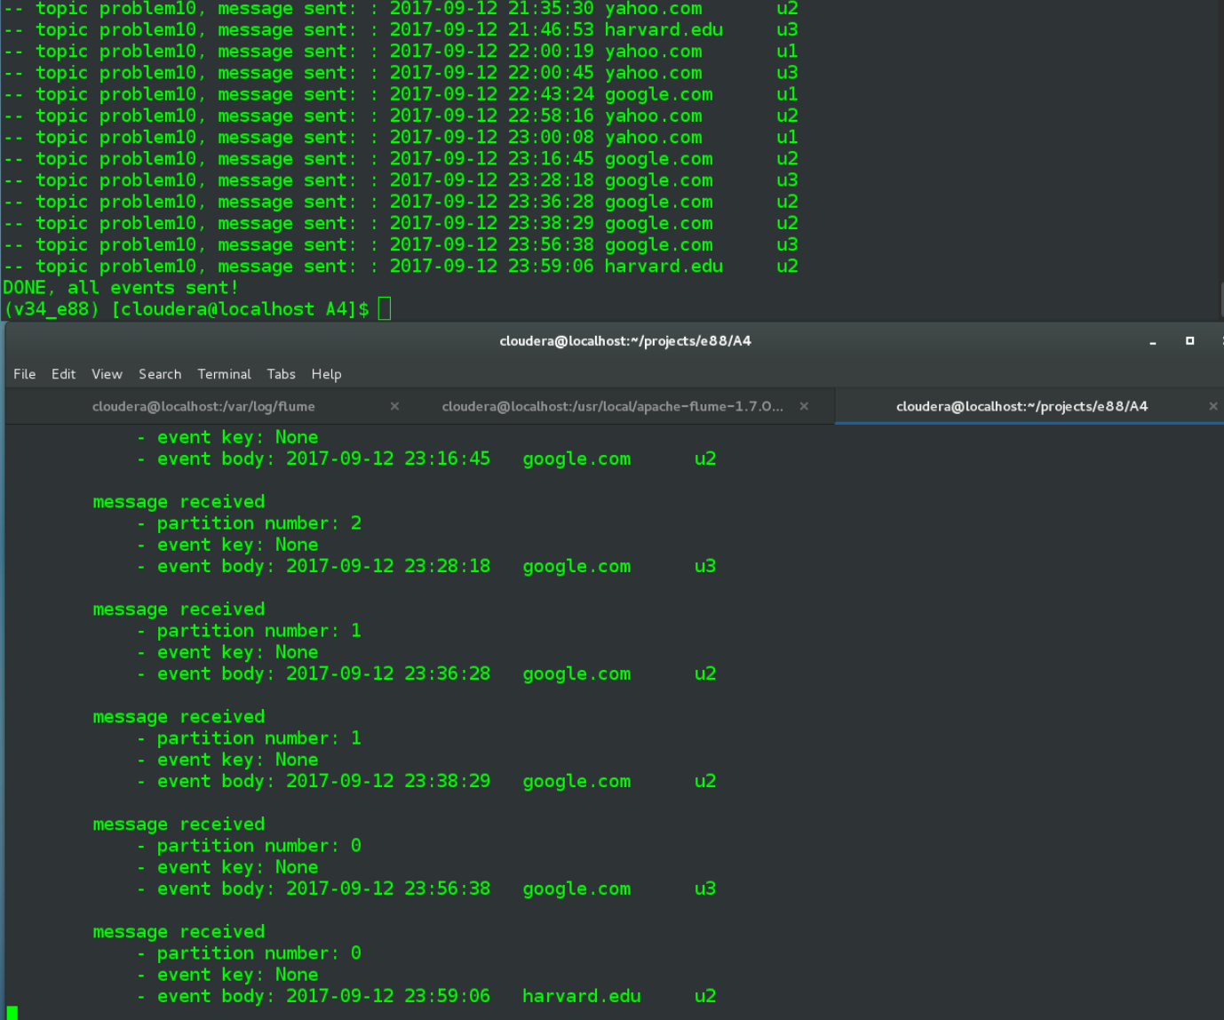

Above screenshot shows all new messages having been sent/consumed.

In a 3rd terminal window, run the kafka-console-producer.sh script on the topic = problem10a (which was apparently auto-created the first time I ran the consumer .py, which subscribes to it).

kafka-console-producer.sh --broker-list localhost:9092 --topic problem10a

And in this new terminal, type anything at the prompt and hit return to trigger a message being sent to "watcher" topic problem10a.

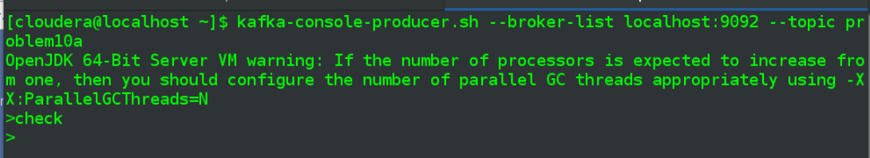

Once that "check" message is received by p10_consumer.py, a summary of the to-date messages will be displayed,

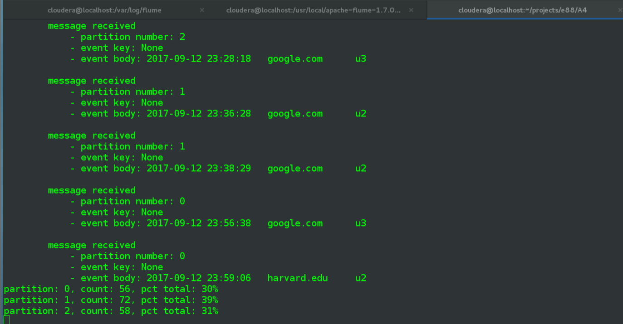

We see 56+72+58 = 186, i.e. the first demo of 6 events followed by the main run of 180. The partition number breakdown isn't entirely even but it is reasonably close, each partition received between 30% and 39% of the messages, where a perfect division would have displayed 33% each. If I ran a set that included several hundred events the breakdown should be even more evenly distributed.

* **Modify Problem10Producer to send events with the key partitioned based on the userIDs:**
* **Events with the same userID should go to the same partition number**
* **Make sure that there is at least one userID corresponding to each partition (you have 3 partitions, remember)**
* **In your Problem10Consumer, verify that the events for the same userID are received from the same partition**

Modify the produce_topic_events function of p10_producer.py, now passing in a key value = the uid from the event, which is parsed out of the full log line by a split() that splits the tab separated line into three parts, the final one being the uid, e.g. u1.

|  |
| --- |
| **def** produce_topic_events(thread_number, data, is_debug=**False**):  *# use same url as passed into the --broker-list arge for kafka-console-producer* producer = KafkaProducer(bootstrap_servers=**'localhost:9092'**)  topic_name = **'problem10'   for** line **in** data:  *# for aesthetic purposes, sleep 1 second between each send* time.sleep(1)  *# use 3 lines below for first part of problem 10  # producer.send(topic_name, str.encode(line))  # if is_debug:  # print('-- topic {}, message sent: : {}'.format(topic_name, line))   # update to use userid as key value* uid = line.split()[-1]  uid_num = int(uid[-1]) - 1  producer.send(topic_name, key=str, key=str.encode(uid), value=str.encode(line))  **if** is_debug:  print(**'-- topic {}, key {}, message sent: : {}'**.format(topic_name, uid, line))   producer.flush() |

The documentation I found on the send() method of the KafkaProducer class seemed to indicate this alone should be sufficient:

**key** (optional) – a key to associate with the message. Can be used to determine which partition to send the message to. If partition is None (and producer’s partitioner config is left as default), then messages with the same key will be delivered to the same partition (but if key is None, partition is chosen randomly). Must be type bytes, or be serializable to bytes via configured key_serializer.

To me this sounds like the partitions will still be randomly assigned initially but a given uid value (my example will only have 3) should always go to the same partition. My first 180-event processing using the updated code wasn't so successful though:



Ran it multiple times and still saw the same thing, all events were only going to two partitions, even through topic was defined with three. Also tried passing an argument with partition=None, which didn't make a difference. Passing only a number, e.g. 1 or 2 or 3, as the key value didn't help. The only way I got an even division was to set the partition argument in addition:

**partition** (int, optional) – optionally specify a partition. If not set, the partition will be selected using the configured ‘partitioner’.

Below shows the updated code, now setting the partition argument to an integer value = to the uid -1 (to match zero-base of partition numbering):

|  |
| --- |
| uid = line.split()[-1]  uid_num = int(uid[-1]) - 1  producer.send(topic_name, partition=uid_num, key=str.encode(uid), value=str.encode(line))  **if** is_debug:  print(**'-- topic {}, key {}, message sent: : {}'**.format(topic_name, uid, line)) |

The result is perfect distribution of events

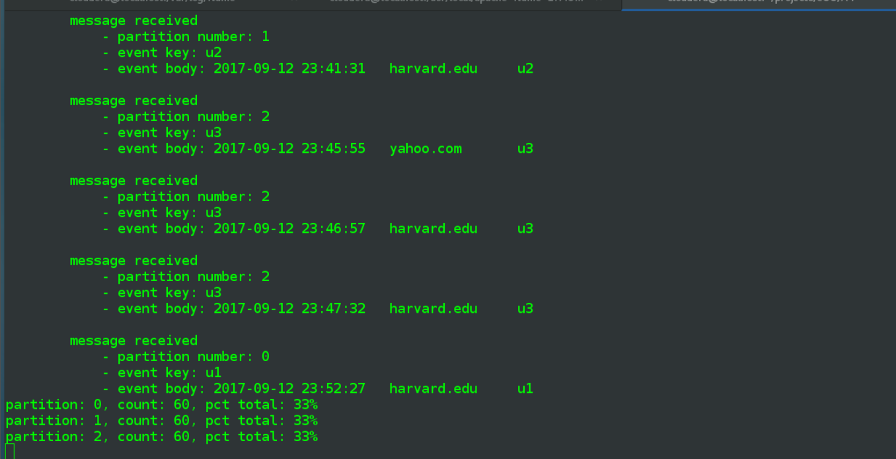

**Problem 11: (Points: 15) consumer groups**

* **Building up on the Problem 10's setup: start a second instance of the Problem10Consumer, with the same consumer group ID**

For best examination of results, I start two p10_consumer.py instances at about the same time. They both have a hard-coded group id = "p10consumer".

In a third window run the p10_producer.py, with same arguments as before, resultin in 180 events

python p10_producer.py -n 3 -u 'google.com,yahoo.com,harvard.edu' -e 20 -t 1 -d True

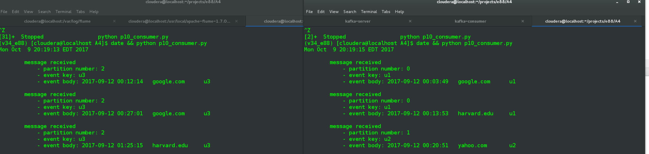

…

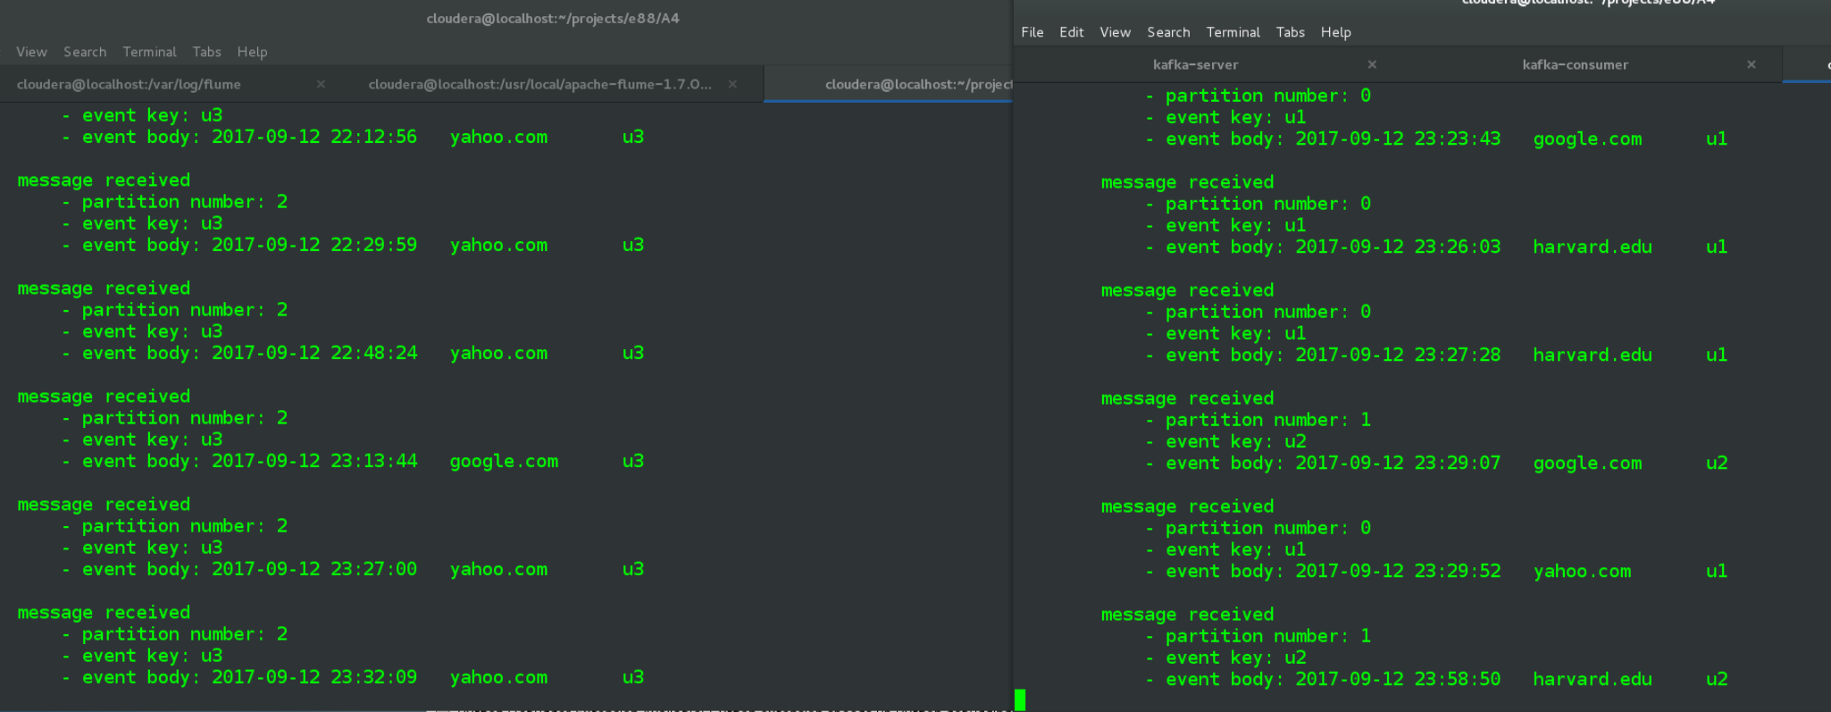

Per the above the terminal on the left side appears to be only receiving messages directed to partition number 2, the 3rd partition. The window on the right includes events directed at both partition numbers 0 and 1. Scrolling through the events in both windows confirms the same.

* **Demonstrate how partitions are re-balanced between the two consumer instances - which partitions are processed by which instance now?**

But I also want independednt verification and to that end I had created a new problem10b topic, this time with 3 partitions (problem10a topic had been auto-created last time, with only a single partition).

kafka-topics.sh --create --zookeeper localhost:2181 --replication-factor 1 --partitions 3 --topic problem10b



And now if I start a kafka-console-producer.sh with arguments that include "--property parse.key=true" and "--property key.separator=," (i.e. comma as the separator)

kafka-console-producer.sh --broker-list localhost:9092 --topic problem10b --property parse.key=true --property key.separator=,

I can direct my distribution queries to either of the two windows

0,test

1,test

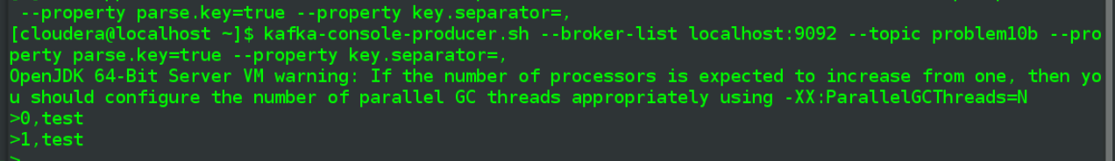

The first line of text, sending key = 0, results in summary information for the left window (problem10 partition 2)

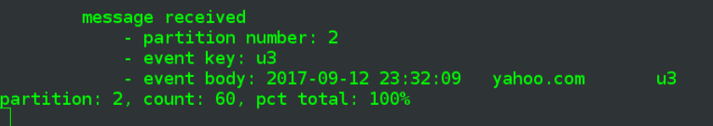

Then using key = 1 (or, presumably, key), results in distribution info for the othe terminal, the one with partitions 0 and 1 for topic = problem10

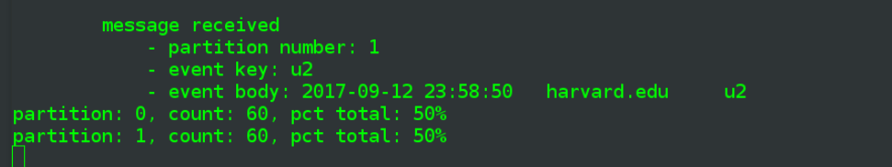

Both of which confirm that one instance processed all messages for partition 2 while the other instance "took" all those for the remaining partitions, i.e. 0 and 1.

* **Start two more instances of the Problem10Consumer with the same group ID - to the total of 4 instances now. Demonstrate the partition re-balancing and explain the results. Which instances are processing which partitions, if any?**

With those other two instances still in a pending state, having temporarily processed all available messages, I open two more terminal windows and start the scripts in each





Start a new producer batch of 180 events

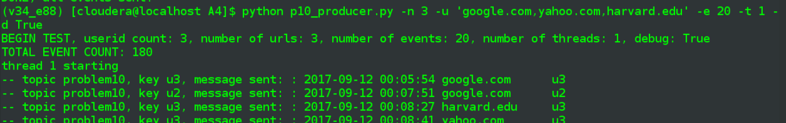

This next bit, in the box, is a bit confusing since I continued on from the above run. It was only after documenting everything and seeing it rather messy that I decided to do a new set of events from beginning:

|  |
| --- |
| One big screenshot with events being produced in upper left, the original two consumer instances on the bottom, and then two terminal windows in upper center and left that represent the new instances    Perform a similar visual inspection as before and it looks like the two pre-existing consumer instances both consumed a partition each (partitions 0 and 1). And then one of the new instances processed all the messages for the remaining partition = 2. The 4th instance didn't process any messages at all, which makes sense since the topic being consumed only had 3 partitioned defined to begin with.  In the in topic problem10b producer session, begin send a message to each partition  0,test  1,test  2,test  The first message goes to the 3rd terminal window    Next, the "1,test" goes to the second window, which of course includes messages from the initial run. In fact the percentages no longer make sense due to how my code calculates them, only the raw numbers can be analyzed.    Below screenshot is from the first run, where this script processed both partition 0 and 1. In this last run only partition 0 was being processed with this script, so these 60 new messages have been included in the new calculations, nothing new here from partition 1.    "2,test" sent from topic problem10b repeats the 3rd window again actually, not until "4,test" do I get stats on the first window (problem10 partitoin 1)    Again, below is from first run for this particular script instance, when it had been attached to partition 2 only. In this new batch it only processed partition 1, so a full complement of 60 is displayed for partition 2 and nothing enw for partition 1. |

Ok, clean slate, restart all 4 consumers and generate the 180 events

Similar results, only the partition numbers swapped between lower left and center.

This time the numbers more clearly make sense, all messages targeted for a given partition were consumed by only one of the consumers.

All together:

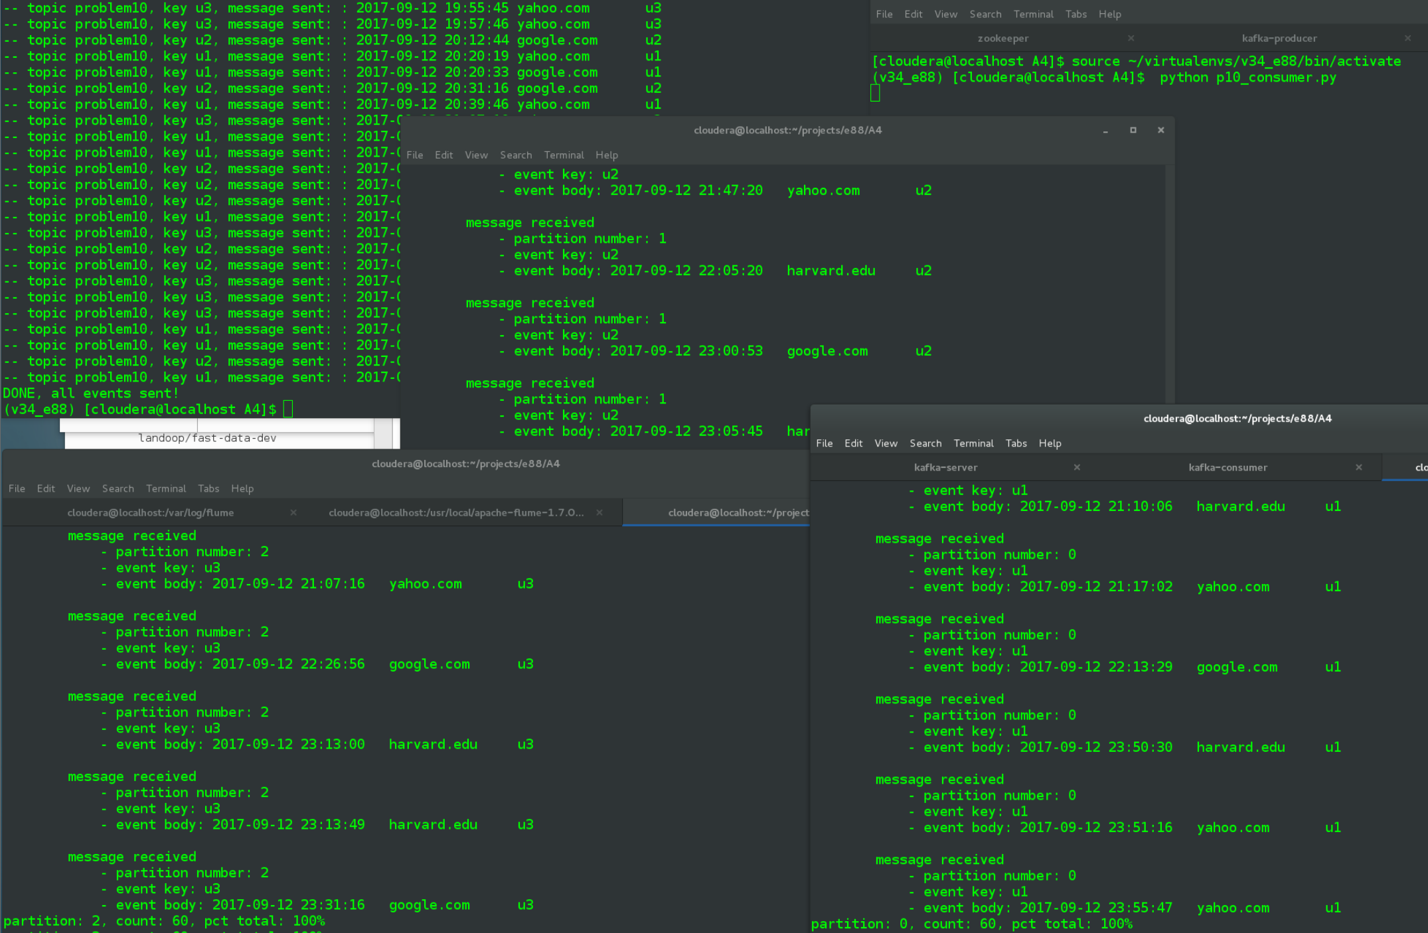

Lower left, all partition 2

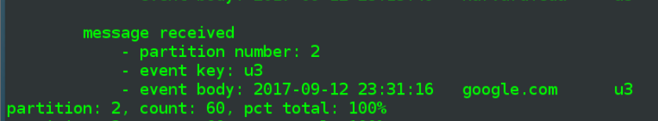

Lower right, all partition 0

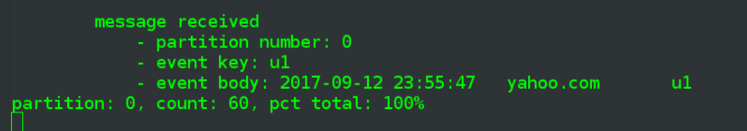

Center, all partition 1

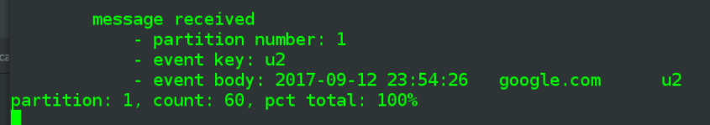

* **Stop two instances of the Problem10Consumer - demonstrate the partition re-balancing again**

Kill the first two instances, the two on bottom, and generate 180 events again. Rearrange the windows a bit but general layout the same. Can now see that the 4th instance of the consumer, upper right, which hadn't gotten anything before, is now actively receiving events for partition 2. The originally-3rd instance in the middle is now taking events for both partitions 0 and 1.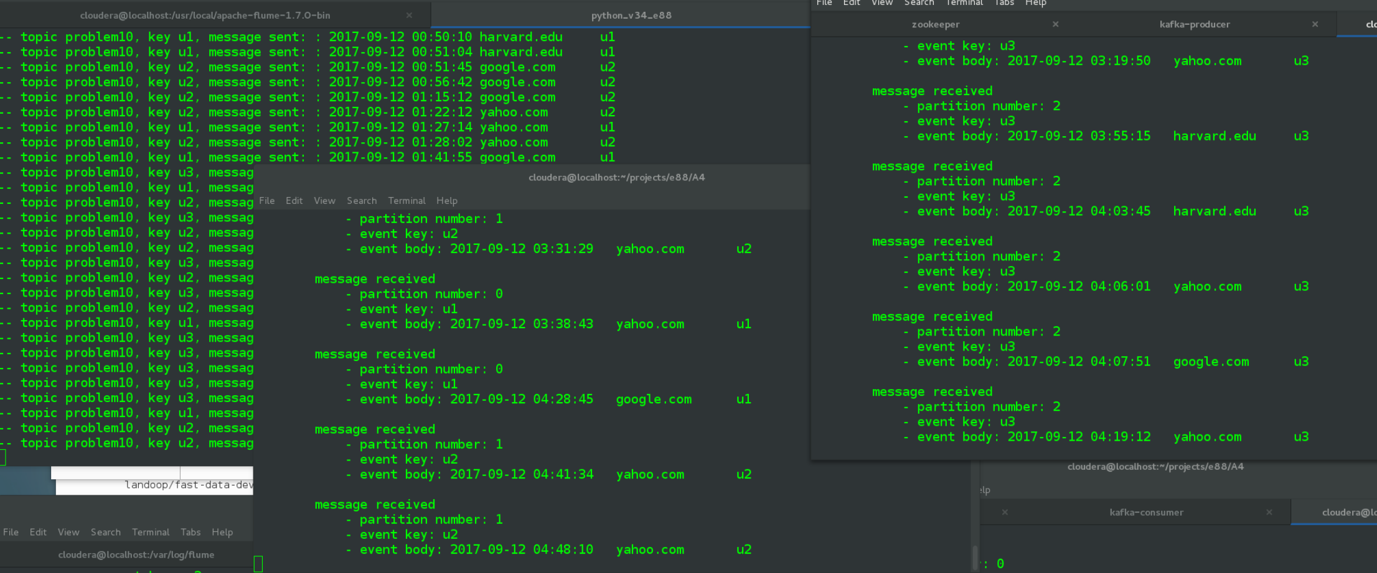

Here are the relevant stats, where the numbers on the terminal on the left include the 60 from previous run, and then another 60 for partition 1 + a whole new set of 60 for partition 0. The right terminal is the one that hadn't gotten any before, so it simply shows a count = 60 for its partition.

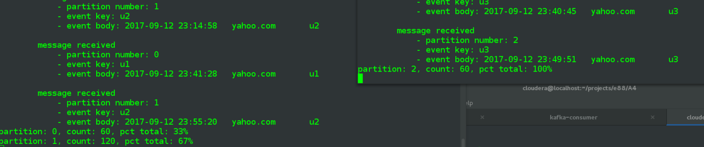

**Problem 12: (Points: 20) multi-node cluster**

* **Setup a 3-node Kafka cluster - you can do it either in AWS or using Docker**
* **make sure each node has a distinct broker.id, has privateIPs to talk to Zookeeper, but uses publicIPs as advertised hosts in the server.properties for each node; myid file for zookeeper should have the same id as the broker.id**
* **Create a topic, "problem12", with 4 partitions and replication factor 2**
* **Examine the state of the cluster and show how all replicas are spread over the cluster nodes - show all ISRs**
* **Using console producer, send a few events to the "problem12" topic; verify you have received them using the console consumer**
* **Stop Kafka on one of the nodes (do not stop Zookeeper), wait for a few seconds - show the state of the cluster now, and all ISRs of the "problem12" topic**
* **inspect Kafka's application logs - what kind of errors/messages do you see?**
* **Run console producer and consumer again, see if you can still send/receive messages**
* **re-start Kafka on that node - observe how fast the cluster gets into the full ISR state**

As of Tuesday evening there wasn't yet a lab video and the pdf with lab notes was imposing to say the least. Even after viewing the video at a later time it seems doubtful I could have gotten much done on a brand new EMR cluster before having to shut the cluster down, either overnight or during the day.

Then I investigated the docker approach for a while, beginning with the Landoop docker image mentioned in the lab. I'd actually used that before on my VM, while reviewing some online videos regarding kafka. I didn't see any out of the box way, or any blog post etc., discussing use of the image with multiple brokers spread across multiple docker instances. The best solution appeared to involve a Docker setup available at <https://github.com/wurstmeister/kafka-docker>, which included ability to specify a number of brokers on startup. But while I have some experience with simple docker instances I haven't done anything with docker-compose and networks. Wasn't able to find a practical way of being able to do the private/public IP config, though of course I didn't really know what I was looking for.

So after a decent amount of time doing research I cut my losses and went on to a bonus problem that I could move forward with.

**Problem 13: (Bonus: +20)**

* **Convert your Problem10Consumer into a multi-threaded Problem13Consumer - where you start multiple Consumer threads per specified consumer group.**
* **Do not use offset autocommit anymore (if you were using it before) - make sure each cnsumer thread commits its offset via commitAsync() operation**
* **Make the number of consumer threads configurable via your Problem11Consumer input parameter**

Note, this is a Linux VM borrowing two cores off of its host laptop:

htop info

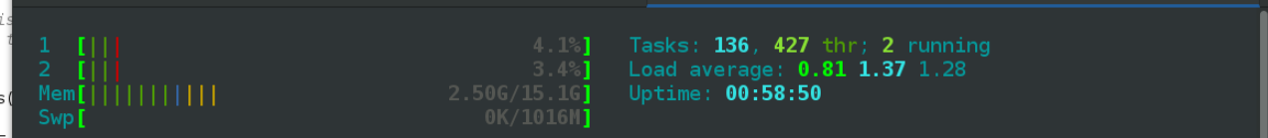

The new consumer is a combinarion of p10_consumer.py and one of the multithreading scripts from Assignment 1.

**p13_consumer.py**

|  |
| --- |
| **import** argparse **from** threading **import** Thread **from** queue **import** Queue **import** time **import** collections  **from** kafka **import** KafkaConsumer   **def** consumer(q, thread_id, group_id, main_topic, check_topic, is_debug=**False**):  *# auto_offset_reset = 'earliest',* c = KafkaConsumer(  bootstrap_servers=**'localhost:9092'**,  group_id=group_id,  enable_auto_commit=**False** *# for Problem 13, turn off auto-commit* )  *# will create topic if it doesn't already exist* c.subscribe([main_topic, check_topic])   **for** msg **in** c:  **if** msg.topic == main_topic:  key_value = **None if** msg.key **is None else** msg.key.decode()  info = **'''  thread {} message received  - partition number: {}  - event key: {}  - event body: {}'''**.format(thread_id, msg.partition, key_value, msg.value.decode())  print(info)  *#q.put(thread_id)* q.put((thread_id, msg.partition))   **else**:  *# report on per-thread_id/partition combinations, in a sorted manner* **for** k, v **in** sorted(collections.Counter(q.queue).items(), key=**lambda** val: (val[0], val[1])):  print(**'thread_id: {}, count: {}, pct total: {:.0f}%'**.format(k, v, v / len(q.queue) * 100))   *# python version of commitAsync()* c.commit_async()   *# if is_debug:  # time.sleep(1)* **def** do_threads(thread_count, is_debug=**False**):   group_id = **'p13consumer'** main_topic = **'problem13'** *# topic to be used to display distribution informaiton* check_topic = **'problem13a'** q = Queue()   log_threads = []  **for** i **in** range(1, thread_count + 1):  new_thread = Thread(target=consumer, args=(q, i, group_id, main_topic, check_topic, is_debug))  print(**'thread {} starting'**.format(i), flush=**True**)  log_threads.append(new_thread)  new_thread.start()   *#don't return until all the threads have completed* [t.join() **for** t **in** log_threads]   **return True   if** __name__ == **'__main__'**:  parser = argparse.ArgumentParser(description=**'Run selected number of threads'**)  parser.add_argument(**'-t'**, **'--thread-count'**, type=int, default=1)  parser.add_argument(**'-d'**, **'--debug'**, type=bool, default=**False**)  args = parser.parse_args()   threads_complete = do_threads(args.thread_count, args.debug)   print(**'DONE'**) |

Number of threads is configurable on the command line, via the -t argument.

Modifications of note:

* Turned off autocommit on creating the KafkaConsumer:

enable_auto_commit=**False**

* And added a commit Async" that occurs after each message is reported upon:

*# python version of commitAsync()* c.commit_async()

* Consumer group id, main topic and the watcher topic are all hard-coded in the do_threads() function

group_id = **'p13consumer'** main_topic = **'problem13'** *# topic to be used to display distribution informaiton* check_topic = **'problem13a'**

* The queue.Queue() now holds both thread "id" and partition number, for displaying summary info

q.put((thread_id, msg.partition))

- that information is sorted by thread id and then partition number, for easier viewing

**for** k, v **in** sorted(collections.Counter(q.queue).items(), key=**lambda** val: (val[0], val[1])):  
 print(**'thread_id: {}, count: {}, pct total: {:.0f}%'**.format(k, v, v / len(q.queue) * 100))

I also felt it best to create a new p13_producer.py, 95% similar to p10_producer.py but with the sending of key and partition values removed, as it seemed that was unnecessary and would tie the event generation to the number of consumer threads, e.g. would want 10 userids if running against a topic with 10 partitions.

* **Create a new topic, "problem13", with 10 partitions**

Run the usual commands, also creating a problem13a "watcher" topic that can be used to display distribution info on the threads/partitions involved in the main topic.

kafka-topics.sh --create --zookeeper localhost:2181 --replication-factor 1 --partitions 10 --topic problem13

kafka-topics.sh --create --zookeeper localhost:2181 --replication-factor 1 --partitions 10 --topic problem13a

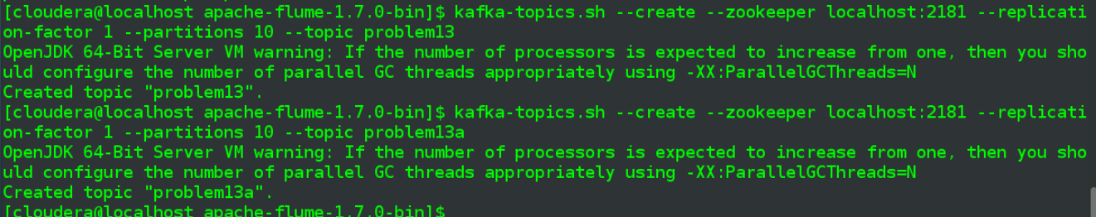

* **Start one Problem11Consumer instance with 5 consumer threads, joining consumer group "p13consumers"**

Pass in setting for 5 threads, along with debug mode

python p13_consumer.py -t 5 -d true

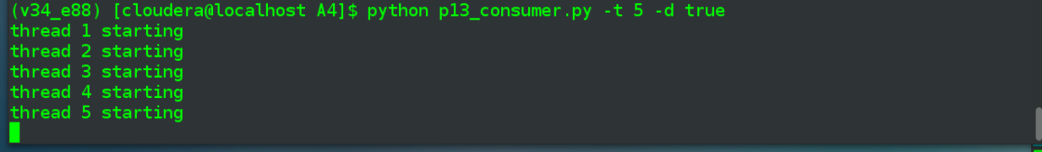

* **Keep pushing events into the "problem13" topic**

Go with the 180 events again (3 userids, 3 urls, 20 events), with debug prinout

python p13_producer.py -n 3 -u 'google.com,yahoo.com,harvard.edu' -e 20 -t 1 -d True

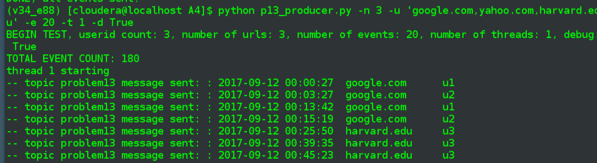

…

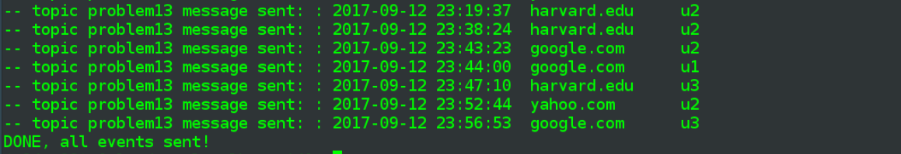

* **Demo partition distribution among all consumer threads**

Messages have been received by consumer

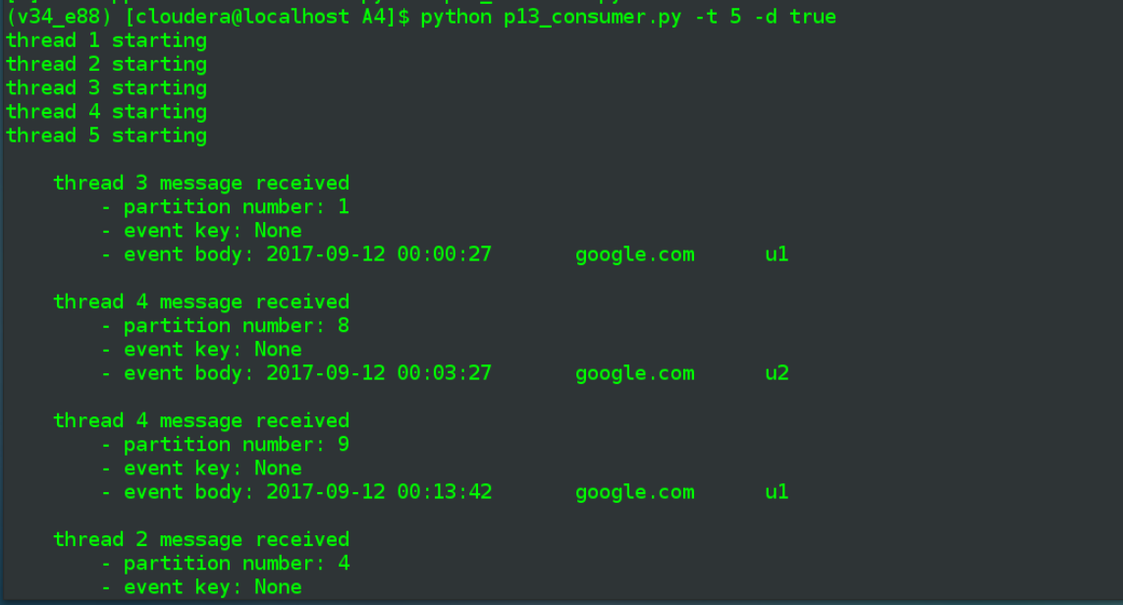

…

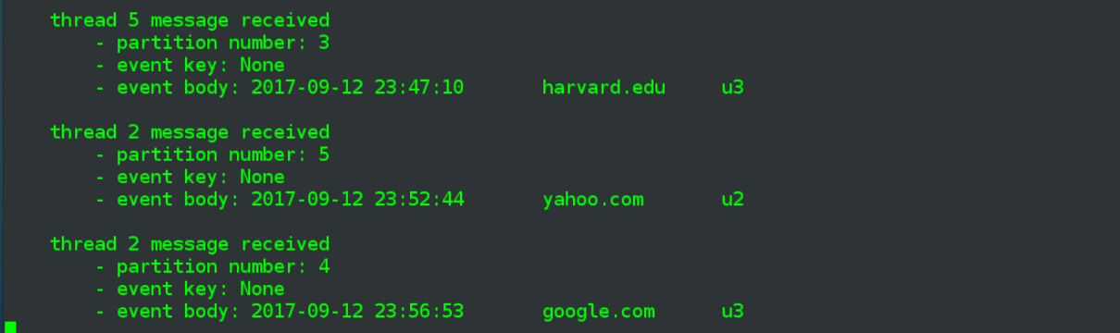

Above is the last consumed message, Now, in separate terminal, send a poke message on the problem10a topic, to get distribution info

kafka-console-producer.sh --broker-list localhost:9092 --topic problem13a

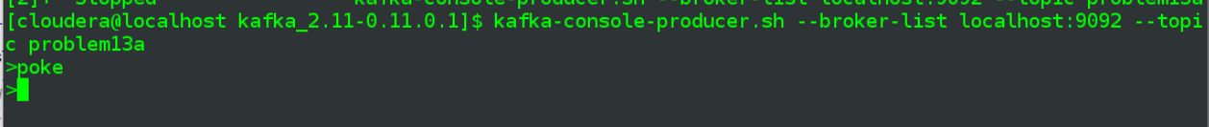

And the consumer terminal is updated with thread/partition information

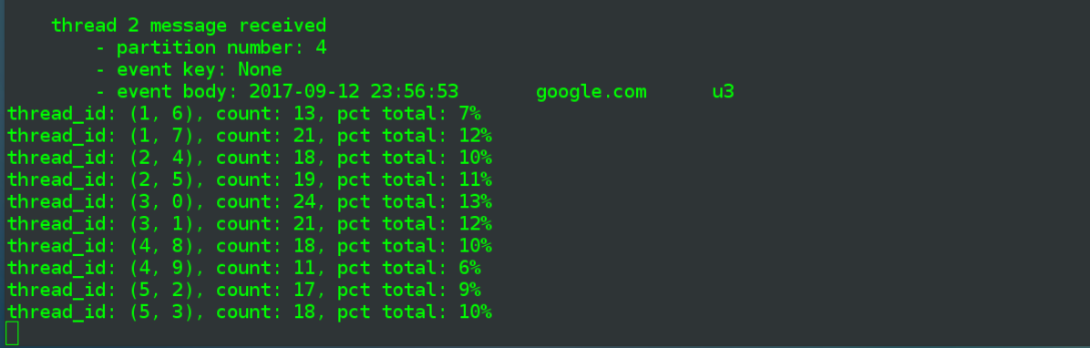

Reasonably even distribution, where each of the five threads received messages tied to 2 out of the 10 partitions. Either looking at partitions by themselves, or adding up the the number of messages in each of the thread's partiions, see that each thread consumed ~20% of the messages.

Run one more slew of 180 messages and do another poke, and see that distribution is evening up further, rule of large numbers would lead me to believe that with another few runs each of the partitions would be at 10%, leading even distribution across threads (though of course I was also rounding all the % numbers for display, so they are slightly misleading as-is)

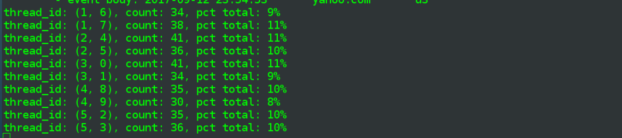

* **Run kafka-consumer-group tool and show offset movement for the consumer group**

First run the tool against the consumer group, including all results

kafka-consumer-groups.sh --describe --group p13consumer --bootstrap-server localhost:9092

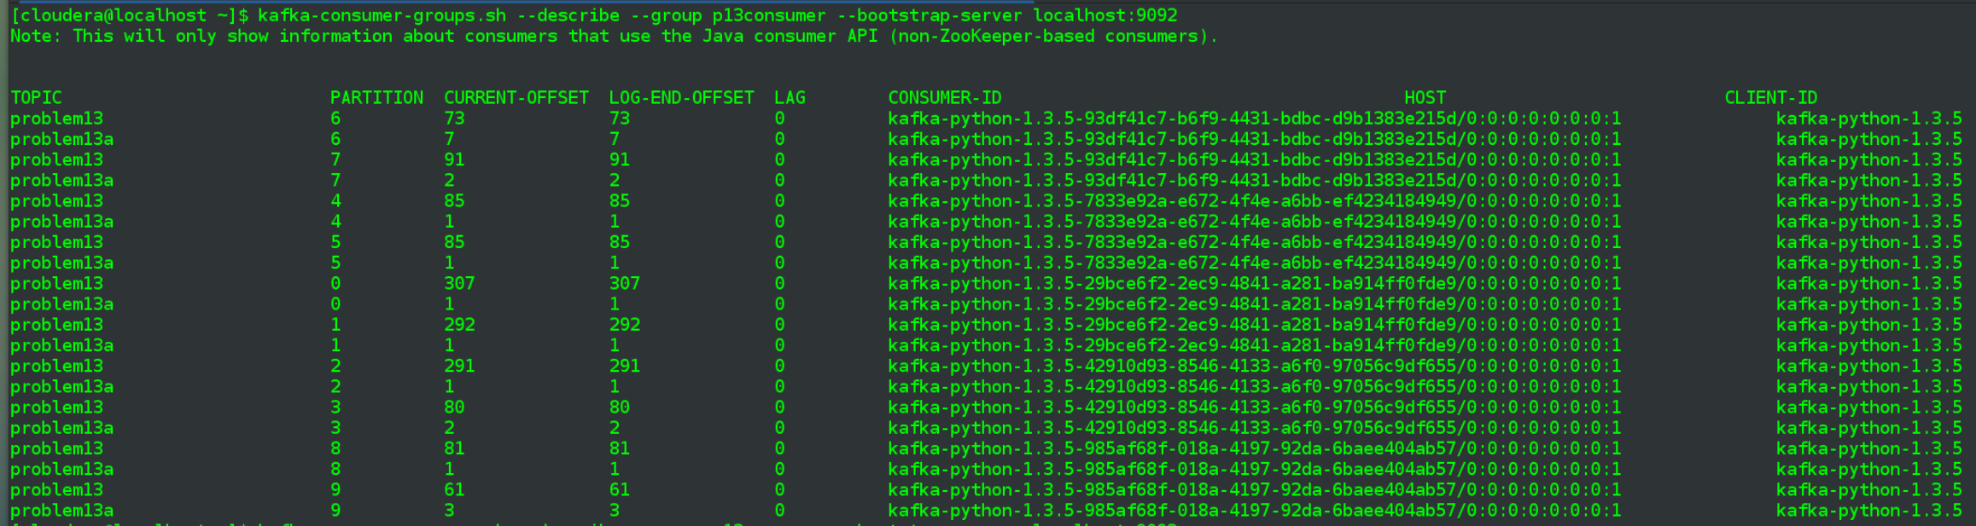

Maybe stripping out the problem13a watcher topic will help

kafka-consumer-groups.sh --describe --group p13consumer --bootstrap-server localhost:9092 | grep -v problem13a

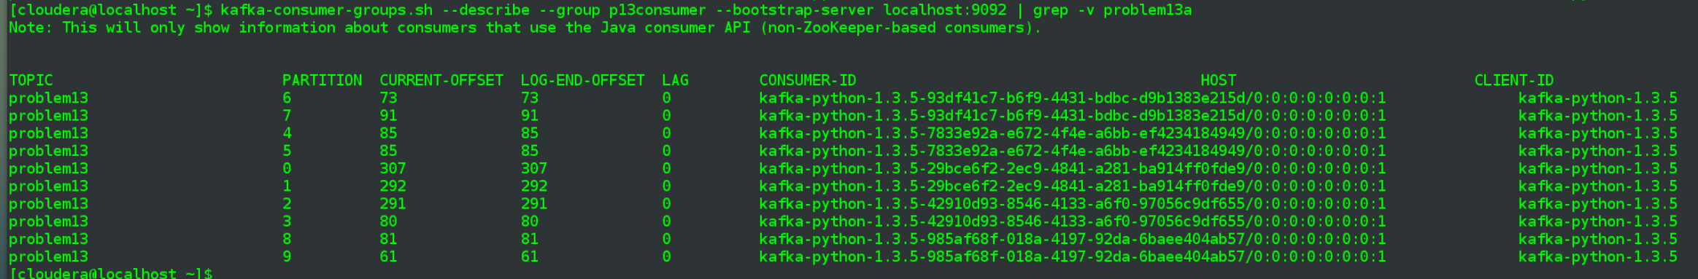

* **Start one more instance of the Problem11Consumer, also with 5 threads, joining the same consumer group "p13consumers"**

New terminal window, start another p13 consumer with 5 threads

python p13_consumer.py -t 5 -d true

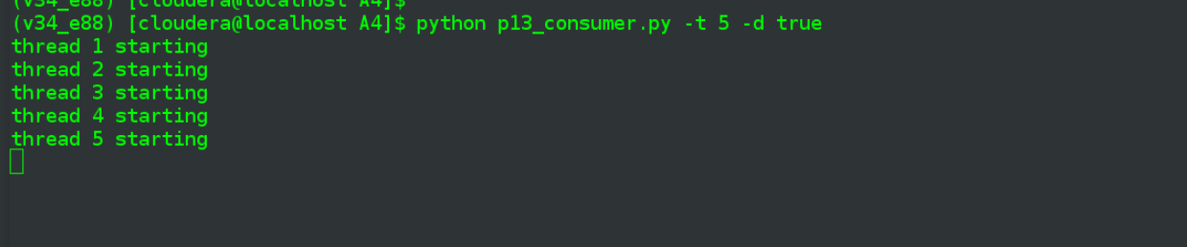

Start another run of 180 events

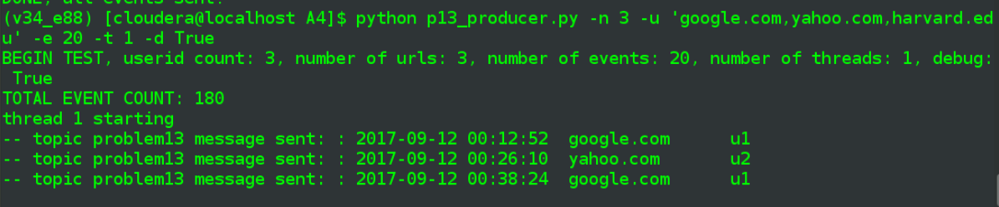

* **Demo partition re-balancing between all consumers**

Event generation in upper left, pre-existing 5-thread consumer in lower left, new 5-thread consumer in lower left, see that events are being received by both instances of p13_consumer.py.

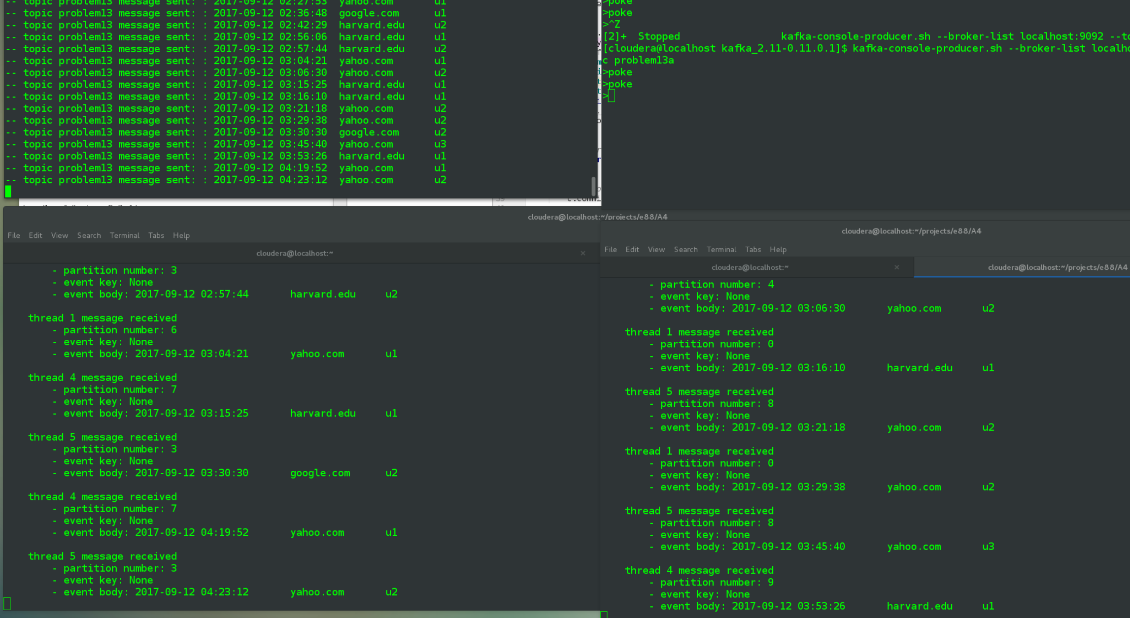

Run the kafka-consumer-group.sh command on p13consumer group again, earlier results on top and new on bottom, note that the ordering is different.

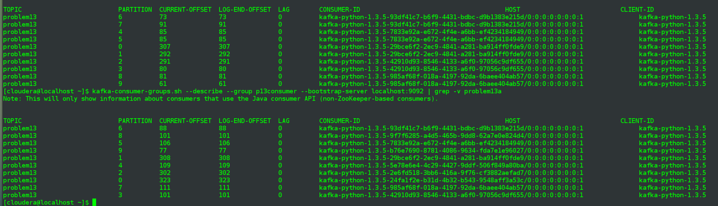

I'm afraid earlier tests I ran where I was using a p13_producer.py closer to the original p10_producer.py throws off the results overall, as that version was still outputing partition/key values tied to the userid values. Have been including only 3 userids for all event generation in this assignment, so partitions 0,1,2 had many more messages received vs. partitions 3 through 9.

A topic problem13a poke message may better reveal partition rebalancing, again the long-running consumer on the left, newer instance on the right.

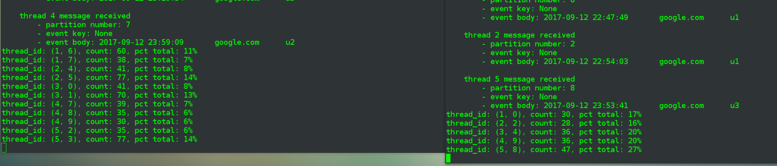

Easiest to first note that the new instance has only been processing messages for 5 out of the 10 total partitions, 0,2,4,9,8, unlike earlier when that first instance had all 10 spread across 5 threads, 2 partitions per thread.

Review numbers for those same partitions (0,2,4,9,8) and note the % values are lower relative to the other partitions, presumably for this last batch of messages the pre-exisitng consumer was only processing messages on the remaining partitions, i.e. partitions 1,3,5,6,7.

(Also, a visual review of the two sets of output messages agrees with above analysis.)

One final, brand new run of 360 events, new consumer script instances, below is the distribution.

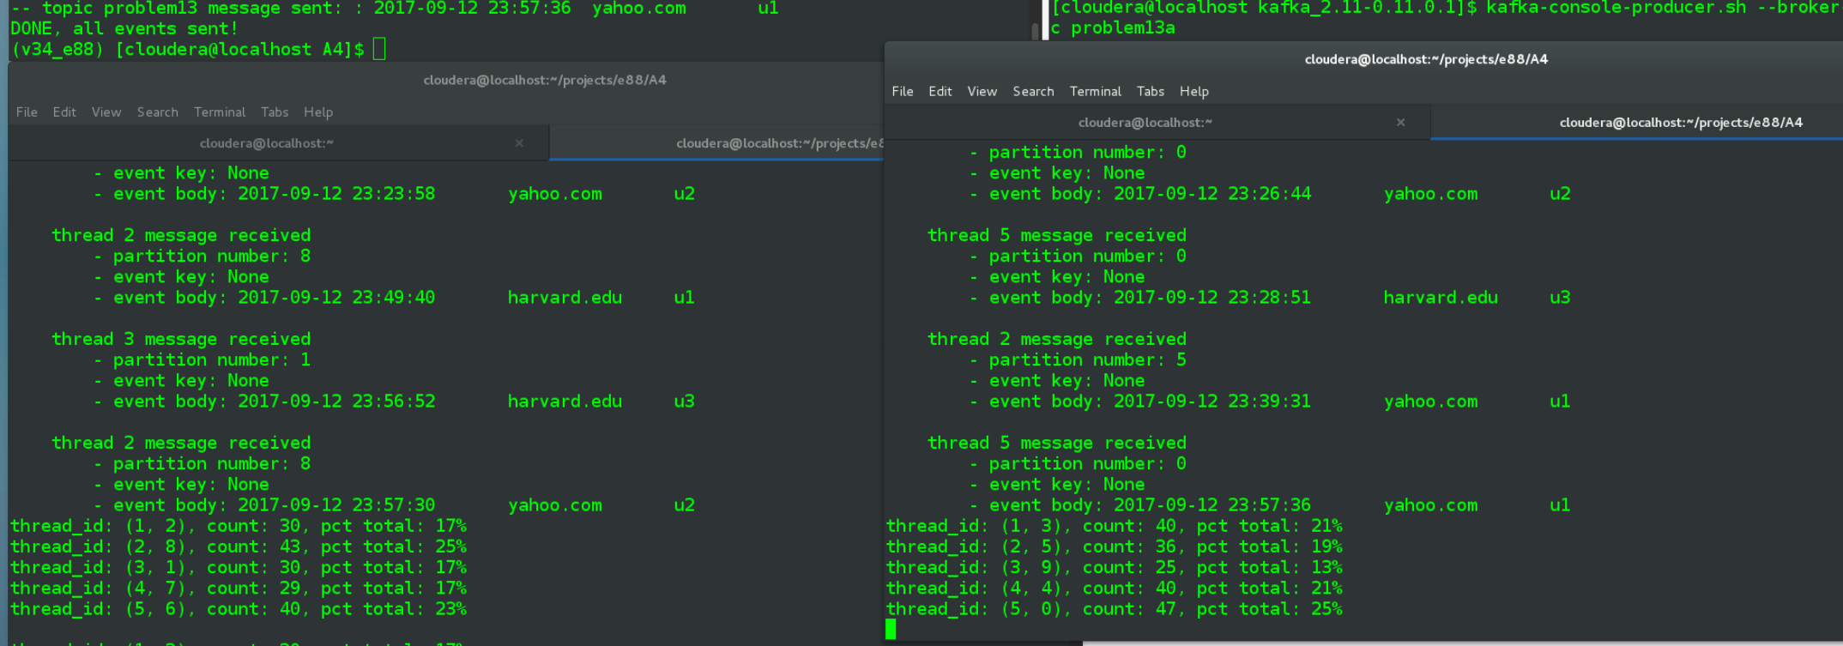

Different breakout on which partitions went to which consumer instance of course but reasonably even distribution.